Social Media for “Empowering Girls Through Sports” Webchat

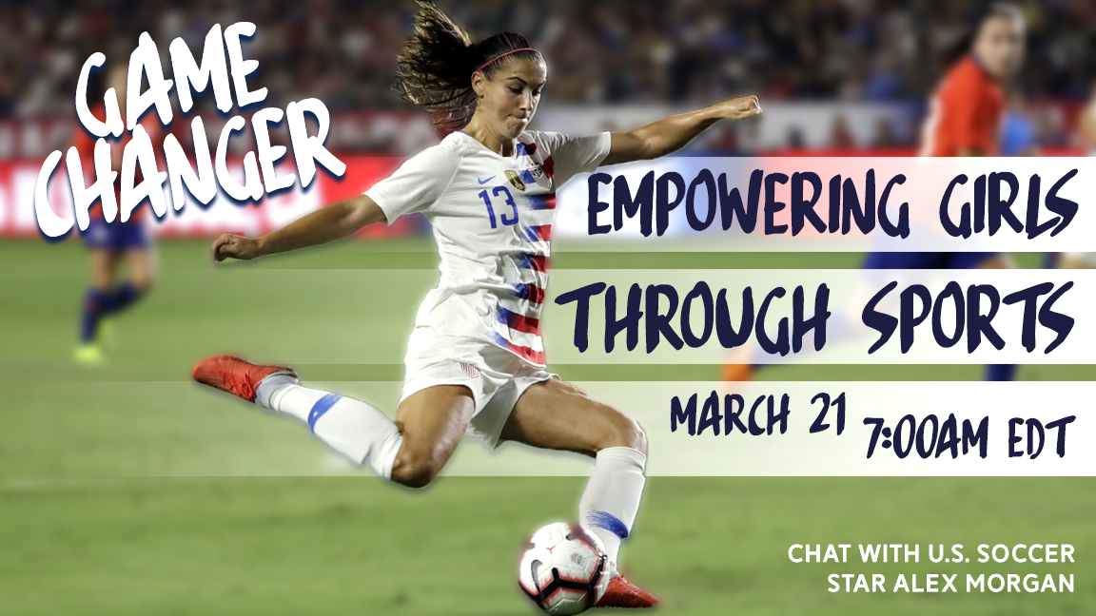
Title: Game Changer - Empowering Girls Through Sports
Key Details:
- Theme: Equal access to sports and education for girls featuring Alex Morgan, U.S. Women’s National Soccer Team co-captain
- Date/Time: Thursday, March 21 - 7:00am EDT (Washington, DC time)
- Event page: www.facebook.com/SportsDiplomacyDivision
- Marketing materials and additional info: tinyurl.com/yyvbjfme
- Language: English
- If interested in hosting a viewing group: Contact Joshua and Simon
- Anchor post: U.S. Embassy Dar Es Salaam, Tanzania

Description:
In celebration of Women’s History Month and leading up to the 2019 Women’s World Cup, US soccer star Alex Morgan will discuss how sports and education empowers women around the world and why affording girls access and opportunities benefits them and their communities.

On March 21, join Alex for a Facebook Live webchat to hear her thoughts on levelling the playing field for girls and how policies and changing attitudes can open doors for women in sports, education, and careers. Joining Alex will be an audience of youth sports participants in Tanzania, a country Alex visited as a Sports Envoy in 2017. Viewers of the webchat will be able to type in their questions for Alex during the discussion.

To participate, visit the event page www.facebook.com/SportsDiplomacyDivision on March 21 at 7:00am EDT (Washington, DC time). We hope you can join the conversation and share your perspectives.

Panelists (bios at bottom of doc):

Alex Morgan
Co-captain
U.S. Women’s National Soccer Team

Lauren Gibson (moderator)
Foreign Service Officer
U.S. Department of State

Sample Facebook Postings and Suggested Times

[Post anytime]
- In Celebration of Women’s History Month, participate in a Facebook Live webchat with Alex Morgan, a star of the U.S. Women’s National Soccer Team. She will answer your questions about the importance of equal access to sports for girls and how it empowers them to succeed in school and their future careers. Add your perspectives to the conversation by joining the live discussion on March 21 at 7:00 a.m. EDT (Washington, DC time) >> Facebook.com/SportsDiplomacyDivision. #EmpowerWomen

- Title IX legislation in the U.S. paved the way for many girls and women to be able to compete in athletics. Studies have shown that greater athletic opportunities lead to women staying in school longer and provides them with important leadership and teamwork skills.

Hear from U.S. soccer star Alex Morgan about what inspired her to follow her dream of becoming a professional athlete and how equal opportunities played a key role. Join the live chat on March 21 and #AskAlex your questions! Event page: Facebook.com/SportsDiplomacyDivision

- How can participating in sports help girls develop leadership skills and help their communities? In honor of Women’s History Month and leading up to the Women’s World Cup in June, participate in a live webchat with U.S. soccer star Alex Morgan to celebrate women in sports! Learn about how playing sports empowers young women and girls, and ask your questions on the Facebook Live page: Facebook.com/SportsDiplomacyDivision or on Twitter using #EmpowerWomen.

[Post March 20, the day before the event]
- Tomorrow is the day! Participate in a #WomensHistoryMonth Facebook Live webchat to hear U.S. soccer star Alex Morgan discuss how sports and education empowers women around the world and why affording girls access and opportunities benefits all of society. Take part in the conversation here: Facebook.com/SportsDiplomacyDivision. #EmpowerWomen

[Post March 21, immediately before the event]
- Going live soon! U.S. Soccer star Alex Morgan is ready to answer your questions about how sports is a game changer for young girls. When girls have equal access to athletics and education, they thrive and so do their communities. Join the conversation with Alex and the U.S. Department of State: Facebook.com/SportsDiplomacyDivision.

Sample Tweets and Suggested Times

[Post anytime]
- When women and girls do better, communities do better. Join a #WomensHistoryMonth webchat with U.S. soccer star Alex Morgan to discuss how sports and education empowers women and communities all over the world > March 21 at 7:00 a.m. EDT > Facebook.com/SportsDiplomacyDivision #EmpowerWomen

- There are many successful and amazing female athletes, but girls throughout the world still face limited opportunities to participate in sports. Hear from U.S. soccer star @alexmorgan13 about how to #EmpowerWomen through sports & education > Live webchat: Facebook.com/SportsDiplomacyDivision

- How can participating in sports help girls develop leadership skills and help their communities? In honor of Women’s History Month and leading up to the Women’s World Cup in June, participate in a live webchat with U.S. soccer star Alex Morgan. March 21 at Facebook.com/SportsDiplomacyDivision

[Post March 20, the day before the event]
- Tomorrow is the day! Participate in a #WomensHistoryMonth Facebook Live webchat to hear U.S. soccer star @alexmorgan13 discuss how sports gives girls critical leadership and teamwork skills. Take part in the conversation: Facebook.com/SportsDiplomacyDivision. #EmpowerWomen

[Post March 21, at beginning of the event]
- LIVE NOW: U.S. Soccer star Alex Morgan is ready to answer your questions about how sports is a game changer for young girls. When girls have equal access to athletics and education, they thrive and so do their communities. Don’t miss the conversation! Facebook.com/SportsDiplomacyDivision.

Hashtags/Handles
#EmpowerWomen
#WomensHistoryMonth

Alex Morgan - @alexmorgan13

Speaker Bios:
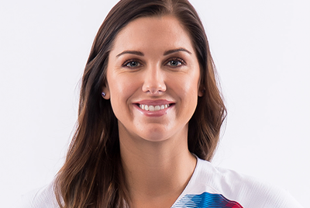
Alex Morgan
As co-captain of the U.S. Women’s National Soccer Team and starting forward for the Orlando Pride, Alex Morgan has become one of the most recognized stars in the sport. Helping to lead her teams to championships in the Olympics, Women’s World Cup, Women’s Professional Soccer, and the National Women’s Soccer League, Alex is a proven winner. She has also been named the U.S. Soccer Female Athlete of the Year and a member of the U.S. Women’s National Team's All-Time Best XI squad.

Hailing from Southern California, Alex excelled in high school soccer and was awarded a scholarship to play at the University of California, Berkeley. She finished her career as the Golden Bears' single season-season leading scorer, a four-time all-Pac 10 performer, and a 2010 All-American.

Off the field, Alex is one of sports’ most recognizable faces. A media fixture, she has graced the pages of publications ranging from Sports Illustrated’s Swimsuit Issue to ESPN the Magazine’s Music Issue, while also having appeared in ESPN’s documentary series Nine for IX.

In 2017, Alex Morgan traveled to Tanzania as an official U.S. Department of State Sports Envoy, leading soccer clinics for youth and women in Dar es Salaam, Zanzibar, and Arusha. She shared her powerful message of women’s empowerment with communities of disparate backgrounds while learning more about the challenges Tanzanian women still face for equal opportunities.

Alex feels her most meaningful contribution away from the pitch has come by way of her work as a best-selling author. Writing to celebrate her love of the game and her meteoric rise up the sport’s mountain, Alex hopes her novels inspire young girls everywhere, and that one day they might help the next unknown climb to the top of the soccer world.

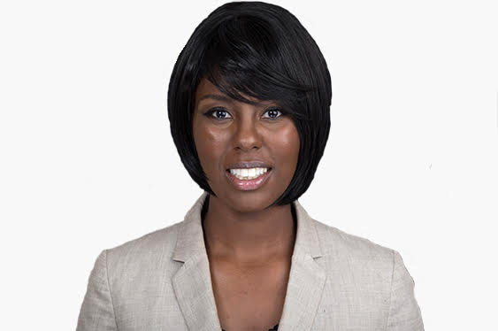
Lauren Gibson (moderator)
Lauren Gibson is a Foreign Service Officer with the U.S. Department of State. She joined the Department in 2011 and served in Lome, Togo, and Ho Chi Minh City, Vietnam. Lauren currently works as a South and Central Asia Regional Policy Officer in the Bureau of International Information Programs.

Prior to joining the Department, Lauren worked in alternative marketing as an account manager for Nestle and Target. Lauren attended American University, where she earned a bachelor's degree in business administration and a master's degree in international affairs. She speaks Vietnamese and French.

