Reporting for Democracy: The Role of a Free Press in Elections
World Press Freedom Day webchat
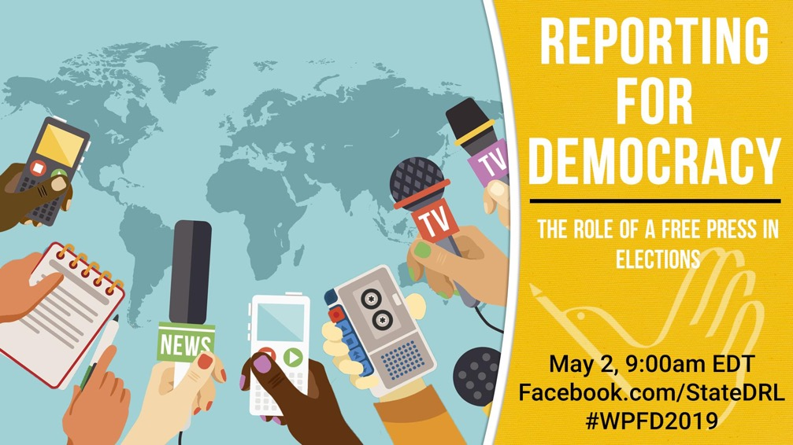

-Social Media Package-

World Press Freedom Day interactive webchat
- Title: Reporting for Democracy: The Role of a Free Press in Elections
- Date/time: May 2, 9:00 a.m. - 10:00 a.m. EDT (Washington time)
- Event page: www.Facebook.com/StateDRL
- Shortened link: FB.com/StateDRL
- Language: English
- If hosting a viewing group: Please confirm with Simon van Steyn and Al Murphy
- Promotional site and marketing materials: http://bit.ly/2U6R5Nb
- Poll question: What aspects of "Election Reporting" are you most interested in hearing about during the May 2 World Press Freedom Day webchat? Poll link: http://bit.ly/2ImPwZg
Description:
May 3rd marks the 26th anniversary of World Press Freedom Day. This year, the worldwide commemoration of the event will focus on the essential role that media plays in supporting elections and democracy, especially in the face of the increasing challenges of disinformation, declining trust in news media, and intimidation and violence against journalists.

As part of this effort, the U.S. Department of State will host an interactive webchat featuring journalists and policy experts who will discuss how the digital transformation of media is affecting election reporting and how increasing pressures on a free press undermine democracy.

In keeping with the theme of World Press Freedom Day 2019, the panel will discuss these topics, amongst others:

1) How digital transformation of the media is affecting election reporting, including disinformation.
2) How threats to freedom of the press undermine the critical role of media in democracy.
3) How a free press contributes to peace and democracy, especially during elections.

The panelists will also answer viewer questions and provide links to resources. Those watching online or participating at a viewing group will be able to share their own experiences and thoughts in the comments section. This Facebook Live webchat will take place on Thursday, May 2, 9:00 a.m. EDT at Facebook.com/StateDRL. #WPFD2019

Time Zone: 9:00 a.m. EDT can be converted to your time zone here: http://bit.ly/2UrTRBS

Hashtags/Handles:
- #WPFD2019 #PressFreedom #WorldPressFreedomDay
- Dept. of State, Bureau of Democracy, Human Rights and Labor @StateDRL
- Insert speaker Twitter handles

Panelists:

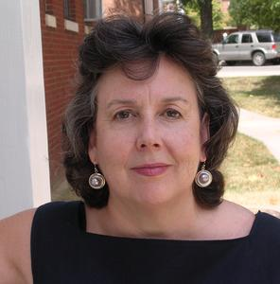
Lucinda Fleeson
Award-winning journalist with extensive international training experience in investigative reporting election coverage. Lucinda has trained journalists in Africa, Eastern and Central Europe, Latin America and South Asia.

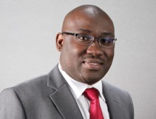
Peter Clottey
Host of Nightline Africa, a radio magazine show on Saturdays and Sundays and One on One with Peter Clottey, a TV segment on Voice Of Americas’ Africa 54 TV show. Peter has interviewed African heads of state and other governmental officials, as well as rebel and insurgent leaders.

*Additional speaker to be announced soon

Sample Social Media Posts

Facebook

[Post anytime]
- Participate in a World Press Freedom Day interactive discussion on May 2. Ask questions about the role that media plays in supporting elections and hear experts’ thoughts on recognizing and challenging disinformation. The webchat will go live on May 2 at 9:00 a.m. EDT (Washington, DC time). To take part in the conversation, go to: www.Facebook.com/StateDRL. #WPFD2019

- POLL! What aspects of "election reporting" are you most interested in hearing about during the May 2 World Press Freedom Day webchat? Answer the poll question here: http://bit.ly/2ImPwZg. Then join the conversation at www.FB.com/StateDRL on May 2 at 9:00 a.m. EDT to hear the panelists reactions to the poll.

- Join a Facebook Live webchat where media professionals will answer your questions and share their insights on election reporting, recognizing disinformation, and understanding the credibility of media sources. Join us for this interactive chat & ask questions LIVE at www.Facebook.com/StateDRL or on Twitter #WPFD2019. The event takes place on May 2 at 9:00 a.m. EDT (Washington, DC time).

- Are you interested in learning how digital transformation of the media is affecting electtion reporting, including disinformation? Participate in a live webchat featuring policy experts and journalists who will discuss the important role that journalists play during elections and how increasing pressures on a free press undermine democracy. Ask the experts your questions on May 2: www.Facebook.com/StateDRL.

Tune in on May 2 for a World Press Freedom Day webchat to ask the media experts your questions and hear their insights on the role of a free press in elections. Event page: www.Facebook.com/StateDRL. #WPFD2019

- Check out this video on spotting fake news https://youtu.be/w1Bwqoj-FFI - then participate in a World Press Freedom Day webchat to hear how digital transformation is affecting election reporting, including disinformation in the fragmented news and social media landscape. Media experts will answer your questions. The Facebook Live will take place at 9:00 a.m. EDT, here: www.FB.com/StateDRL.
[Post morning of May 1, day before event]
- In the lead up to World Press Freedom Day, learn more about the role of a free press in democracy and elections - join a Facebook Live webchat at 9:00 a.m. EDT (Washington, DC) >> www.FB.com/StateDRL. And join the conversation on Twitter! #WPFD2019 #PressFreedom

[Post May 2, immediately before live event]
- Tomorrow is World Press Freedom Day, so today we’re talking about the role of the press in free and open elections, disinformation, and the importance of protecting journalists. Your questions on these topics will be answered by a panel of media experts. Go to www.Facebook.com/StateDRL to join the webchat and tweet about it at #WPFD2019.

Twitter

[Post anytime]
- Celebrate #WorldPressFreedomDay - Join @StateDept live webchat to hear media experts discuss the critical role of a free press in democracy and how digital transformation of the media is affecting election reporting >> May 2, 9:00am EDT at: www.Facebook.com/StateDRL #WPFD2019
- POLL! What aspects of "election reporting" are you most interested in hearing about during the World Press Freedom Day webchat? Poll question here: http://bit.ly/2ImPwZg. Then join the conversation at www.FB.com/StateDRL on May 2 at 9:00 a.m. EDT #WPFD2019
- Media experts [Insert Twitter handles] ‏will answer your questions and share their thoughts on the importance of a free press to elections and democracy, and how to challenge disinformation. #WorldPressFreedomDay webchat on May 2 >> www.FB.com/StateDRL #WPFD2019

- Join a #WorldPressFreedomDay webchat to hear media experts’ insights on the importance of 📺 📻 📰 💻[TV, radio, newspaper, and computer emojis] in accurately covering elections. Participate in the discussion and ask your questions during the Facebook Live chat on May 2: www.FB.com/StateDRL. #WPFD2019

[Post morning of May 1, day before event]
- Tomorrow is #WorldPressFreedomDay! Learn more about how digital transformation of the media is affecting election reporting, including disinformation. Join a Facebook Live webchat at 9:00 a.m. EDT (Washington, DC) >> www.FB.com/StateDRL. #WPFD2019

[Post May 2, before the live event]
- LIVE NOW: Don’t miss the #WorldPressFreedomDay webchat featuring media experts discussing the critical role of a free press in elections and the importance of challenging disinformation >> www.Facebook.com/StateDRL #WPFD2019 #PressFreedom

Speaker Bios:
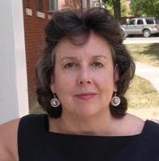
Lucinda Fleeson is an award-winning journalist who has extensive international training experience in investigative reporting election coverage, and other topics including migration, youth and women's issues and financial crimes. She has trained journalists in Africa, Eastern and Central Europe, Latin America and South Asia. Lucinda’s training manual for teaching investigative reporting in developing democracies has been translated into 18 languages and circulated to more than 20,000 journalists.

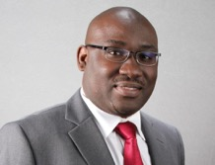
Peter Clottey is the host of Nightline Africa, a radio magazine show on Saturdays and Sundays and One on One with Peter Clottey, a TV segment on Voice Of Americas’ Africa 54 TV show. Peter has interviewed African heads of state and other governmental officials, as well as rebel and insurgent leaders. His impartial economic and political news reports have established him as a highly respected international broadcast journalist with Voice of America.

*Additional speaker to be announced soon

Press Freedom Resources:

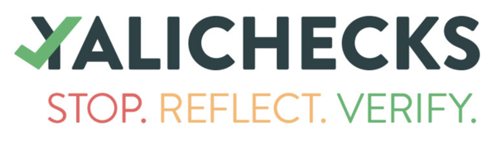
YALIChecks: a Young African Leaders Initiative campaign to raise awareness about disinformation and provide resources to check content from news sites, bloggers, and social media. Learn more: https://yali.state.gov/checks #YALICHECKS

Videos:
- 5 Tips for Spotting Fake News: https://youtu.be/w1Bwqoj-FFI
- https://youtu.be/h3Eyu7fw6Ms (Conversation on Press Freedom with the Committee to Protect Journalists)

Podcasts:
https://youtu.be/4__rZB9cmvQ (Free Press in Nigeria)
https://youtu.be/7g4gtkT7q38 (Free Press in Tunisia)
https://youtu.be/f3QpvjOgIz4 (Free Press in India)

Quotes:
“Our liberty depends on the freedom of the press, and that cannot be limited without being lost.”
-Thomas Jefferson

“Freedom of teaching and of opinion in book or press is the foundation for the sound and natural development of any people.” - Albert Einstein

“Freedom of the press is a precious privilege that no country can forego.” -Mahatma Ghandi

Shareable Quote Images

ENGLISH
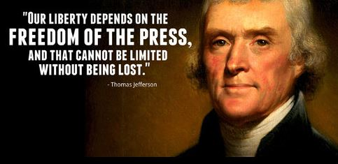

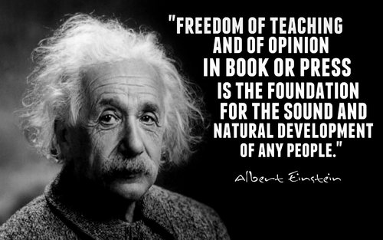

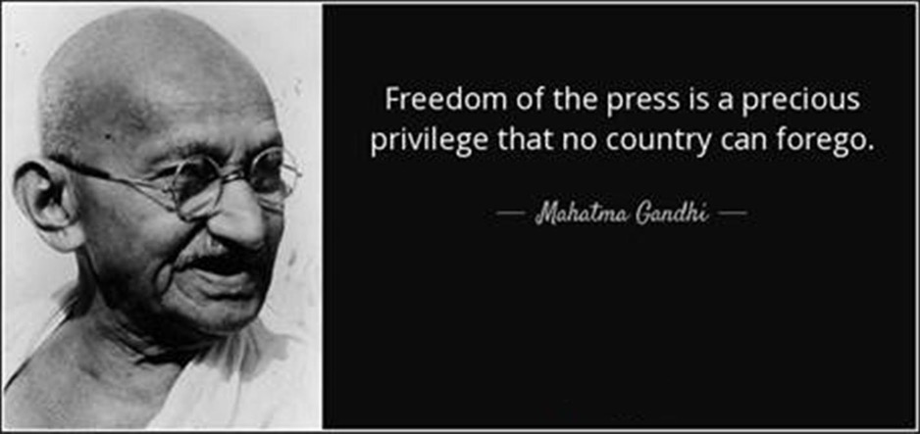

FRENCH
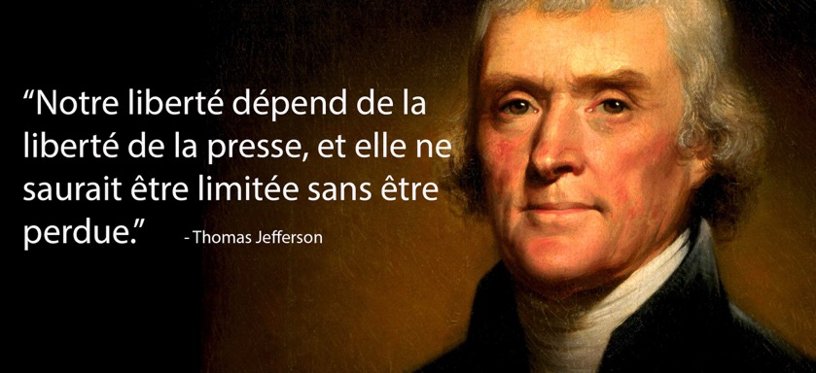

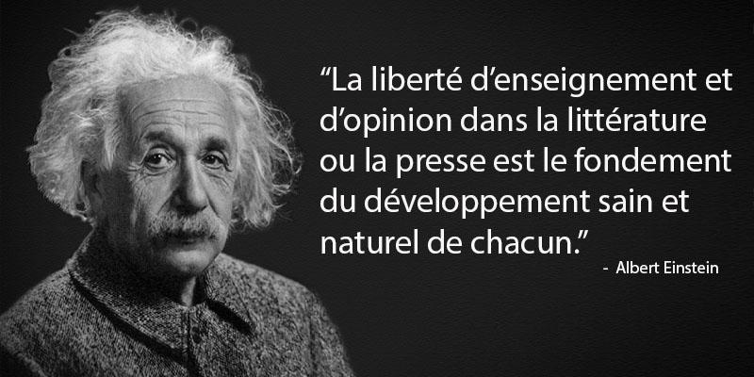

SPANISH
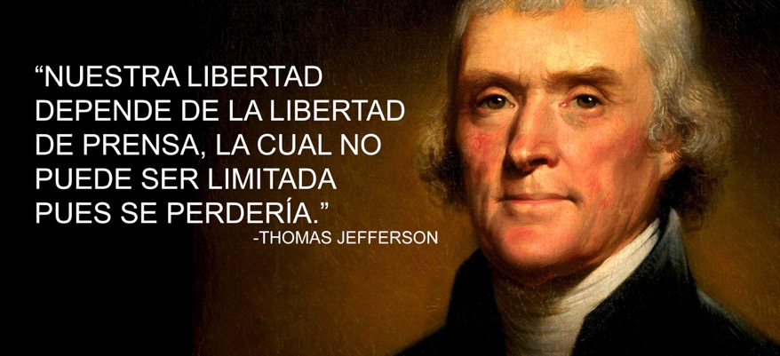

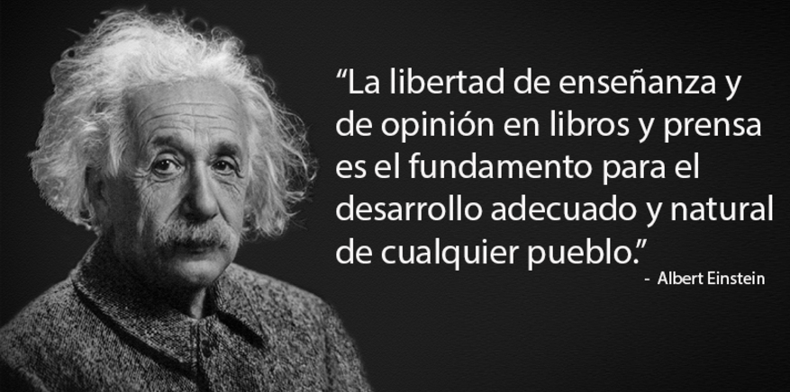

RUSSIAN
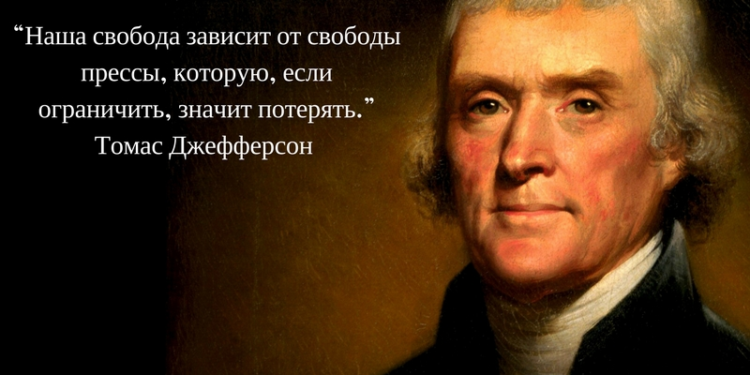

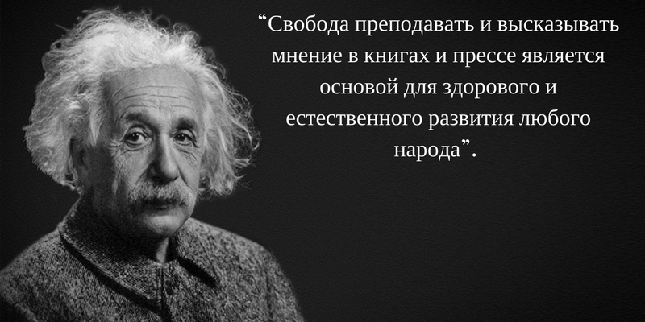

ARABIC
