Social Media Toolkit
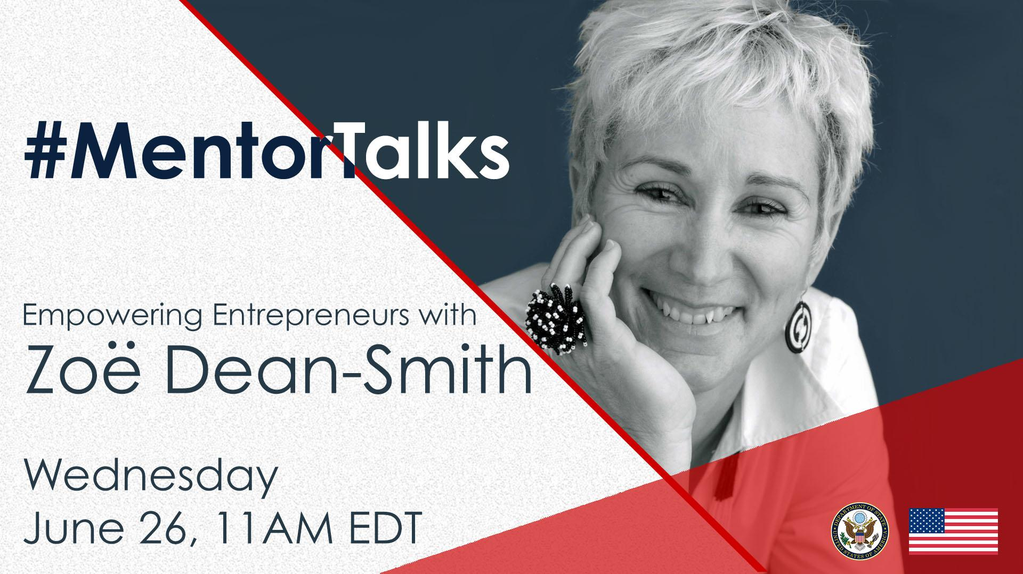
#MentorTalks: Empowering Entrepreneurs with Zoe Dean-Smith (Facebook Live)

Description:
Get 15 minutes of entrepreneurial inspiration! Join us for our first #MentorTalks, a new Facebook Live series that puts exchange program alumni in touch with extraordinary mentors on a wide variety of topics.
On June 26, at 11:00 am EDT, Zoë Dean-Smith of Vital Voices will offer advice to aspiring entrepreneurs during a 15-minute session on Facebook Live. She will answer questions live on everything from building a better business climate for women, to finding and being a successful mentor.
Zoë empowers entrepreneurs in emerging markets in her role as Vice President, Economic Empowerment and Entrepreneurship at Vital Voices, and she is excited to chat with you.
Come ready to ask questions and be inspired! Use #MentorTalks when tagging your question.

Event Details - Snapshot:
Title: #MentorTalks Empowering Entrepreneurs with Zoë Dean-Smith
Format: 15-minute Facebook Live with live Q&A
Date and Time: June 26 @ 11am EDT
URL: facebook.com/InternationalExchangeAlumni
Speaker: Zoë Dean-Smith, Vice President, Economic Empowerment and Entrepreneurship at Vital Voices
Topic: Entrepreneurship
Audience: Alumni of U.S. government-sponsored exchange programs and aspiring entrepreneurs (particularly women). The conversation will also be geared to alumni with projects in Africa.

Hashtags:
#MentorTalks (program hashtag)
#ExchangeAlumni

Graphics:
Download here (bottom of page): https://interactive.america.gov/iip_event/mentor-talks-with-zoe-dean-smith/

Sample Social Media Posts:
[Facebook/Instagram]
[schedule for any time]
Are you an entrepreneur looking for advice? Do you have questions about improving your community while still turning a profit? Are you curious about what it’s like to be an architect, fitness instructor, and mentor for the @MandelaWashingtonFellowship? Join our 15-minute #MentorTalks with Zoë Dean-Smith on Wednesday, June 26 at 11am EDT [edit for local time] to find out!
Zoë is Vice President of Economic Empowerment and Entrepreneurship at @vitalvoices, where she directs programs that empower female entrepreneurs all over the world. She also water skis and teaches indoor cycling classes.
Got 15 minutes? You’ve got a mentor! facebook.com/InternationalExchangeAlumni #ExchangeAlumni
[use program graphic]

[schedule for any time]

How did working on a musical horror comedy show in Eswatini lead Zoë Dean-Smith to start running a handcraft business and microfinance? Join Zoë for @InternationalExchangeAlumni’s #MentorTalks on Wednesday, June 26 at 11am EDT [edit for local time] to find out! This 15-minute conversation will be a highlight of your day. Have questions about Zoë’s wild career path? Send them ahead of the conversation by using #MentorTalks!

[schedule for June 25]
TOMORROW at 11am EDT [edit for local time]: Watch #MentorTalks with Zoë Dean-Smith from @vitalvoices and get 15 minutes of mentoring, inspiration and entrepreneurship advice! Come ready to ask questions about everything from Zoë’s advice on how to empower women in business, to her love of waterskiing and dogs! facebook.com/InternationalExchangeAlumni #ExchangeAlumni [use program graphic]

[schedule for June 26]
LIVE TODAY at 11am EDT [edit for local time]: Tune in to #MentorTalks with Zoë Dean-Smith from @vitalvoices! Get 15 minutes of mentoring, inspiration and entrepreneurship advice. Come ready to ask questions about everything from Zoë’s advice on how to empower women in business to her love of waterskiing and her dogs! facebook.com/InternationalExchangeAlumni #ExchangeAlumni
[use program graphic]

______________________________
[Twitter]
[schedule for any time]
Are you an entrepreneur looking for advice? Join Zoë Dean-Smith of @VitalVoices for #MentorTalks on June 26 at 11am EDT [edit for local time] and have your questions ready for this 15-minute discussion! facebook.com/InternationalExchangeAlumni #ExchangeAlumni
[use program graphic]

[schedule for any time]
Need some career advice? Got 15 minutes? Join Zoë Dean-Smith of @VitalVoices for #MentorTalks on June 26 at 11am EDT [edit for local time] and ask your questions!
facebook.com/InternationalExchangeAlumni #ExchangeAlumni
[use program graphic]

[schedule for June 25]
TOMORROW at 11am EDT [edit for local time]: Join Zoë Dean-Smith of @VitalVoices for mentoring, inspiration and entrepreneurship advice! Got 15 minutes? You’ve got a mentor!
facebook.com/InternationalExchangeAlumni #MentorTalks #ExchangeAlumni
[use program graphic]

[schedule for June 26]
LIVE TODAY at 11am EDT [edit for local time]: Watch #MentorTalks with Zoë Dean-Smith of @VitalVoices! Get mentoring, inspiration and entrepreneurship advice! Come ready to ask questions. Got 15 minutes? You’ve got a mentor! facebook.com/InternationalExchangeAlumni #MentorTalks #ExchangeAlumni
[use program graphic] [#ExchangeAlumni]

Got 15 minutes? You’ve got a mentor! Tune in to #MentorTalks with Zoë Dean-Smith from @VitalVoices at 11am EDT [edit for local time]. Head over to Facebook now to get ready for the conversation with other #ExchangeAlumni! facebook.com/InternationalExchangeAlumni
[use program graphic]

About Zoë:
With 36 years of experience in the for-profit, non-profit, corporate, and social enterprise sectors, Zoë Dean-Smith provides vision and leadership for the organization’s economic empowerment and entrepreneurship focused programs, including the Global Ambassadors Program, the VVGROW fellowship, and the Fortune-U.S. Department of State Global Women’s Mentoring Partnership.

Previously based in Swaziland, Zoë served as Senior Director of Vital Voices’ Global Entrepreneurs in Handcrafts Program. She was Managing Director of Gone Rural, working with 700+ women artisans in Swaziland and launched Gone Rural BoMake, a community development non-profit organization serving the Gone Rural communities. Zoe has also managed the Coca-Cola Africa Foundation’s programs across Africa.

Zoë received a 2011 World of Difference Award from The International Alliance of Women and a 2005 Pan African Business-Woman Award for Capacity Building.

She has been a featured speaker internationally in her role as a social entrepreneur, as well as addressing issues concerning Swaziland such as HIV/AIDS, women’s rights, and basic community needs.

In 2008, Zoë initiated a Young Women’s Mentorship Program in Swaziland. She currently serves as a mentor in the Cherie Blair Mentoring Women in Business program and the Mandela Washington Fellowship Program for Young African Leaders. Learn more about Zoë here: https://www.vitalvoices.org/people/zoe-dean-smith/.

