Social Media Toolkit
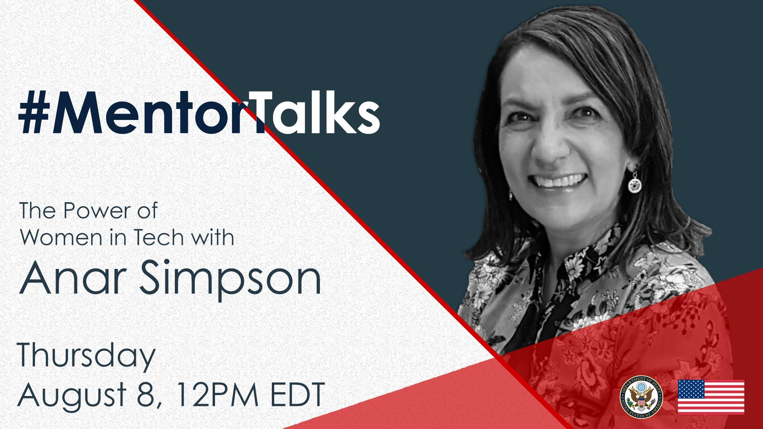
#MentorTalks: The Power of Women in Tech with Anar Simpson (Facebook Live)

Description:
Got 15 minutes? You’ve got a mentor! Join us for our latest #MentorTalks, a new Facebook Live series that puts exchange program alumni in touch with extraordinary mentors on a wide variety of topics.
On August 8, at 12:00 pm EDT, Anar Simpson of Technovation will offer advice to women in tech and to anyone interested in pursuing a career in tech! She will answer your questions live and give advice on everything from networking to overcoming work and career challenges.
Through the TechWomen program, Anar empowers and connects #ExchangeAlumni from Africa, Central and South Asia, and the Middle East, and she is excited to chat with you.
Come ready to ask questions and be inspired! Use #MentorTalks when asking your question.

Event Details - Snapshot:
Title: #MentorTalks: The Power of Women in Tech with Anar Simpson
Format: 15-minute Facebook Live with live Q&A
Date and Time: August 8@ 12pm EDT
URL: facebook.com/InternationalExchangeAlumni
Speaker: Anar Simpson, Global Ambassador, Technovation
Topic: Women in Tech
Audience: Alumni of U.S. government-sponsored exchange programs and women in the tech field or aspiring to have careers in the tech field.

Hashtags:
#MentorTalks (program hashtag)
#ExchangeAlumni
#WomenInTech

Graphics:
Download here (bottom of page): https://interactive.america.gov/iip_event/mentortalks-the-power-of-women-in-tech-with-anar-simpson/

Sample Social Media Posts:
[Facebook/Instagram]
[schedule for any time]
Are you a woman in tech looking for advice? Are you interested in a career in STEM, but want to find out more? Join our 15-minute #MentorTalks with Anar Simpson on Thursday, August 8 at 12pm EDT [edit for local time] to find out!
Anar is Global Ambassador @technovation, an organization that teaches young girls all over the world the skills they need to emerge as tech entrepreneurs and leaders.
Got 15 minutes? You’ve got a mentor! facebook.com/InternationalExchangeAlumni Follow our page to receive updates! #ExchangeAlumni #womenintech
[use Facebook or Instagram graphic]

[schedule for any time]

Want some words of advice from a key influencer of women, girls and tech? Want to talk to someone who has been recognized by the UN for her work to close the gender gap in the tech field? Join Anar Simpson for @InternationalExchangeAlumni’s #MentorTalks on Thursday, August 8 at 12pm EDT [edit for local time]! Be a part of the conversation! Send in your questions for Anar now by using #MentorTalks. #womenintech #ExchangeAlumni [use Facebook or Instagram graphic]

[schedule for Aug 7]
TOMORROW at 12 pm EDT [edit for local time]: Join other alumni of [Insert exchange program/ U.S. Embassy handle] for #MentorTalks with Anar Simpson from @technovation! Get 15 minutes of mentoring, inspiration and advice for women in tech! Come ready to ask questions about everything from networking to overcoming challenges women face in the STEM fields! facebook.com/InternationalExchangeAlumni #ExchangeAlumni #womenintech Follow us on Facebook to receive updates! Send us your questions for Anar in the comments below. [use Facebook or Instagram graphic]

[schedule for August 8]
LIVE TODAY at 12pm EDT [edit for local time]: Watch #MentorTalks with Anar Simpson from @technovation! Get 15 minutes of mentoring, inspiration and advice for women in tech. Come ready to ask questions about everything from networking to overcoming challenges women face in the STEM fields! facebook.com/InternationalExchangeAlumni #ExchangeAlumni #womenintech Follow @InternationalExchangeAlumni on Facebook to receive updates! Send us your questions for Anar now before in the comments below. [use Facebook or Instagram graphic]

______________________________
[Twitter]

[schedule for any time]
Are you a woman in tech looking for advice? Join Anar Simpson of @technovation for #MentorTalks on August 8 at 12pm EDT [edit for local time] and have your questions ready for this 15-minute discussion! http://bit.ly/2YnXWnM #ExchangeAlumni #womenintech
[use Twitter graphic]

[schedule for any time]
Need some career advice? Got 15 minutes? Join Anar Simpson of @technovation for #MentorTalks on August 8 at 12pm EDT [edit for local time] and ask your questions!
http://bit.ly/2YnXWnM #ExchangeAlumni #womenintech
[use Twitter graphic]

[schedule for August 7]
TOMORROW at 12pm EDT [edit for local time]: Join Anar Simpson of @technovation for mentoring, inspiration, and advice for #womenintech! Got 15 minutes? You’ve got a mentor!
http://bit.ly/2YnXWnM #MentorTalks #ExchangeAlumni
[use Twitter graphic]

[schedule for August 8]
LIVE TODAY at 12pm EDT [edit for local time]: Watch #MentorTalks with Anar Simpson of @technovation! Got 15 minutes? You’ve got a mentor! Get mentoring, inspiration and advice for #womenintech! Come ready to ask questions. http://bit.ly/2YnXWnM #ExchangeAlumni
[use Twitter graphic]

Got 15 minutes? You’ve got a mentor! Tune in to #MentorTalks with Anar Simpson of @technovation at 12pm EDT [edit for local time]. Head over to Facebook now to get ready for the conversation! http://bit.ly/2YnXWnM
[use Twitter graphic]

________________________________________________________________

About Anar:
Anar Simpson is a key influencer for women, girls and technology, and works with governments, international agencies and technology companies on the digital inclusion of women. She is the Global Ambassador for Technovation, an organization that is building a pipeline of young girls to enter STEM careers in over 100 countries. She was appointed as a Deputy to the UN High Level Panel on Women's Economic Empowerment and led this initiative at Mozilla.
She has been instrumental in the growth and outreach of the US Department of State’s TechWomen initiative, which empowers and supports the next generation of women leaders in science, technology, engineering and mathematics (STEM) from Africa, Central and South Asia, and the Middle East and connects them with their counterparts in Silicon Valley.
Anar has been recognized for her leadership and outstanding contribution for closing the industry gender gap by numerous institutions, including the University of Calgary and the United Nations.

