SOCIAL MEDIA TOOLKIT

GIST TechConnect: Catalyzing Resources for Women Led Startups
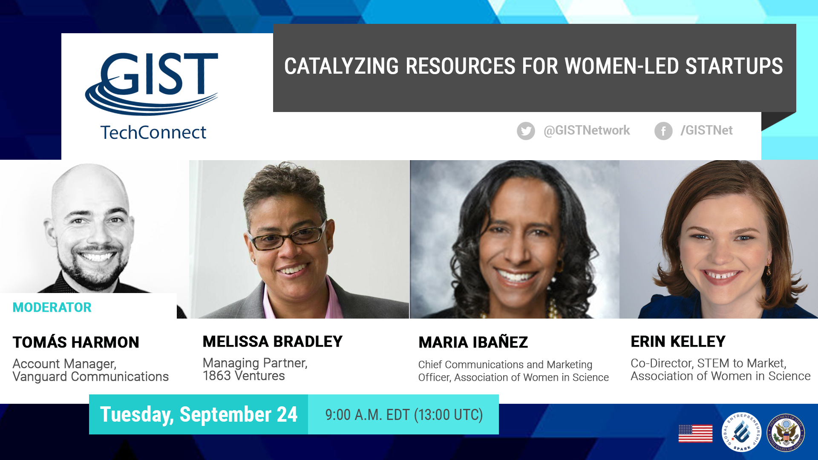

Entrepreneurship Interactive Chat
Tuesday, September 24
9:00 a.m. EDT (13:00 UTC)

Links
Event Page (in English): http://www.gistnetwork.org/content/gist-online (http://bit.ly/GISTTechConn)
Event Page (In Spanish): http://bit.ly/TCEspanol
Event Page (In French): http://bit.ly/TCFrancais

Social Media
Accounts to follow, or to include and mention in posts or tweets
- GIST Network: @GISTNetwork (Twitter)
- GIST Network: Facebook.com/GISTNet (Facebook)

Hashtags
- #GISTTechConnect

Marketing Assets
- Official Banner: http://bit.ly/2kCAFkd

Program Description
Cultivating a thriving, equitable, and inclusive entrepreneurial ecosystem across developing economies requires a robust and supportive ecosystem. This is especially true for women in STEM. Supporting women-led startups to commercialize their technologies helps catalyze innovation, spur economic growth, and support women’s economic self-empowerment.

The Global Innovation through Science and Technology (GIST) Initiative is continuing its support for Women in STEM in developing economies by hosting a GIST TechConnect expert panel on how to build, support, and scale women-led, science and technology-based ventures. This edition of GIST Techconnect will take a close look at support women in STEM in the Middle East and South Central Asia.

This GIST TechConnect will be in advance of the GIST APEC Catalyst Pitch Competition in La Serene, Chile from Sep. 29 - Oct. 4th. This Competition will highlight leading women-led science and technology startups from across the 21 APEC economies.

Speaker Biographies

Melissa Bradley
Managing Partner, 1863 Ventures
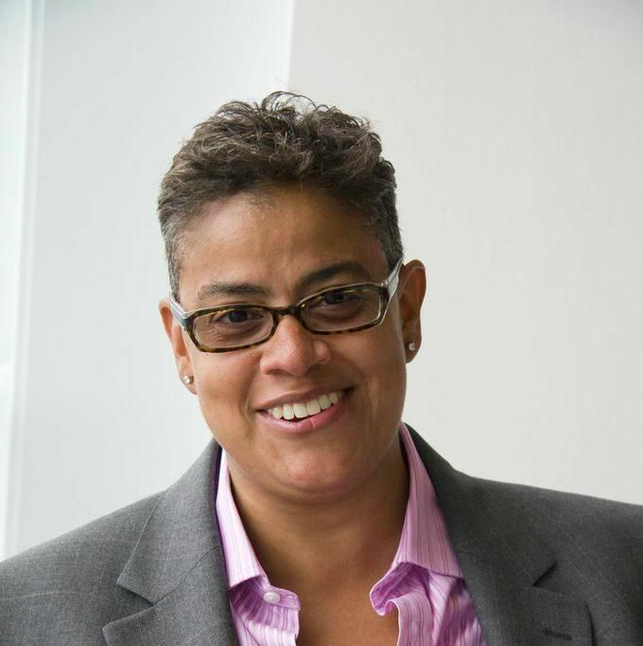

Melissa L. Bradley is Managing Partner of 1863 Ventures, a business development program that accelerates New Majority entrepreneurs from high potential to high growth. She also serves an advisor the New Voices Foundation and New Voices Fund, as well as the Halcyon Fund. Melissa is the former Co- Chair, National Advisory Council for Innovation and Entrepreneurship and was recently named one of The Most Entrepreneurial Women Investors in 2018.

Melissa is a professor at the McDonough School of Business at Georgetown University where she teaches impact investing, social entrepreneurship, P2P economies and innovation. She recently received
The Ideas Worth Teaching Award which celebrates exceptional courses that are preparing future business leaders to tackle society’s largest challenges and create a more inclusive, just, and sustainable version of capitalism. She is also a Co-Founder and Managing Partner of Sidecar Social Finance, a social impact agency that provides impact investing advisory and capital services to individuals, institutions, and social enterprises. Melissa currently serves as board chair for MOXY Bank (in organization) and a board member for AEO. She is a Founding Advisor to the Dell Center for Entrepreneurs as well as a Senator with the Board of Governors at Georgetown University.

Melissa’s educational background includes graduation from Georgetown University in 1989 with a Bachelor of Science degree in Finance from the School of Business, and a Master’s degree in Business Administration in Marketing from American University in 1993.
.

Maria Ibanez
Chief Communications & Marketing Officer, Association of Women in Science

Maria Ibañez is Chief Communications and Marketing Officer at the Association for Women in Science. She has more than 20 years of communications experience leading efforts for public policy issues including family reunification, education, women’s rights, community development, and healthcare. Prior to joining AWIS, she served in several senior management positions in the public and private sector. She was also an adjunct instructor at the University of Maryland, School of Journalism, and Trinity University's School of Communications. Maria holds an MA in Public Communications from The American University and a BA from the University of the District of Columbia.

Erin Kelley
Co-Director, STEM to Market, Association of Women in Science

Erin Kelley is the Co-Director for STEM to Market, an initiative of the Association for Women in Science. She has degrees in international relations (BA, Mount Holyoke College; MA, Johns Hopkins University) and general management/corporate innovation (MBA, University of Virginia). With her unique interdisciplinary background, Erin has research, policy and programmatic expertise in innovation and commercialization; organizational and systemic change; entrepreneurship ecosystems; international development; design thinking and product/process development; and instructional design. Through her work at IBM, T. Rowe Price, and the National Women’s Business Council, Erin’s work has improved the business climate and outcomes for women entrepreneurs and leaders.

Moderator:

Tomás Harmon
Account Manager, Vanguard Communications

With over five-years of experience in communicating important concepts to specific audiences, Tomás understands the critical role multimedia elements play in digital storytelling. As an account manager at Vanguard Communications, Tomas works to help clients make a positive impact in their communities by developing communication strategies that support positive social change. Vanguard is a Hispanic woman-owned PR and social marketing firm that has been working for more than 30 years to open hearts and minds about issues and individuals, and realize a more inclusive and equitable world.

Suggested Social Media Posts:

Facebook:

MARK YOUR CALENDARS: #GISTTechConnect is returning on Tuesday, September 24 at 9:00 AM EDT. Learn about Cultivating a thriving, equitable, and inclusive entrepreneurial ecosystem across developing economies requires a robust and supportive ecosystem. Tune in here: http://bit.ly/GISTTechConn
[Insert Banner]

Supporting women-led startups to commercialize their technologies helps catalyze innovation, spur economic growth, and support women’s economic self-empowerment. To learn more join #GISTTechConnect to find out! Tune in Tuesday, September 24 at 9 AM EDT. http://bit.ly/GISTTechConn
[Insert Banner]

Historically, investment in women-led #startups has been low – so how can we change this? Join #GISTTechConnect to learn more from a panel on why catalyzing recourse for women-led startups is so important. Tune in Tuesday, September 24 at 9:00 AM EDT. http://bit.ly/GISTTechConn
[Insert Banner]

Tell us your thoughts! What aspect of cultivating a thriving, equitable, and inclusive entrepreneurial ecosystem across developing economies most excites you? To answer the poll question check out #GISTTechConnect at http://bit.ly/GISTTechConn, then join the LIVE discussion on Tuesday, September 24 at 11:00 AM EDT.
[Insert Banner]

Join the LIVE broadcast, Tuesday, September 24 at 11:00 AM EDT to chat with a panel of women about cultivating a thriving, equitable, and inclusive entrepreneurial ecosystem across developing economies. You can ask questions via the live chatbox or on Twitter using #GISTTechConnect! http://bit.ly/GISTTechConn
[Insert Banner]

Monday, September 23
TOMORROW! #WomenEntrepreneurs join a global [world emojis] conversation on women-led #startups. Join #GISTTechConnect to send our panel of pros your questions. Broadcast starts at 9:00 AM EDT. http://bit.ly/GISTTechConn
[Insert Banner]

Tuesday, September 24
TODAY! The #GISTTechConnect a panel of women about cultivating a thriving, equitable, and inclusive entrepreneurial ecosystem across developing economies. Learn from the pros on why it’s important for investors to invest in women-led #startups. Join the live discussion at 11:00 AM EDT right here: http://bit.ly/GISTTechConn
[Insert Banner]

RIGHT NOW: We’re talking about #WomenLedStartups! Tune in to ask questions and chat LIVE with a panel of women investors now! http://bit.ly/GISTTechConn #GISTTechConnect
[Insert Banner or Banner #2]

