Social Media Toolkit
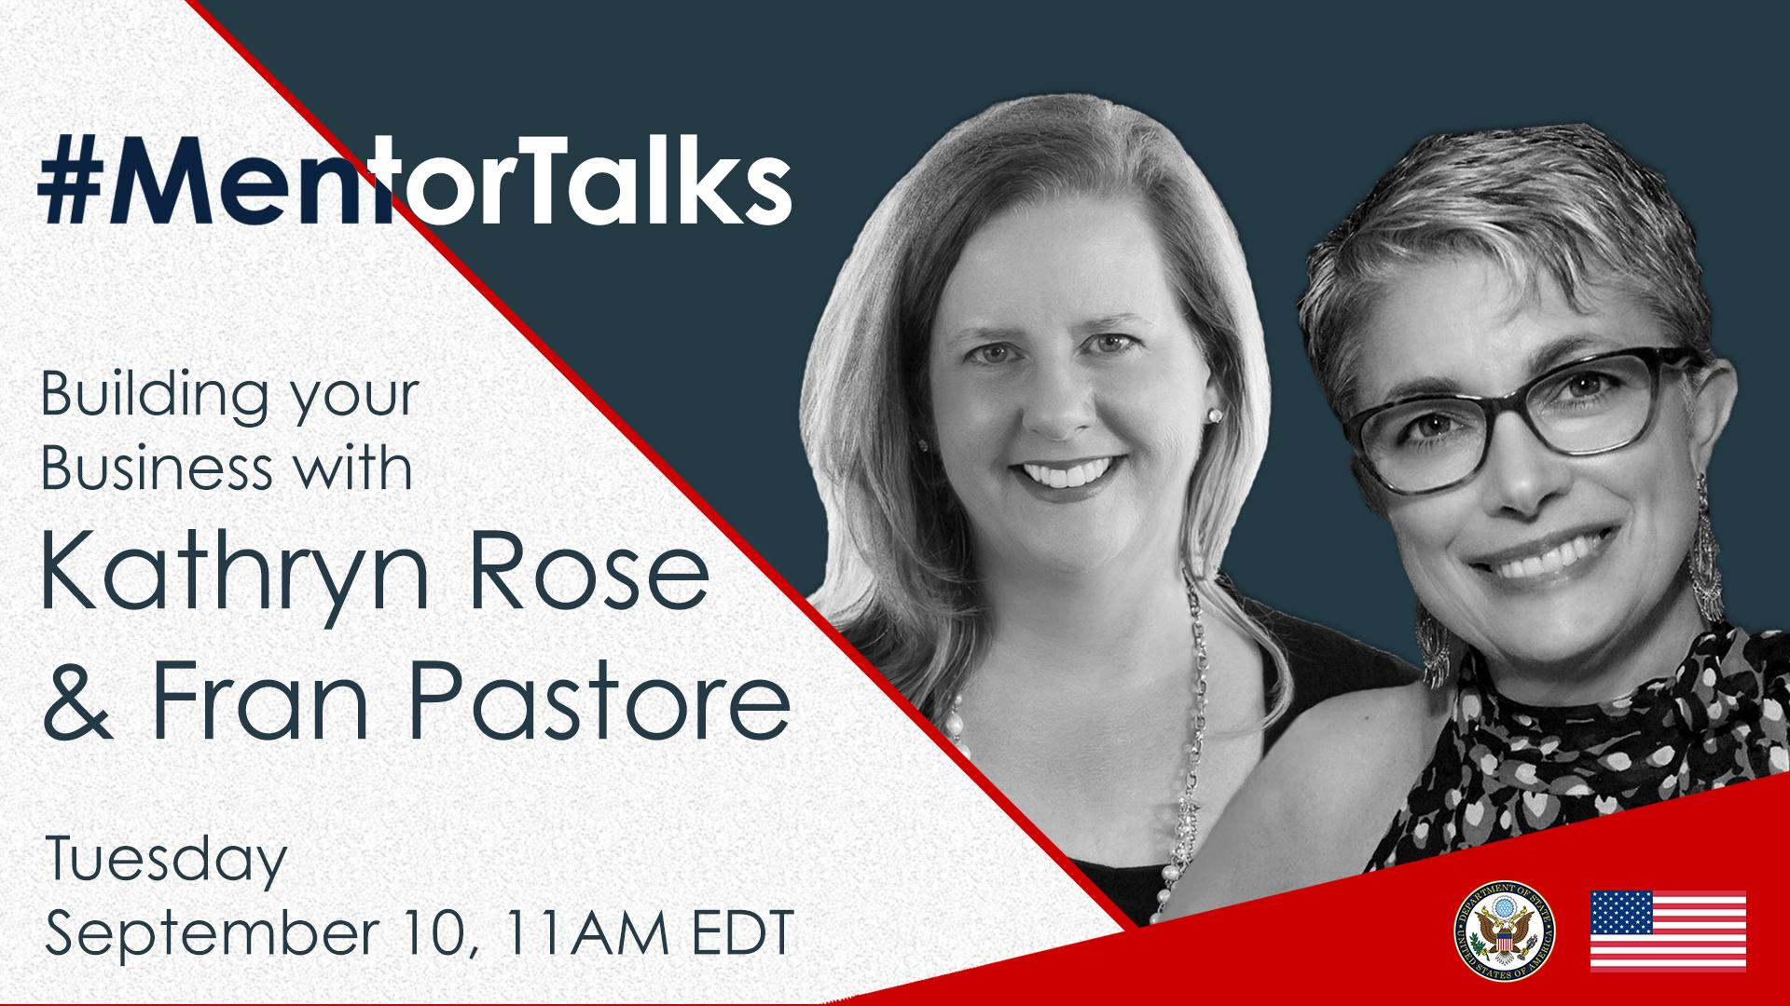
#MentorTalks: Building your Business with Kathryn Rose & Fran Pastore (Facebook Live)

Description:
Got 15 minutes? You’ve got a mentor! Join us for our next #MentorTalks, a Facebook Live series that puts exchange program alumni in touch with extraordinary mentors on a wide variety of topics.
On Tuesday, September 10 at 11:00 am EDT, Kathryn Rose, Founder and CEO of wiseHer, and Fran Pastore, Founder and CEO of the Women’s Business Development Council, will share their advice on how to build your business. Kathryn and Fran will also offer tips on how to meet business development challenges and answer your questions live.
Come ready to ask questions and be inspired! Kathryn and Fran will provide excellent examples of how women can plan a business strategy and balance competing priorities for sustainable success. Use #MentorTalks when asking your question, and we’ll see you online!

Event Details - Snapshot:
Title: #MentorTalks: Building your Business with Kathryn Rose & Fran Pastore
Format: 30-minute Facebook Live with live Q&A
Date and Time: Tuesday, September 10 @ 11am EDT
URL: facebook.com/InternationalExchangeAlumni
Speakers:
Fran Pastore, Founder and CEO, Women’s Business Development Council
Fran Pastore is the Founder and CEO of the Women's Business Development Council (WBDC), Connecticut’s leading organization championing the independence of women through entrepreneurship. Globally, Ms. Pastore’s influence has been exemplified through her direct work with women entrepreneurs. In conjunction with the U.S. Department of State and the University of Connecticut’s Office of Global Affairs, Ms. Pastore taught women business owners in Costa Rica. Ms. Pastore continued to share her expertise with women through partnerships with The Center for Creative Leadership in Ethiopia and The Akilah Institute for Women in Rwanda. For over two decades, Ms. Pastore has been instrumental in the passage of legislation benefiting women entrepreneurs. Ms. Pastore has provided numerous testimonies before the U.S. Congress, addressing the state of women’s entrepreneurship.

Kathryn Rose, Founder and CEO, wiseHer
Kathryn Rose is the founding CEO of wiseHer, an award-winning global knowledge marketplace that helps women business owners and professionals overcome unique challenges. She is a former Wall Street sales leader and an author of nine books. Kathryn is a highly sought after speaker at leading global industry events, a member of the Executive Council of Advancing Women in Technology, and a sales coach for MBA candidates at Harvard Business School. Kathryn is regarded for her grit, tenacity, creative problem solving, glass-half-filled approach and her ability to laugh, always. A tireless champion for women, Kathryn has received accolades for her vision, commitment, and leadership including the CompTIA Advancing Women in Technology Mentor of the Year Spotlight award and more.

Topic: Empowering Women Entrepreneurs
Audience: Alumni of U.S. government-sponsored exchange programs and women entrepreneurs aspiring to build successful businesses.

Hashtags:
#MentorTalks (program hashtag)
#ExchangeAlumni

Graphics:
Download here (bottom of page): https://interactive.america.gov/iip_event/mentortalks-building-your-business-with-kathryn-rose-fran-pastore/

Sample Social Media Posts:
[Facebook/Instagram]
[schedule for any time]
Are you interested in developing a business, but not sure how to start? Join our 30-minute #MentorTalks with Kathryn Rose and Fran Pastore on Tuesday, September 10 at 11am EDT [edit for local time] to find out! Kathryn and Fran teach women all over the world the strategy, leadership skills, and ways to develop their businesses. facebook.com/InternationalExchangeAlumni Follow our page to receive updates! #ExchangeAlumni
[use Facebook or Instagram graphic]

[schedule for any time]
Want advice from key influencers in women-led business development? Join Kathryn Rose and Fran Pastore for @InternationalExchangeAlumni’s #MentorTalks on Tuesday, September 10 at 11am EDT [edit for local time]! Send in your questions for Kathryn & Fran now by using #MentorTalks. #ExchangeAlumni
[use Facebook or Instagram graphic]

[schedule for September 9]
TOMORROW at 11 am EDT [edit for local time]: Join fellow alumni of [Insert exchange program/ U.S. Embassy handle] for #MentorTalks with Kathryn Rose and Fran Pastore. Get 30 minutes of mentoring, inspiration, and advice for women entrepreneurs! Come ready to ask questions about everything from networking to overcoming challenges women face in building their businesses! facebook.com/InternationalExchangeAlumni #ExchangeAlumni Follow us on Facebook to receive updates! Send us your questions for Kathryn & Fran in the comments below. [use Facebook or Instagram graphic]

[schedule for September 10]
LIVE TODAY at 11am EDT [edit for local time]: Watch #MentorTalks with Kathryn Rose and Fran Pastore! Get 30 minutes of mentoring, inspiration and advice for women entrepreneurs. Come ready to ask questions about everything from networking to overcoming challenges women face building their businesses! facebook.com/InternationalExchangeAlumni #ExchangeAlumni Follow @InternationalExchangeAlumni on Facebook to receive updates! Send us your questions for Kathryn & Fran now in the comments below. [use Facebook or Instagram graphic]

______________________________
[Twitter]

[schedule for any time]
Are you a woman in business looking for advice? Join Kathryn Rose and Fran Pastore for #MentorTalks on September 10 at 11am EDT [edit for local time] and have your questions ready for this 30-minute discussion! http://bit.ly/mentortalks #ExchangeAlumni
[use Twitter graphic]

[schedule for any time]
Need some business career advice? Got 30 minutes? Join Kathryn Rose and Fran Pastore for #MentorTalks on September 10 at 11am EDT [edit for local time]!
http://bit.ly/mentortalks #ExchangeAlumni
[use Twitter graphic]

[schedule for September 9]
TOMORROW at 11am EDT [edit for local time]: Join Kathryn Rose and Fran Pastore for mentoring, inspiration, and advice! Got 30 minutes? You’ve got a mentor! http://bit.ly/mentortalks #MentorTalks #ExchangeAlumni
[use Twitter graphic]

[schedule for September 10]
LIVE TODAY at 11am EDT [edit for local time]: Watch #MentorTalks with Kathryn Rose and Fran Pastore! Got 30 minutes? You’ve got a mentor! Get mentoring, inspiration and advice! Come ready to ask questions. http://bit.ly/mentortalks #ExchangeAlumni
[use Twitter graphic]

Got 30 minutes? You’ve got a mentor! Tune in to #MentorTalks with Kathryn Rose and Fran Pastore at 11am EDT [edit for local time]. Head over to Facebook now to get ready for the conversation! http://bit.ly/mentortalks
[use Twitter graphic]

