Social Media Toolkit
#MentorTalks: The Future of Cities with Rhonda Binda (Facebook Live)
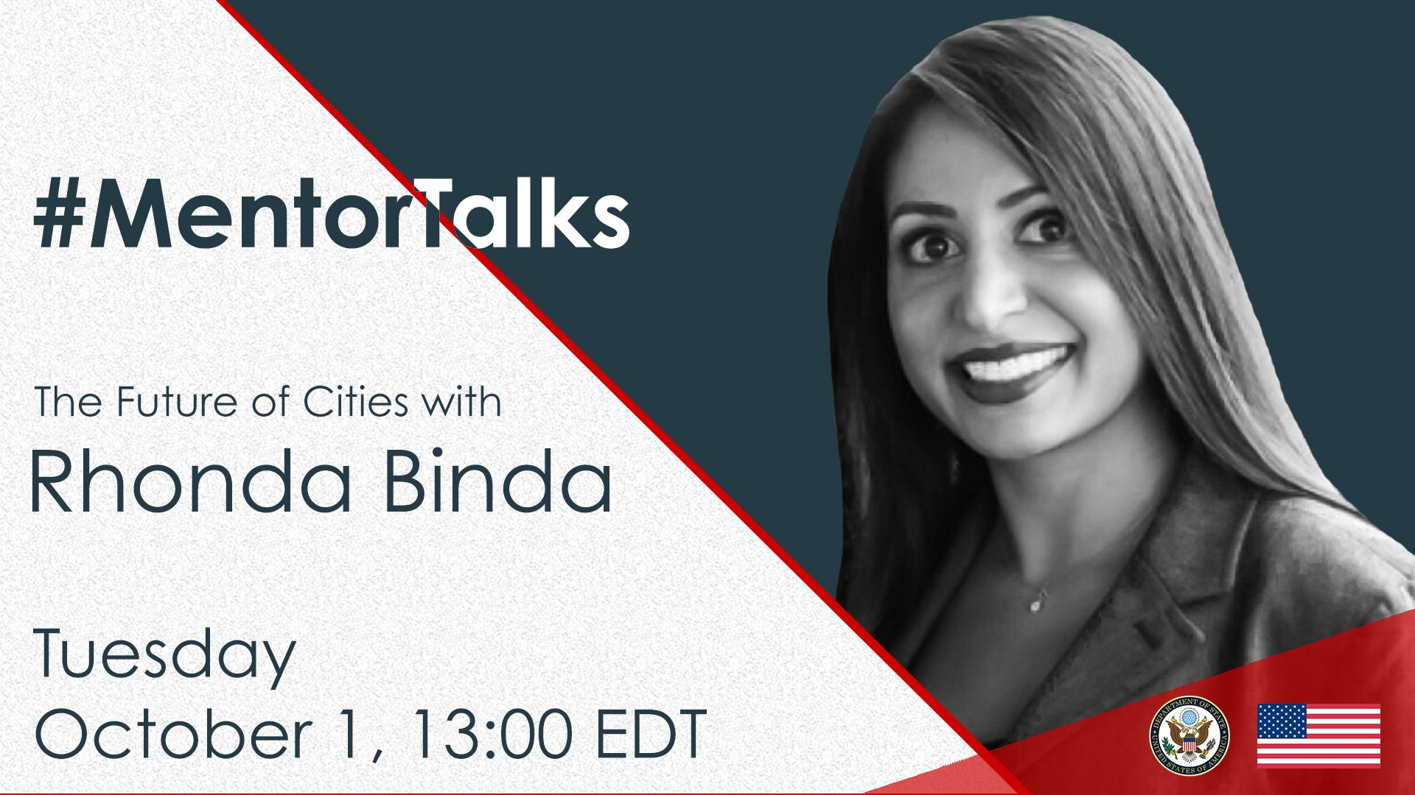

Description:
Got 20 min? You’ve got a mentor! Join us for our latest #MentorTalks, a Facebook Live series that puts you in touch with experts doing extraordinary things in a wide variety of fields. These programs are for International Exchange Alumni and anyone interested in improving themselves and the communities around them.
On October 1 at 1:00 pm EDT, Rhonda Binda of Venture Smarter will talk about smart cities and public-private partnerships. What is a smart city? How do smart cities benefit private citizens, businesses, and governments? How can anyone start an initiative to take their city from regular to “smart”? Find out the answers to these questions and more!
Viewers are encouraged to ask Rhonda their questions on Facebook, or post them in advance on Twitter and other social media platforms. We will get to as many as possible! Use #MentorTalks when asking your question.

Event Details - Snapshot:
Title: #MentorTalks: The Future of Cities with Rhonda Binda
Format: 20 minute Facebook Live with live Q&A - audience questions welcomed!
Language: English
Date and Time: October 1 at 1:00 p.m.EDT
URL: facebook.com/InternationalExchangeAlumni
Speaker: Rhonda Binda, Co-Founder and COO, Venture Smarter
Topic: Smart Cities
Audience: Open to all. Youth interested in community design and improvement/tech innovation; especially Alumni of U.S. government-sponsored exchange programs.
Promo page: https://interactive.america.gov/iip_event/mentortalks-the-future-of-cities-with-rhonda-binda-facebook-live/

Hashtags:
#MentorTalks (program hashtag)
#ExchangeAlumni
#SmartCities

Graphics:
Download here (pics found at bottom of page): https://interactive.america.gov/iip_event/mentortalks-the-future-of-cities-with-rhonda-binda-facebook-live/

Social Media Posts:
[Facebook/Instagram]
[schedule for any time]
You know about smartphones📱… How about smart cities🏙️? Join our 20-minute #MentorTalks with Rhonda Binda on Tuesday, October 1 at 1pmEDT [edit for local time] to find out what smart cities are, and how you can improve your community by taking it from average to smart🧠!
Rhonda is Co-Founder and COO of @VentureSmarter, an organization that helps communities around the world develop smart cities. Got 20 minutes⏰? You’ve got a mentor! facebook.com/InternationalExchangeAlumni Follow our page to receive updates and to watch the live program! #ExchangeAlumni #smartcities
[use Facebook/Twitter or Instagram graphic]

[schedule for any time]
Curious about what the cities🏙️ of the future🤖 will look like, and how you can help your community prepare? Join Rhonda Binda for #MentorTalks on @InternationalExchangeAlumni on Tuesday, October 1 at 1pmEDT [edit for local time]! Send in your questions for Rhonda now by using #MentorTalks and be sure to watch the live program on facebook.com/InternationalExchangeAlumni. #smartcities #ExchangeAlumni [use Facebook/Twitter or Instagram graphic]

[schedule for September 30]
TOMORROW at 1pmEDT [edit for local time]: Participate in the next #MentorTalks for 20 minutes⏰ of inspiration and mentoring for those interested in improving their communities and learning about the cities🌆 of the future🤖! Follow us on facebook.com/InternationalExchangeAlumni to receive updates and watch the live program! Send in your questions for Rhonda now by using #MentorTalks #ExchangeAlumni #smartcities [use Facebook/Twitter or Instagram graphic]

[schedule for October 1]
LIVE TODAY at 1pmEDT [edit for local time]: Watch #MentorTalks with Rhonda Binda from @VentureSmarter! Get 20 minutes⏰ of mentoring, inspiration and information on how to improve your community and what cities🌆 of the future🤖will look like! Come ready to ask questions. Follow facebook.com/InternationalExchangeAlumni to watch the live program. Follow @InternationalExchangeAlumni on Facebook to receive updates and send us your questions for Rhonda now by using #MentorTalks. #ExchangeAlumni #smartcities [use Facebook/Twitter or Instagram graphic]

______________________________
[Twitter/Instagram]

[schedule for any time]
Got 20 minutes⏰? Do you want to know what we cities🏙️ of the future🤖 will look like and how you can turn your city into a “smart city”🧠? Join Rhonda Binda from @VentureSmarter for #MentorTalks on August 8 at 1pmEDT [edit for local time] and have your questions ready for this 15-minute discussion! http://bit.ly/2YnXWnM #ExchangeAlumni #womenintech
[use Facebook/Twitter or Instagram graphic]

[schedule for any time]
Got 20 minutes⏰? Rhonda Binda of @VentureSmarter will explain what a “smart city” is and how you can transform your community from regular😕 to smart🧠! Watch #MentorTalks on October 1 at 1pmEDT [edit for local time] and be ready to ask questions: http://bit.ly/2YnXWnM #ExchangeAlumni #smartcities
[use Facebook/Twitter or Instagram graphic]

[schedule for September 30]
TOMORROW @1pmEDT [edit for local time]: Join Rhonda Binda of @VentureSmarter for a #MentorTalks on #smartcities - the cities🏙️ of the future🤖! Got 20 minutes? You’ve got a mentor! Watch live tomorrow here: http://bit.ly/2YnXWnM #ExchangeAlumni
[use Facebook/Twitter or Instagram graphic]

[schedule for October 1]
LIVE TODAY @1pmEDT [edit for local time]: Watch #MentorTalks with Rhonda Binda of @VentureSmarter! Learn about #smartcities - the cities🏙️ of the future🤖! Watch live & ask questions here: http://bit.ly/2YnXWnM
[use Facebook/Twitter or Instagram graphic]

[schedule for October 1 - 5 min before program start time]
Join @AlumniExchange NOW for #MentorTalks with Rhonda Binda of @VentureSmarter. Go to Facebook http://bit.ly/2YnXWnM NOW to learn about #smartcities - the cities🏙️ of the future🤖.
[use Facebook/Twitter or Instagram graphic]
________________________________________________________________

About Rhonda Binda:
Rhonda is Co-Founder & COO for Venture Smarter and Executive Director of the Smart Regions Initiative, bringing smart city solutions to communities in the U.S. and around the world. She is recognized internationally as a leader in developing smart cities.
Rhonda recently returned to her hometown of Jamaica, Queens, New York City, where she led a community revitalization effort that brought many awards from the government and private sector. She was named Business Leader of the Year and currently teaches as an Adjunct Professor in the School of Business at The City University of New York – Medgar Evers College.
Rhonda previously served at the U.S. Department of State and in the White House. During that time, she was nominated as a rising political leader by the American Council of Young Political Leaders, a State Department supported program that chooses rising political leaders from around the world to experience what political life is like in countries other than their own.
Rhonda graduated from Duke University and Georgetown Law, and is an Oxford University Lord Rothermere Scholar. She currently teaches as an Adjunct Professor in the School of Business at The City University of New York – Medgar Evers College.

