Social Media for “The Future of Digital Tech in Africa” webchat

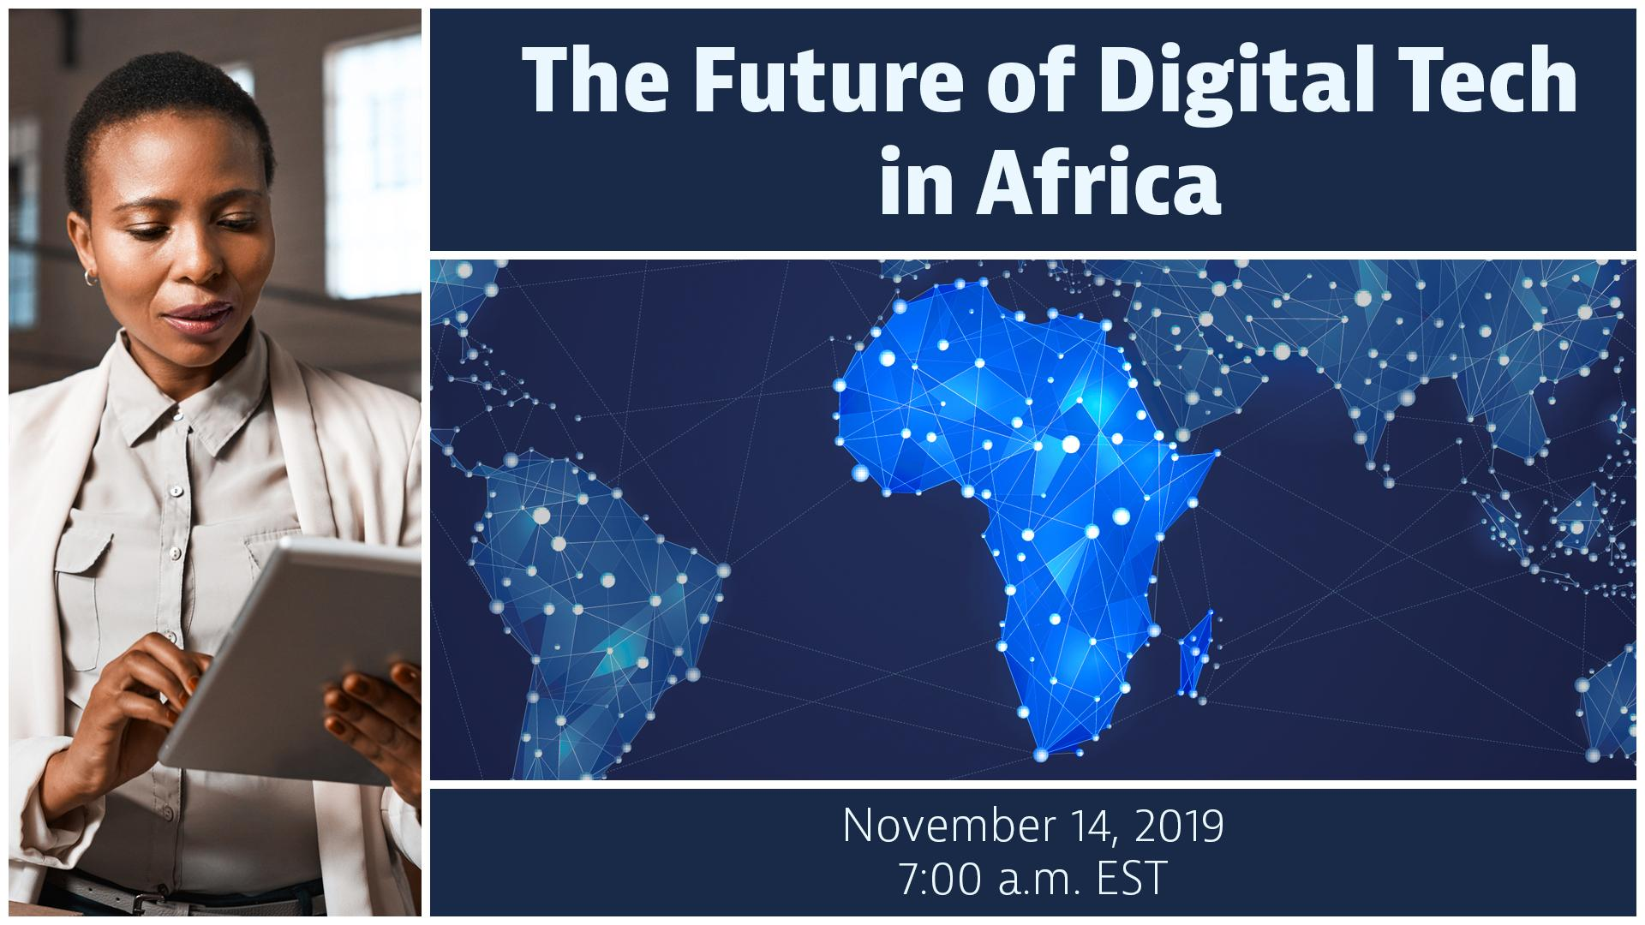
- Title: The Future of Digital Tech in Africa
- Theme: Emerging tech and cybersecurity insights for the growing digital economy in Africa
- Date/time: Thursday, November 14 at 7:00am EST (Washington, DC time)
- Event page and promo materials: https://interactive.america.gov/the-future-of-digital-tech-in-africa
- Shortened link - event and promo page: http://bit.ly/AfricaNewTech
- Language: English
- If interested in hosting a viewing group: Contact Simon van Steyn
Description:
On November 14, join us for an interactive webchat focused on how technologies in Africa such as mobile apps, online services, and existing networks (2G, 3G), as well as emerging infrastructure like 4G connectivity, are pathways for entrepreneurs and civil society to become more engaged in the growing digital economy across the continent.

The discussion will also address cybersecurity awareness to ensure entrepreneurs and others are protecting their data and IP. The U.S. and Africa-based panelists will share their insights and advice, as well as answer questions from viewers.

The live webchat will take place on Thursday, Nov. 14 at 7:00 a.m. EST (Washington, DC time). To participate, visit the event page, where you can also find additional promotional materials: http://bit.ly/AfricaNewTech. We hope you can join the conversation and share your perspectives.

Panelists (TBA):

Sample Facebook Postings

[Post anytime]
- The technology landscape is changing rapidly in Africa and with that comes new opportunities in the fast-evolving digital economy. There are substantial economic benefits tied to the growth of tech services and infrastructure across the continent, including opportunities for jobs, investment, and innovation. As these technologies are adopted, alongside the benefits, there are also risks to users through cyber threats, IP theft, service disruption that users need to prepare for.

Join an interactive webchat to hear experts share their insights on emerging technologies in Africa, how entrepreneurs, businesses, and organizations can benefit from them, and cybersecurity best practices. The panelists will answer viewer questions and share recommended resources. On November 14 at 7:00am EST (Washington, DC time) visit this event page to participate in the discussion: http://bit.ly/AfricaNewTech. #NextGenAfrica

- Interested in learning how current and emerging technologies are changing the landscape of Africa’s digital economy? Take part in an interactive webchat to hear how entrepreneurs, civic leaders, and Africa’s youth can benefit from these new opportunities. A panel of experts will provide tips and advice on NextGen tech, and explain why cybersecurity is a critical part of any tech strategy.

The live streamed discussion will take place on November 14 at 7:00am EST (Washington, DC time). To ask your questions and share your thoughts, visit the event page: http://bit.ly/AfricaNewTech.

- Sub-Saharan Africa is the fastest growing region in the world for mobile subscriptions; by 2025, there will be an estimated 625 mobile accounts across Africa. The continent is becoming more interconnected with new technologies and services, which presents a range of possibilities to businesses, communities, and governments. Learn more about this during an interactive webchat featuring U.S. and African tech experts and entrepreneurs. Ask your questions live: http://bit.ly/AfricaNewTech #NextGenAfrica

[Post Nov. 14, before the event]
- Going live soon! Panelists are ready to answer your questions about emerging technologies in Africa’s growing digital economy. Also learn about the importance of cybersecurity as this new tech becomes a part of business, communications, and everyday life. Join the discussion: http://bit.ly/AfricaNewTech

Sample Tweets

[Post anytime]
- New technologies are presenting new opportunities for entrepreneurs in Africa’s growing digital economy. Join a webchat to hear from experts about how businesses, organizations, and communities can benefit. Nov. 14 at 7am DC time, visit: http://bit.ly/AfricaNewTech #NextGenAfrica

- With the increased role of technology in the African digital economy, there are enormous benefits, but also substantial risks through cyber threats. Learn more about how entrepreneurs can employ cybersecurity best practices. Join the webchat http://bit.ly/AfricaNewTech #NextGenAfrica

- Africa’s digital economy is growing and a big part of it are the new technologies and improved networks that are enabling entrepreneurs and businesses to innovate. Ask your questions during a live webchat. Event page: http://bit.ly/AfricaNewTech #NextGenAfrica

[Post Nov. 14, at beginning of the event]
- LIVE NOW: Don’t miss the conversation on emerging technology in Africa. Experts from the U.S. and Africa will share tech & cybersecurity strategies for entrepreneurs taking part in Africa’s growing digital economy. Ask your questions live! http://bit.ly/AfricaNewTech #NextGenAfrica

Hashtags/Handles

#NextGenAfrica

- U.S. Department of State: @StateDept
- YALI Network: @YALINetwork
- Assistant Secretary for the Bureau of African Affair, Tibor Nagy: @AsstSecStateAF
- Bureau of Economic and Business Affairs: @EconAtState
- Office of the Coordinator for Cyber Issues: @State_Cyber

Speaker Bios:
Coming soon

