Social Media for “The Future of Digital Tech in Africa” webchat

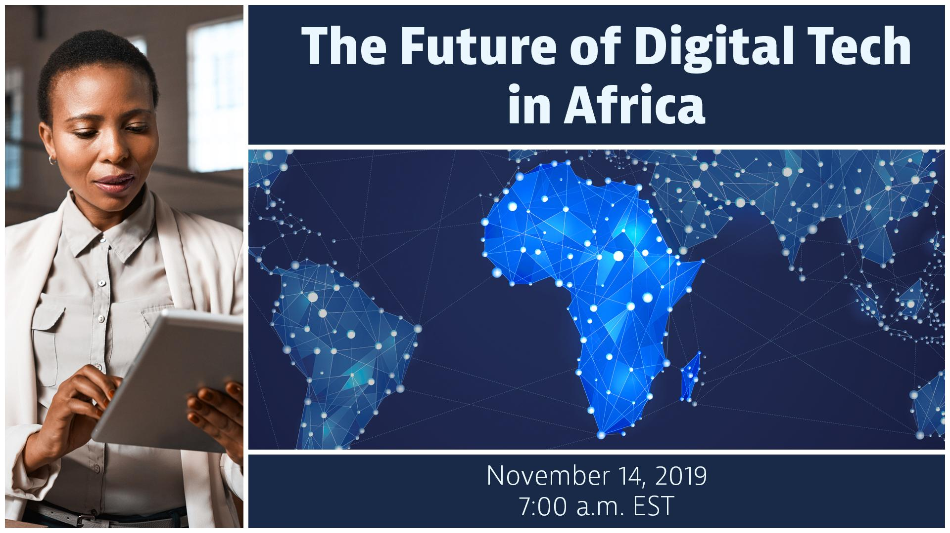
- Title: The Future of Digital Tech in Africa
- Theme: Emerging tech and cybersecurity insights for the growing digital economy in Africa
- Date/time: Thursday, November 14 at 7:00 - 8:15am EST (Washington, DC time)
- Event page & promo materials: https://interactive.america.gov/the-future-of-digital-tech-in-africa
- Shortened link - event and promo page: http://bit.ly/AfricaNewTech
- Language: English
- If interested in hosting a viewing group: Contact Simon van Steyn
Description:
On November 14, join us for an interactive webchat focused on how technologies in Africa such as mobile apps, online services, and existing networks (2G, 3G), as well as emerging infrastructure like 4G connectivity, are pathways for entrepreneurs and civil society to become more engaged in the growing digital economy across the continent.

The discussion will also address cybersecurity awareness to ensure entrepreneurs and others are protecting their data and IP. The U.S. and Africa-based panelists will share their insights and advice, as well as answer questions from viewers.

The live webchat will take place on Thursday, Nov. 14 at 7:00 a.m. EST (Washington, DC time). To participate, visit the event page, where you can also find additional promotional materials: http://bit.ly/AfricaNewTech. We hope you can join the conversation and share your perspectives.

Panelists (full bios below)

Fola Olatunji-David
Head of Startup Success and Services, Launchpad Africa, Google

Elizabeth Vish
Policy Advisor in the Office Coordinator for Cyber Issues, U.S. Department of State (S/CCI)

Taurai Chinyamakobvu
Managing Director of Flocash, and Chief Operations Officer of LoopChat. 2014 YALI Fellow.

Moctar Yedaly
Head of Information Society Division, African Union Commission

Sadie Tucker (Moderator)
Foreign Service Officer, Bureau of Africa Affairs, U.S. Department of State

Sample Facebook Postings

[Post anytime]
- The technology landscape is changing rapidly in Africa and with that comes new opportunities in the fast-evolving digital economy. There are substantial economic benefits tied to the growth of tech services and infrastructure across the continent, including opportunities for jobs, investment, and innovation. As these technologies are adopted, alongside the benefits, there are also risks to users through cyber threats, IP theft, service disruption that users need to prepare for.

Join an interactive webchat to hear experts share their insights on emerging technologies in Africa, how entrepreneurs, businesses, and organizations can benefit from them, and cybersecurity best practices. The panelists will answer viewer questions and share recommended resources. On November 14 at 7:00am EST (Washington, DC time) visit this event page to participate in the discussion: http://bit.ly/AfricaNewTech. #NextGenAfrica

- Interested in learning how current and emerging technologies are changing the landscape of Africa’s digital economy? Take part in an interactive webchat to hear how entrepreneurs, civic leaders, and Africa’s youth can benefit from these new opportunities. A panel of experts will provide tips and advice on NextGen tech, and explain why cybersecurity is a critical part of any tech strategy.

The live streamed discussion will take place on November 14 at 7:00am EST (Washington, DC time). To ask your questions and share your thoughts, visit the event page: http://bit.ly/AfricaNewTech.

- Sub-Saharan Africa is the fastest growing region in the world for mobile subscriptions; by 2025, there will be an estimated 625 mobile accounts across Africa. The continent is becoming more interconnected with new technologies and services, which presents a range of possibilities to businesses, communities, and governments. Learn more about this during an interactive webchat featuring U.S. and African tech experts and entrepreneurs. Ask your questions live: http://bit.ly/AfricaNewTech #NextGenAfrica

[Post Nov. 14, before the event]
- Going live soon! Panelists are ready to answer your questions about emerging technologies in Africa’s growing digital economy. Also learn about the importance of cybersecurity as this new tech becomes a part of business, communications, and everyday life. Join the discussion: http://bit.ly/AfricaNewTech

Sample Tweets

[Post anytime]
- New technologies are presenting new opportunities for entrepreneurs in Africa’s growing digital economy. Join a webchat to hear from experts about how businesses, organizations, and communities can benefit. Nov. 14 at 7am DC time, visit: http://bit.ly/AfricaNewTech #NextGenAfrica

- With the increased role of technology in the African digital economy, there are enormous benefits, but also substantial risks through cyber threats. Learn more about how entrepreneurs can employ cybersecurity best practices. Join the webchat http://bit.ly/AfricaNewTech #NextGenAfrica

- Africa’s digital economy is growing and a big part of it are the new technologies and improved networks that are enabling entrepreneurs and businesses to innovate. Ask your questions during a live webchat. Event page: http://bit.ly/AfricaNewTech #NextGenAfrica

[Post Nov. 14, at beginning of the event]
- LIVE NOW: Don’t miss the conversation on emerging technology in Africa. Experts from the U.S. and Africa will share tech & cybersecurity strategies for entrepreneurs taking part in Africa’s growing digital economy. Ask your questions live! http://bit.ly/AfricaNewTech #NextGenAfrica

Hashtags/Handles

#NextGenAfrica

- U.S. Department of State: @StateDept
- YALI Network: @YALINetwork
- Assistant Secretary for the Bureau of African Affair, Tibor Nagy: @AsstSecStateAF
- Bureau of Economic and Business Affairs: @EconAtState
- Office of the Coordinator for Cyber Issues: @State_Cyber

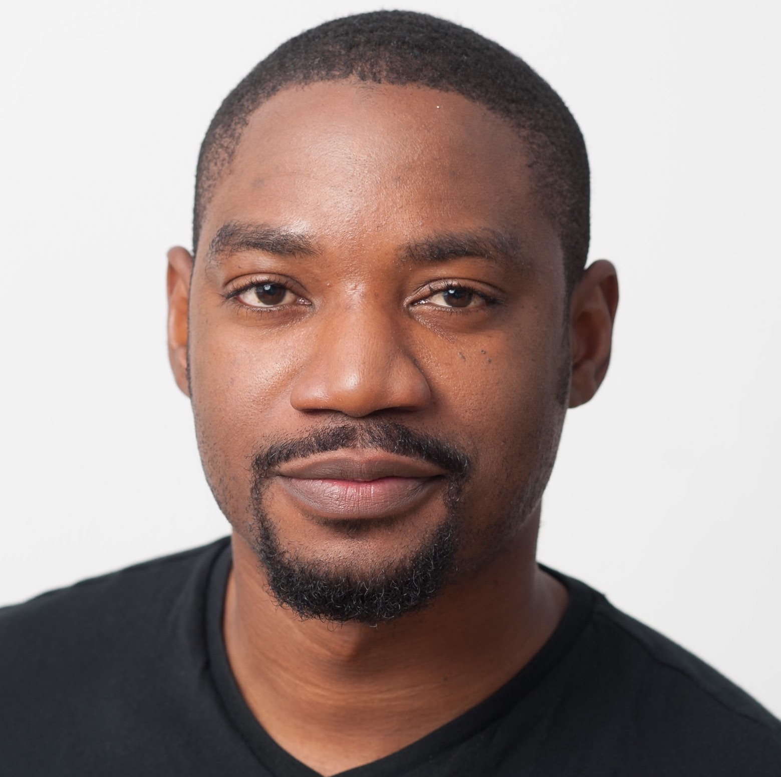
Speaker Bios:
Fola Olatunji-David
Head of Startup Success and Services, Launchpad Africa, Google
Fola Olatunji-David is the co-lead for Google’s Launchpad Accelerator Africa, supporting early and seed stage startups on the continent with technology, networks and mentorship. Fola has worked in technology based roles, creating channels for tech to interface with businesses in 10+ countries in different sectors including finance, retail and investment banking, education, media, power, agriculture, and he now focuses on building an African ecosystem that supports innovators and entrepreneurs.

Prior to Google, he led Ventures Platform startup accelerator, and also worked as Vice President of Business Development at Venture Garden Group, Nigeria where he led the group’s Finatech Division. He has also had prior experience working at CardinalStone Partners (Nigeria), Ninety East Financials (Mauritius), SET IT (Nigeria, UK), Stanbic IBTC Bank (Nigeria), and UCL Advances (UK).

Elizabeth Vish
Policy Advisor in the Office Coordinator for Cyber Issues, U.S. Department of State (S/CCI)
Elizabeth Vish is responsible for cyber policy engagement in sub-Saharan Africa and for policy on capacity building engagements globally. S/CCI brings together the many elements of the State Department working on cyber issues, to more effectively advance the full range of U.S. interests in cyberspace, and provides technical expertise on U.N. negotiations regarding peace and security in cyberspace.

Ms. Vish joined the U.S. government in 2013 as a Presidential Management Fellow, and previously worked in the non-profit sector on policy and programming focusing on democracy and governance issues.

Taurai Chinyamakobvu
Managing Director - Flocash, Chief Operations Officer - LoopChat, and YALI Mandela Washington Fellow
Taurai Chinyamakobvu was an inaugural 2014 Mandela Washington Fellow at Yale School of Management. He is a partner and investor in Flocash, a pan-African payment gateway integrated with Africa's mobile operators to enable online payments for the continent's largest airlines and e-commerce businesses. He has invested in tech ventures, including in blockchain. He also served as an adviser on Africa to Marubeni Corporation, a Fortune Global 500 corporation. Taurai is interested in contemporary tech-driven business models as well as technology transfer and innovation in Africa. He previously worked in banking and telecommunications. Educated in the USA, Sweden, Japan and Zimbabwe, Taurai is a graduate of Harvard University. He was a Mason Fellow at the J. F Kennedy School of Government exploring the intersection of government, technology and business. He recently worked on two fintech ventures in the Harvard Innovation Labs VIP program. His interests include economic development in transition economies, the fourth industrial revolution and tech-driven creative destruction.

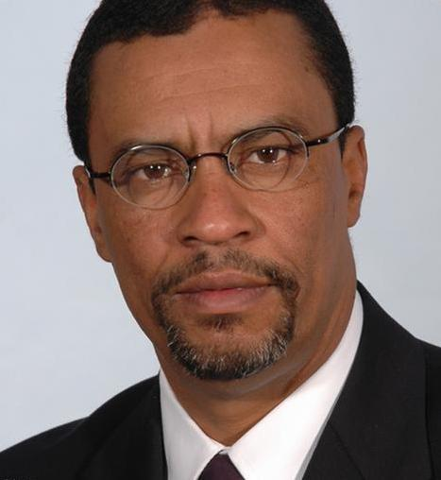
Moctar Yedaly
Head of Information Society Division, African Union Commission
Moctar Yedaly is a telecom, satellite and computer engineer with an MBA in International Business. Moctar has more than 20 years of international experience in the field of communication and networks management, resources evaluation and policy preparation. He is a former staff member of Intelsat in the USA and RASCOM in Cote d’Ivoire.

Since 2008, Moctar has been in charge of the Information Society Division within the Department of Infrastructure and Energy of the African Union Commission – an Intergovernmental organization with headquarters in Addis Ababa, Ethiopia. He graduated from George Washington University, Amity University and Institute of Informatics.

Sadie Tucker (Moderator)
Foreign Service Officer, Bureau of Africa Affairs, U.S. Department of State
Sadie M. Tucker is a career Foreign Service Officer currently serving as a macroeconomist in the Africa Bureau’s Office of Economic and Regional Affairs at the Department of State. She is the Africa Bureau’s lead advisor on economic engagement in Ethiopia, G7, next-generation technologies (including 5G), development finance, debt and credit risks as well as monetary and fiscal policy. Previously, she was chief of staff in the Bureau of Global Public Affairs.

Ms. Tucker is an economics officer with field experience at overseas missions in Anglophone, Francophone, and Lusophone Africa. Her overseas postings include tours in Burkina Faso in 2005, Ghana in 2007, Nigeria in 2009, and Angola in 2016. While in Washington, she advanced entrepreneurial ecosystem development in emerging African markets and engaged African leaders at the United Nations and African Union Commission to establish favorable digital economy and cyber security policies and regulation across the region. She is the mother of three brilliant boys.

