Social Media Toolkit:
“16 Days of Activism: Preventing Gender-Based Violence”
Date & Time: Tuesday, December 10, 2019, 9:30 EST
Event page: https://interactive.america.gov/16-Days/
Shortened link: http://bit.ly/16DaysatState Language: English
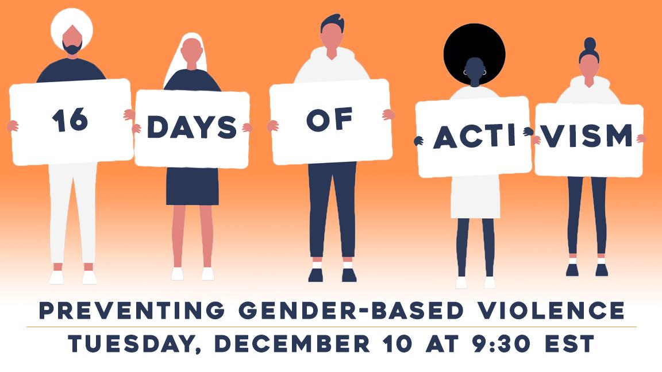
Program Description: November 25th has been designated by the United Nations as the International Day for the Elimination of Violence Against Women. The accompanying 16 Days of Activism Against Gender-Based Violence (November 25- December 10) focus on raising awareness of gender-based violence (GBV) prevention and response efforts. On Tuesday, December 10th, the U.S. Department of State will hold a virtual program on “16 Days of Activism: Preventing Gender-Based Violence.” The hour-long program will discuss how both civil society and government representatives can work to prevent and respond to gender-based violence while also showcasing the work of women and men working to end GBV in many different regions of the world.
Learn More About:
- The impact of gender-based violence on victims and their families.
- Why GBV is a pervasive barrier to women and girl’s empowerment and growth.
- Various ways civil society and government representatives can work to prevent and respond to gender-based violence in their families, communities and countries.
Hashtags & Handles
#GenderEquality  #16days  #orangetheworld  #EndGBV | @GenderAtState  @StateDRL

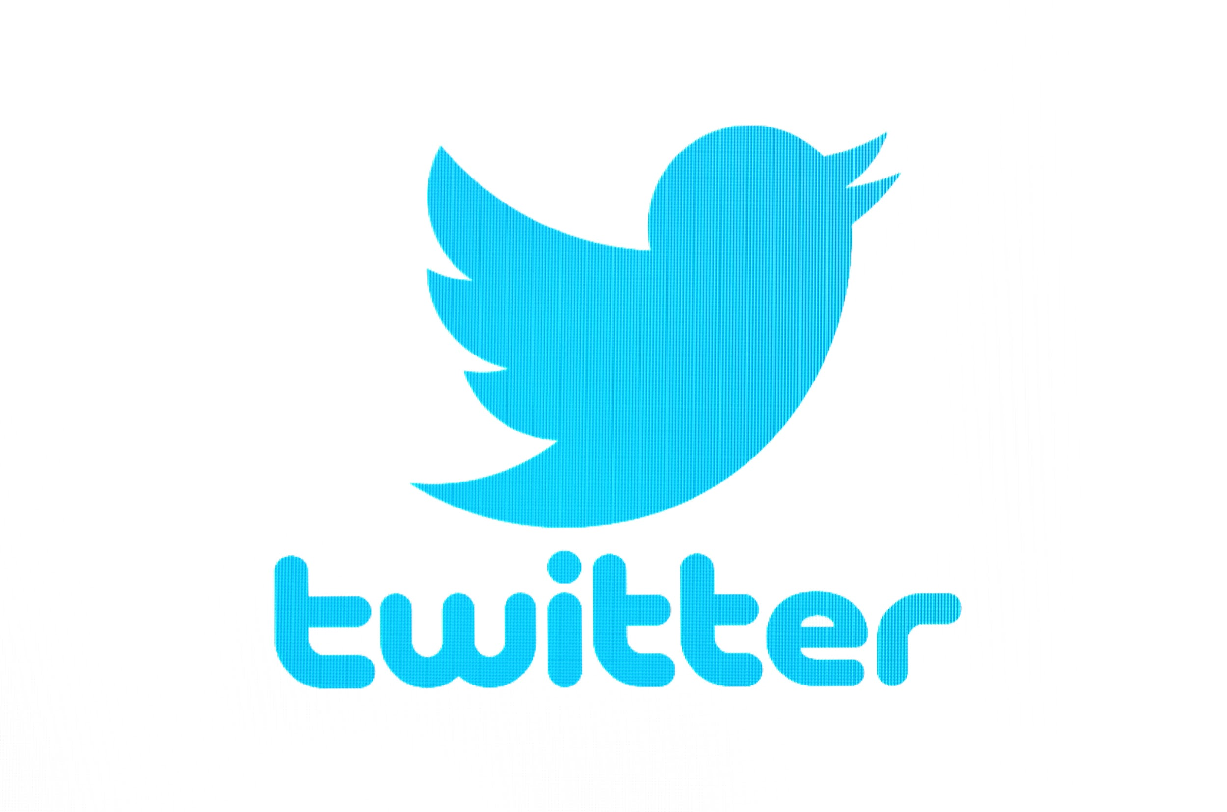
Tweets For Twitter: [Post with program graphic]
- From Nov 25 until Dec 10 activists around the world celebrate the #16Days of Activism. Show your support by joining a live discussion on efforts to #EndGBV. Tune in Dec 10th at 9:30 am at http://bit.ly/16DaysatState
- Violence against women is a violation of human rights. Find out how you can help #EndGBV during a live webchat on “16 Days of Activism: Preventing Gender Based Violence.” Tune in at Dec 10 at 9:30 EST at http://bit.ly/16DaysatState
- #16Days addresses how violence against women is an urgent public health, human rights and social justice issue. Be a champion of women’s human rights and join our LIVE discussion on Dec 10th at 9:30 EST at http://bit.ly/16DaysatState
- Morning of program: December 10, 2019 TODAY! Find out how you can help prevent violence against women in homes, communities and around the world. Join our discussion on “16 Days of Activism: Preventing Gender Based Violence” at 9:30 am EST at http://bit.ly/16DaysatState

Facebook Posts: [Post with program graphic]
- Join us LIVE, for a global program in honor of #16Days of Activism to #EndGBV. According to @UN, about 35% of women worldwide have experienced some form of violence. Find out how activists around the world are raising their voices to #EndGBV on 12/10/19 at 9:30 am EST at http://bit.ly/16DaysatState
- The #16Days of Activism is a global campaign against gender based violence. Find out how you can be a champion for women’s and girl’s human rights by joining a LIVE, global webchat on “16 Days of Activism: Preventing Gender Based Violence.” Learn how civil society can better prevent and respond to GBV in your community. Join the discussion here at 12/10/19 at 9:30 am EST at http://bit.ly/16DaysatState

- Morning of program: December 10, 2019 Today join our LIVE discussion on “16 Days of Activism: Preventing Gender-Based Violence.” Tune in at 9:30 am EDT to learn how violence against women and girls can have long term consequences on their health and wellbeing. Be a part of the discussion by asking your question LIVE during the program at http://bit.ly/16DaysatState

