Social Media Toolkit
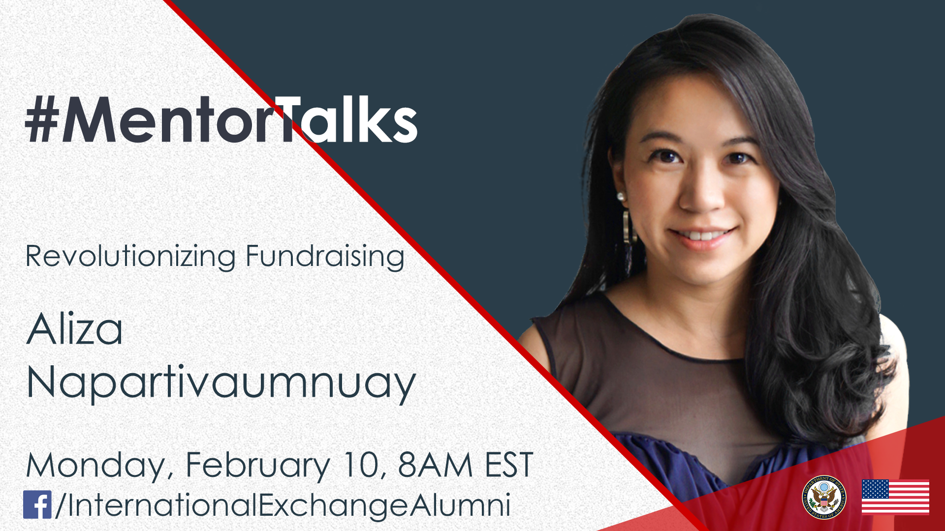
#MentorTalks: Revolutionizing Fundraising with
Aliza Napartivaumnuay (Facebook Live)

Description:
Got 15-20 minutes? You’ve got a mentor! Join us for our next #MentorTalks, a Facebook Live series that puts exchange program alumni in touch with extraordinary mentors on a wide variety of topics.
On Monday, February 10 at 8:00 AM EST, Aliza Napartivaumnuay, co-founder of the award-winning social enterprise, Socialgiver, and alumna of the International Visitor Leadership Program (IVLP) and YSEALI, joins us on our next MentorTalks. Aliza will talk about how she is revolutionizing fundraising in Thailand and offer tips on creating technology for change and sustainability.
Come ready to ask questions and be inspired! Use #MentorTalks when asking your question, and we’ll see you online.

Event Details - Snapshot:
Title: #MentorTalks: Revolutionizing Fundraising with Aliza Napartivaumnuay
Format: 20-minute Facebook Live with live Q&A
Date and Time: Monday, February 10 at 8:00 AM EST
URL: facebook.com/InternationalExchangeAlumni
Speaker:
Aliza Napartivaumnuay, co-founder, Socialgiver
Aliza is the co-founder of the award-winning social enterprise, Socialgiver, an innovative solution that helps consumers, businesses, and social projects to work together to create positive social impact. She is revolutionizing fundraising by tapping into consumer spending power with the vision of turning the world’s spare capacity into social progress. Aliza’s interest in creating social impact projects stems from her previous roles in the corporate sector managing new project developments for top retailers from a supply chain and distribution perspective for more than nine years. Combining with her passion to create a positive change to the community and the environment, she works with the philosophy that in order to create sustainable change, it must be done through public participation. Socialgiver has won awards such as Thailand’s Social Enterprise Award, The Venture Thailand, and the Global Social Venture Competition for Southeast Asia, among others.
Topic: Fundraising & social impact
Audience: YSEALI alumni in Bangkok and neighboring countries, plus entrepreneurs in the East Asia region.

Hashtags:
#MentorTalks (program hashtag)
#ExchangeAlumni

Graphics:
Download here (bottom of page): http://interactive.america.gov/iip_event/mentortalks-feb2020-fundraising/

Sample Social Media Posts:
[Facebook/Instagram]
[schedule for any time]
Are you interested in improving your fundraising, but not sure how to start? Join our 20-minute #MentorTalks with #YSEALI #IVLP exchange alumna and @socialgiver co-founder Aliza Napartivaumnuay on Monday, February 10 at 8:00 AM EST [edit for local time] to find out! Aliza is revolutionizing fundraising by tapping into consumer spending power to drive social progress. facebook.com/InternationalExchangeAlumni Follow our page to receive updates! #ExchangeAlumni
[use Facebook or Instagram graphic]

[schedule for any time]
Want advice from a key influencer on fundraising for social impact? Join #YSEALI #IVLP exchange alumna and @socialgiver co-founder Aliza Napartivaumnuay for @InternationalExchangeAlumni’s #MentorTalks on Monday, February 10 at 8:00 AM EST [edit for local time]! Send in your questions for Aliza now by using #MentorTalks. #ExchangeAlumni
[use Facebook or Instagram graphic]

[schedule for any time]
Next up on #MentorTalks... #YSEALI #IVLP exchange alumna and @socialgiver co-founder Aliza Napartivaumnuay joins us to talk about fundraising and social impact, and we have a surprise video for you too! It all happens on Monday, February 10 at 8:00 AM EST [edit for local time]. Send your questions to Aliza now at @InternationalExchangeAlumni, using #MentorTalks.
[use Facebook or Instagram graphic]

[schedule for February 9]
TOMORROW at 8 am EDT [edit for local time]: Join fellow alumna of [Insert exchange program/ U.S. Embassy handle] for #MentorTalks with Aliza Napartivaumnuay. Get 20 minutes of mentoring, inspiration, and advice for social impact entrepreneurs! Come ready to ask questions about everything from networking to overcoming challenges in building a fundraising base! facebook.com/InternationalExchangeAlumni #ExchangeAlumni Follow us on Facebook to receive updates! Send us your questions for Aliza in the comments below. [use Facebook or Instagram graphic]

[schedule for February 10]
LIVE TODAY at 8am EDT [edit for local time]: Watch #MentorTalks with Aliza Napartivaumnuay! Get 20 minutes of mentoring, inspiration and advice for women entrepreneurs. Come ready to ask questions about everything from networking to overcoming challenges women face building their businesses! facebook.com/InternationalExchangeAlumni #ExchangeAlumni Follow @InternationalExchangeAlumni on Facebook to receive updates! Send us your questions for Aliza now in the comments below. [use Facebook or Instagram graphic]

______________________________
[Twitter]

[schedule for any time]
Are you seeking to improve your fundraising success? Join Aliza Napartivaumnuay for #MentorTalks on Monday, February 10 at 8:00 AM EST [edit for local time] and have your questions ready for this 20-minute discussion! http://bit.ly/mentortalks #ExchangeAlumni
[use Twitter graphic]

[schedule for any time]
Need some fundraising advice? Got 20 minutes? Join Aliza Napartivaumnuay for #MentorTalks on Monday, February 10 at 8:00 AM EST [edit for local time]!
http://bit.ly/mentortalks #ExchangeAlumni
[use Twitter graphic]

[schedule for February 9]
TOMORROW at 8am EDT [edit for local time]: Join Aliza Napartivaumnuay for mentoring, inspiration, and advice! Got 20 minutes? You’ve got a mentor! http://bit.ly/mentortalks #MentorTalks #ExchangeAlumni
[use Twitter graphic]

[schedule for February 10]
LIVE TODAY at 8am EDT [edit for local time]: Watch #MentorTalks with Aliza Napartivaumnuay! Got 20 minutes? You’ve got a mentor! Get mentoring, inspiration and advice! Come ready to ask questions. http://bit.ly/mentortalks #ExchangeAlumni
[use Twitter graphic]

[schedule for February 10]
Got 20 minutes? You’ve got a mentor! Tune in to #MentorTalks with Aliza Napartivaumnuay at 8am EDT [edit for local time]. Head over to Facebook now to get ready for the conversation! http://bit.ly/mentortalks
[use Twitter graphic]

