Promotional materials for Foreign Press Center’s “Elections 2020” interactive program with pollster John Zogby

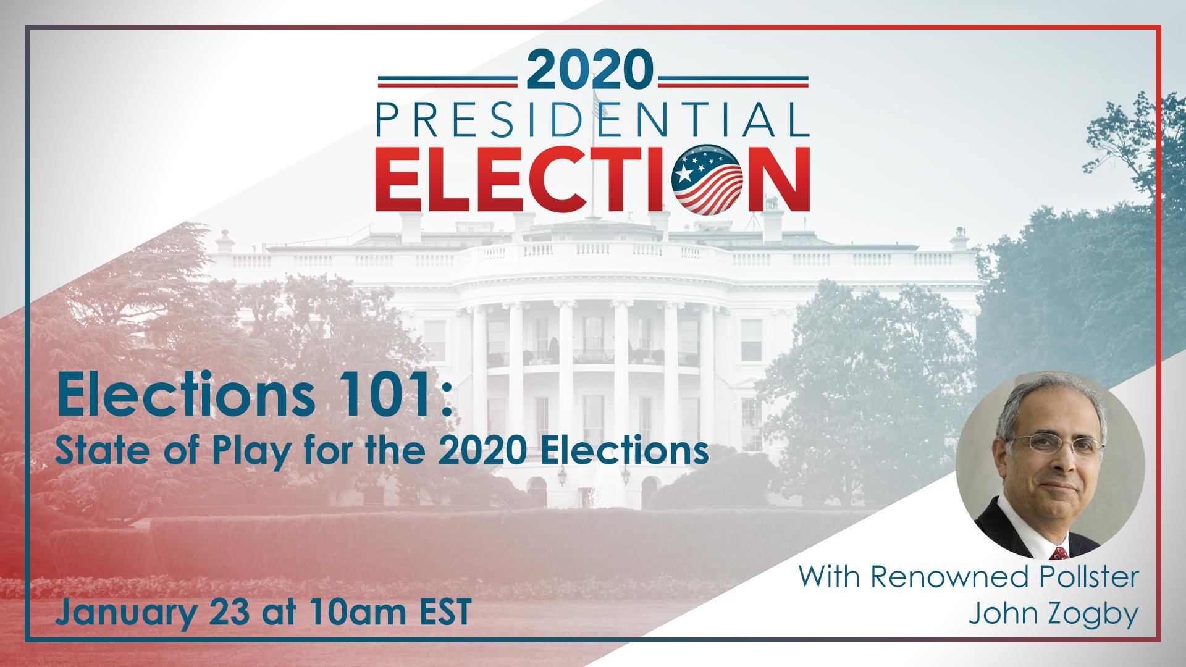
- Title: Elections 101: State of Play for the 2020 Elections
- Date/time: Thursday, January 23, 10:00 a.m. EST (Washington, DC time)
- Event page: interactive.america.gov/elections-2020-zogby
- Shortened link: http://bit.ly/2QzfrAW
- If interested in hosting a viewing group: Contact Simon van Steyn
Description:
Renowned public opinion pollster John Zogby will provide an analysis of the 2020 presidential election, including the Democratic Party debates and first round of primaries, and how they may affect the presidential race and makeup of the U.S. Congress.

Mr. Zogby will take questions from an audience of foreign journalists gathered at the Foreign Press Center in Washington, DC, as well as those submitting questions/comments online on the live streaming page: interactive.america.gov/elections-2020-zogby

Election season is underway, with six Democratic Party debates already completed. The Iowa caucuses (February 3) and New Hampshire primaries (February 11) are right around the corner. The fast-paced political environment makes it difficult to predict electoral outcomes, but this briefing will help set the stage for the current state of play for the 2020 elections.

Speaker:

John Zogby is a renowned public opinion pollster, author, and public speaker, and founder of John Zogby Strategies.

He has spent the past four decades as one of the most accurate pollsters in the world, conducting business in 80 countries, and leading the way in finding the meaning, story, direction, and usefulness of the data collected.

Social media accounts and Hashtags:

- John Zogby - Twitter: @TheJohnZogby
- Foreign Press Center (FPC) - Twitter: @ForeignPressCtr
- John Zogby - Facebook: www.facebook.com/John-Zogby-327444807331559
- FPC - Facebook: www.facebook.com/USDoS.FPC
- #2020Election #2020Elections

Sample Facebook Postings

[Post anytime]
- The Iowa caucuses, the first stage in selecting the Democratic nominee for president, is less than a month away. Join a live streamed discussion with renowned pollster John Zogby at the Foreign Press Center in Washington, DC as he provides an analysis of the 2020 presidential election, including the Democratic Party debates and first round of primaries, and how they may affect the presidential race and makeup of the U.S. Congress.

Zogby will answer your questions on the electoral process and the role polling is playing in this election. To participate, please go to the steaming page on Jan. 23 at 10:00 a.m. EST (Washington, DC time): http://bit.ly/2QzfrAW

- Pollster John Zogby has spent four decades taking the pulse of the electorate on a wide range of topics, including presidential elections. Hear his thoughts on the 2020 election, the Democratic primaries, and how polling will be a central feature of campaigns, reporting, and other key aspects of the electoral process.

Ask you questions live during an interactive briefing at the Foreign Press Center in Washington, DC. Join the discussion here: http://bit.ly/2QzfrAW.

Sample Tweets

[Post anytime]
- The 2020 presidential election season is underway and the Democratic primaries are fast approaching. Renowned pollster John Zogby will provide an analysis of the election, and the role polling will play. Hear his insights and ask him your questions here: http://bit.ly/2QzfrAW

- Interested in how polling will factor into the #2020election? And how it will impact campaigns and media coverage? Join a Jan. 23 online briefing at the @ForeignPressCtr with experienced pollster, John Zogby. Ask him your questions live: http://bit.ly/2QzfrAW. #2020election

[Post Jan. 23, at beginning of the event]
- LIVE NOW: Don’t miss the “Elections 101: State of Play for the 2020 Elections” briefing with renowned public opinion pollster John Zogby. Join the Foreign Press Center event online and ask your questions here: http://bit.ly/2QzfrAW. #2020election

