Social Media Toolkit
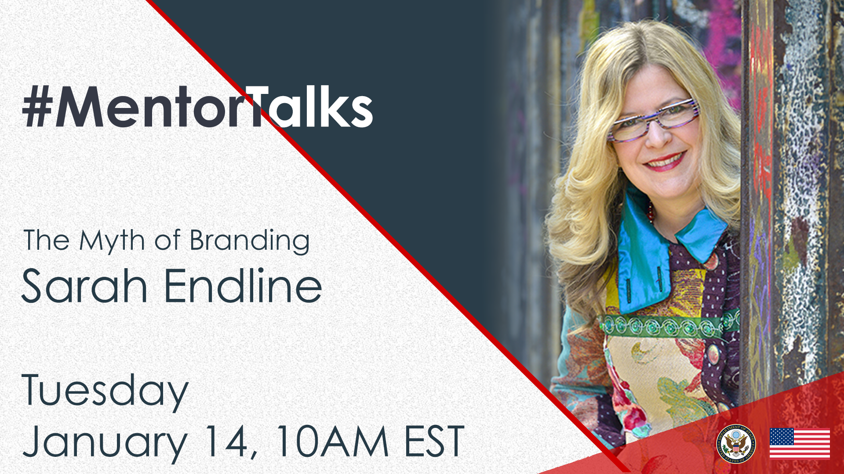
#MentorTalks: The Myth of Branding with
Sarah Endline (Facebook Live)

Description:
Got 15 minutes? You’ve got a mentor! Join us for our next #MentorTalks, a Facebook Live series that puts exchange program alumni in touch with extraordinary mentors on a variety of topics.
On Tuesday, January 14 at 10:00 am EST, we welcome Sarah Endline, Founder and CEO of Sweetriot, and alumna of the Congress-Bundestag Youth Exchange Program (CBYX). Sarah, who has had work and travel experiences in over 85 countries, will talk about “The Myth of Branding.” She will also share her expertise on what works and what you should be aware of when creating marketing plans for your business, as well as best to break into a crowded marketplace with your product.
Don’t miss this important program! Come ready to ask questions, using #MentorTalks, and we’ll see you online!

Event Details - Snapshot:
Title: #MentorTalks: The Myth of Branding with Sarah Endline
Format: 15-20 minute Facebook Live event with live Q&A
Date and Time: Tuesday, January 14 @ 10am EST
URL: facebook.com/InternationalExchangeAlumni
Speaker: Sarah Endline, Entrepreneur in Residence at the Harvard Innovation Lab and Harvard Business School
Sarah Endline is the Founder and former CEO & Chief Rioter of sweetriot in NYC, and a long time entrepreneur. She is a global thinker, creative digital expert, and industry disruptor in consumer products and retail with work and travel experience in more than 85 countries. Her entrepreneurial work has been covered by The Wall Street Journal, The New York Times, The Today Show, Forbes, Fortune, and more.
Sarah is also an alumna of both the Congress-Bundestag Youth Exchange Program (CBYX) 1991 and the Global Entrepreneurship Summit (GES) 2019.
Sarah recently sold sweetriot, a disruptive, socially conscious candy company that was a Whole Foods supermarket partner for over 10 years and sold millions of units throughout the USA.
Sarah currently serves on the regional council of the global Entrepreneur’s Organization (EO) and on the Board of Directors of AIESEC Life. She is also an Entrepreneur in Residence (EIR) at the Harvard Innovation Lab and Harvard Business School.
Sarah grew up in Michigan close to her grandparents’ farm and has an MBA from Harvard Business School and a Bachelor's degree from The University of Michigan.
Topic: Marketing and branding strategy
Audience: Alumni of U.S. government-sponsored exchange programs and entrepreneurs aspiring to build successful businesses.

Hashtags:
#MentorTalks (program hashtag)
#ExchangeAlumni

Graphics:
Download here (bottom of page): https://interactive.america.gov/iip_event/mentortalks-the-myth-of-branding-with-sarah-endline-facebook-live/

Sample Social Media Posts:

Facebook/Instagram
[schedule for any time]
On the next #MentorTalks, join sweetriot CEO and Founder Sarah Endline on Tuesday, January 14 at 10am EDT [edit for local time] to find out how she managed her path to sweet success! Sarah, who is currently an Entrepreneur in Residence (EIR) at the @harvardinnovationlabs and @HarvardBusinessSchool, teaches people all over the world strategy and methods to successfully market their businesses. And she is happy to share her advice with you! 🙂 facebook.com/InternationalExchangeAlumni Follow our page to receive updates! #ExchangeAlumni
[use Facebook or Instagram graphic]

[schedule for any time]
How did former @sweetriotnyc founder and CEO Sarah Endline made a big impact with tiny bits of chocolate? Learn the secrets behind her sweet success on the next #MentorTalks, on Tuesday, January 14 at 10am EDT [edit for local time]! #ExchangeAlumni
[use Facebook or Instagram graphic]

[schedule for any time]
Looking for sweet success with your business or entrepreneurial endeavor? Join @CBYXYoungProfessionals alumna and former @sweetriot CEO Sarah Endline for @InternationalExchangeAlumni’s #MentorTalks on Tuesday, January 14 at 10am EDT [edit for local time]! Send in your questions for Sarah now by using #MentorTalks. #ExchangeAlumni
[use Facebook or Instagram graphic]

[schedule for any time]
How did being an international exchange program alumna shape @sweetriot founder and former CEO Sarah Endline's career? Find out on MentorTalks this Tuesday, January 14 at 10am EDT [edit for local time]! Send in your questions for Sarah now by using #MentorTalks. @CBYXYoungProfessionals #ExchangeAlumni
[use Facebook or Instagram graphic]

[schedule for January 13]
TOMORROW at 10am EDT [edit for local time]: Join @CBYXYoungProfessionals alumna, social entrepreneur, and former @sweetriotnyc CEO Sarah Endline on #MentorTalks on January 14! Sarah will talk about sweet success and the myth of branding, live on facebook.com/InternationalExchangeAlumni #ExchangeAlumni Follow us on Facebook to receive updates! Send us your questions for Sarah in the comments below. [use Facebook or Instagram graphic]

[schedule for January 14]
LIVE TODAY at 10am EDT [edit for local time]: Watch #MentorTalks with industry disruptor and former @sweetriotnyc Founder & CEO Sarah Endline! Find out how she managed to sweet success in a crowded field, and why she thinks branding is a myth. Send us your questions for Sarah now in the comments below.facebook.com/InternationalExchangeAlumni #ExchangeAlumni [use Facebook or Instagram graphic]

______________________________
Twitter

[schedule for any time]
How do you stand out in a crowded field? Join @sarahendline from @HarvardHBS on #MentorTalks on January 14 at 10am EDT [edit for local time] to find out. Ask your questions using #MentorTalks! http://bit.ly/mentortalks #ExchangeAlumni
[use Twitter graphic]

[schedule for any time]
Our next guest on #MentorTalks has the recipe for sweet success. Join @sarahendline from @HarvardHBS on January 14 at 10am EDT [edit for local time] to hear her story and get her advice! http://bit.ly/mentortalks #ExchangeAlumni
[use Twitter graphic]

[schedule for any time]
How did being an international exchange program alumna shape @sweetriot founder and former CEO Sarah Endline's career? Find out on MentorTalks this Tuesday, January 14 at 10am EDT [edit for local time]! Send in your questions for Sarah now by using #MentorTalks. @CBYXAA @CBYX_YP

[schedule for any time]
@sarahendline from @HarvardHBS made a big impact with tiny bits of chocolate. Learn the secrets behind her sweet success on the next #MentorTalks! Tuesday, January 14 at 10am EDT [edit for local time]. http://bit.ly/mentortalks #ExchangeAlumni
[use Twitter graphic]

[schedule for January 13]
TOMORROW at 10am EDT [edit for local time]: Join @sarahendline from @HarvardHBS for mentoring, inspiration, and advice! Got 15 minutes? You’ve got a mentor! http://bit.ly/mentortalks #MentorTalks #ExchangeAlumni
[use Twitter graphic]

[schedule for January 14]
LIVE TODAY at 10am EDT [edit for local time]: Watch #MentorTalks with @sarahendline from @HarvardHBS! Got 15 minutes? You’ve got a mentor! Get mentoring, inspiration and advice! Come ready to ask questions. http://bit.ly/mentortalks #ExchangeAlumni
[use Twitter graphic]

Got 15 minutes? You’ve got a mentor! Tune in to #MentorTalks with @sarahendline from @HarvardHBS at 10am EDT [edit for local time]. Head over to Facebook now to get ready for the conversation! http://bit.ly/mentortalks
[use Twitter graphic]

