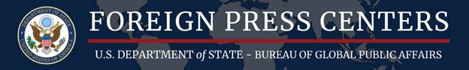

Washington Foreign Press Center
U.S. Department of State

WHAT: Washington Foreign Press Center On-The-Record Briefing

TOPIC: Elections 101– Campaign Finance in the 2020 Elections

SPEAKER: Commissioner Ellen L. Weintraub, Federal Election Commission

WHEN: Tuesday, March 10, 2020, 2:00pm

WHERE: 529 14th Street, NW, Suite 800, Washington, DC 20045

RSVP: Interested journalists should RSVP to DCFPC@state.gov. Please Note: This event is for FPC credentialed media only.
BACKGROUND: The Federal Election Commission (FEC) is the independent regulatory agency charged with administering and enforcing the federal campaign finance law. The FEC has jurisdiction over the financing of campaigns for the U.S. House, Senate, Presidency and the Vice Presidency.
Federal campaign finance law covers three broad subjects:
• Public disclosure of funds raised and spent to influence federal elections;
• Restrictions on contributions and expenditures made to influence federal elections; and
• The public financing of presidential campaigns
Commissioner Weintraub will brief on campaign-finance law enforcement, the current state of the FEC, preventing corruption and “dark-money” spending, disclosure, foreign influence, and other topics pertinent to campaign finance in the 2020 elections.
NOTE: All briefings are subject to change. Please call (202) 504-6300 or visit the FPC website for the latest information on this and other FPC programs.

Washington Foreign Press Center
National Press Building
529 14th Street, NW, Suite 800
Washington, DC 20045
Phone: (202) 504-6300

