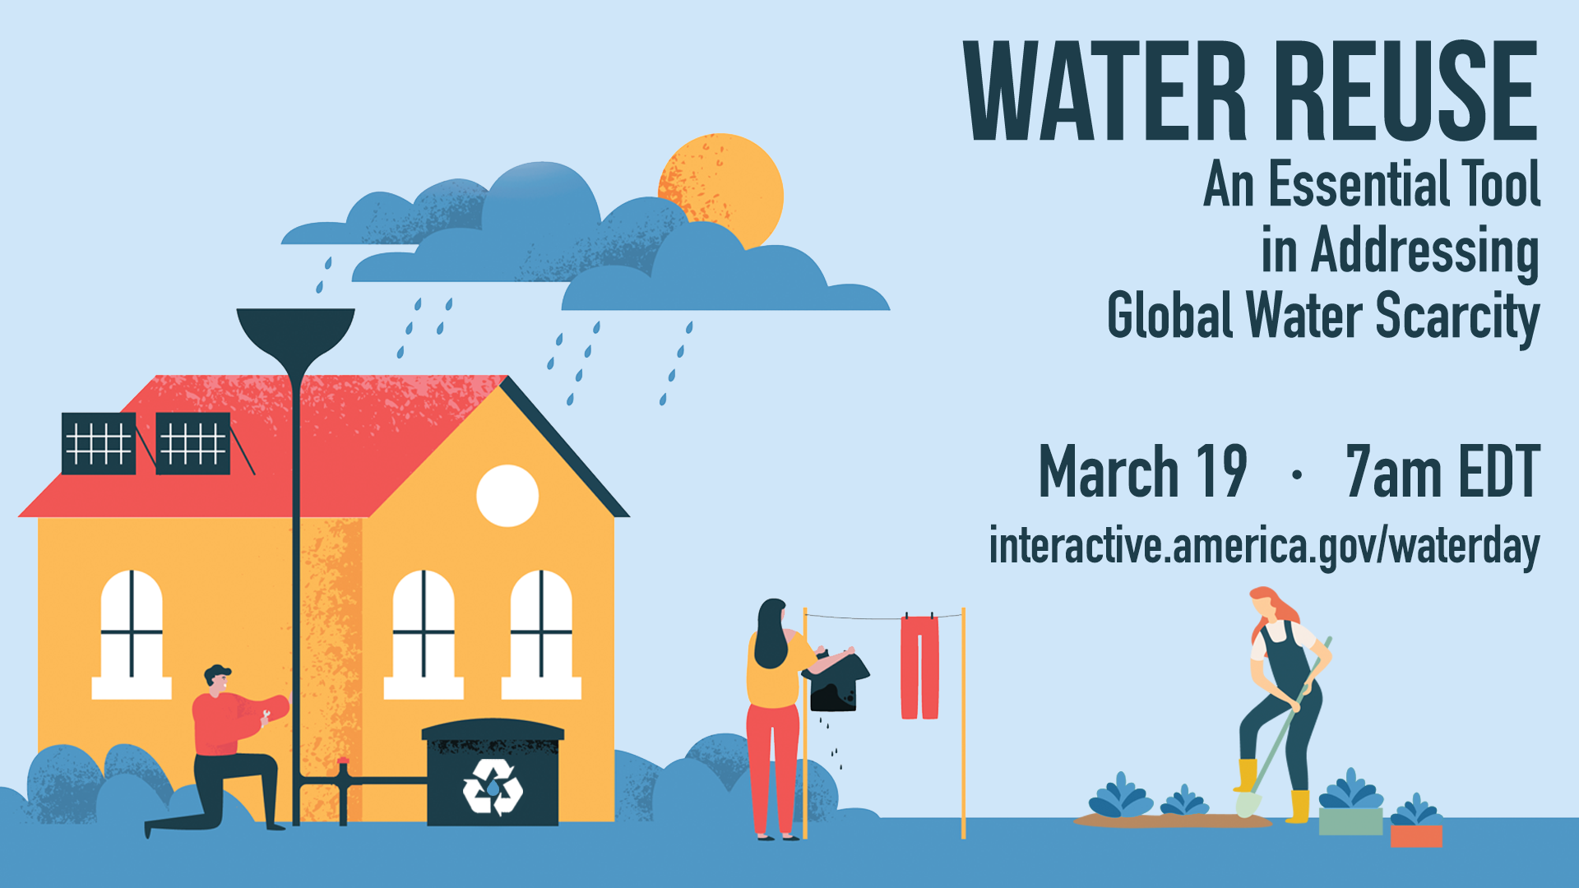
Water Reuse: An Essential Tool in
Addressing Global Water Scarcity

Summary
On Thursday, March 19, 2020 at 7:00 AM EDT, the Bureau of Oceans and International Environmental and Scientific Affairs (OES) and the Office of Global Public Affairs (GPA) are co-hosting an interactive webinar to highlight the importance of water reuse. Our panel of American water reuse experts will educate key stakeholders about national and local best practices, technologies, and policies for water reuse that can reduce water scarcity and raise public awareness, especially in the South and Central Asia region.

Program Description
Did you know that water reuse is an important way to address global water scarcity? Water reuse helps save water resources because it uses treated wastewater and stormwater for agriculture, toilet-flushing, or drinking. It can strengthen the reliability of local water supplies, which may reduce conflict over valuable, shared waters.

In the lead up to World Water Day, the Bureau of Oceans and International Environmental and Scientific Affairs and the Office of Global Public Affairs are co-hosting an interactive webinar to highlight the importance of water reuse. Our panel of American water reuse experts will educate key stakeholders about national and local best practices, technologies, and policies for water reuse that can reduce water scarcity and raise public awareness, especially in the South and Central Asia region. The discussion will also highlight the new EPA-led National Water Reuse Action Plan (WRAP), which taps into expertise from every sector of our society, from federal policy-makers down to district water managers.

Moderator and Speaker Biographies
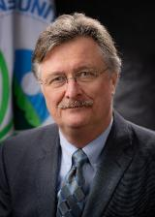
Moderator: Jeff Lape, National Program Leader for Water Reuse, U.S. Environmental Protection Agency
Jeff Lape is the National Program Leader for Water Reuse at the U.S. EPA and leads the National Water Reuse Action Plan. Mr. Lape’s more than 25 years at the EPA have spanned numerous leadership roles. Most recently, he served as Deputy Director of the Office of Science and Technology in the EPA’s Office of Water since 2010. Previously, he directed the Chesapeake Bay Office and served as a dispute resolution specialist for the EPA’s Conflict Prevention and Resolution Center. Mr. Lape holds a M.S. degree in Environmental Science and Engineering from Virginia Tech and a B.S. in Environmental Science from SUNY-Plattsburgh.

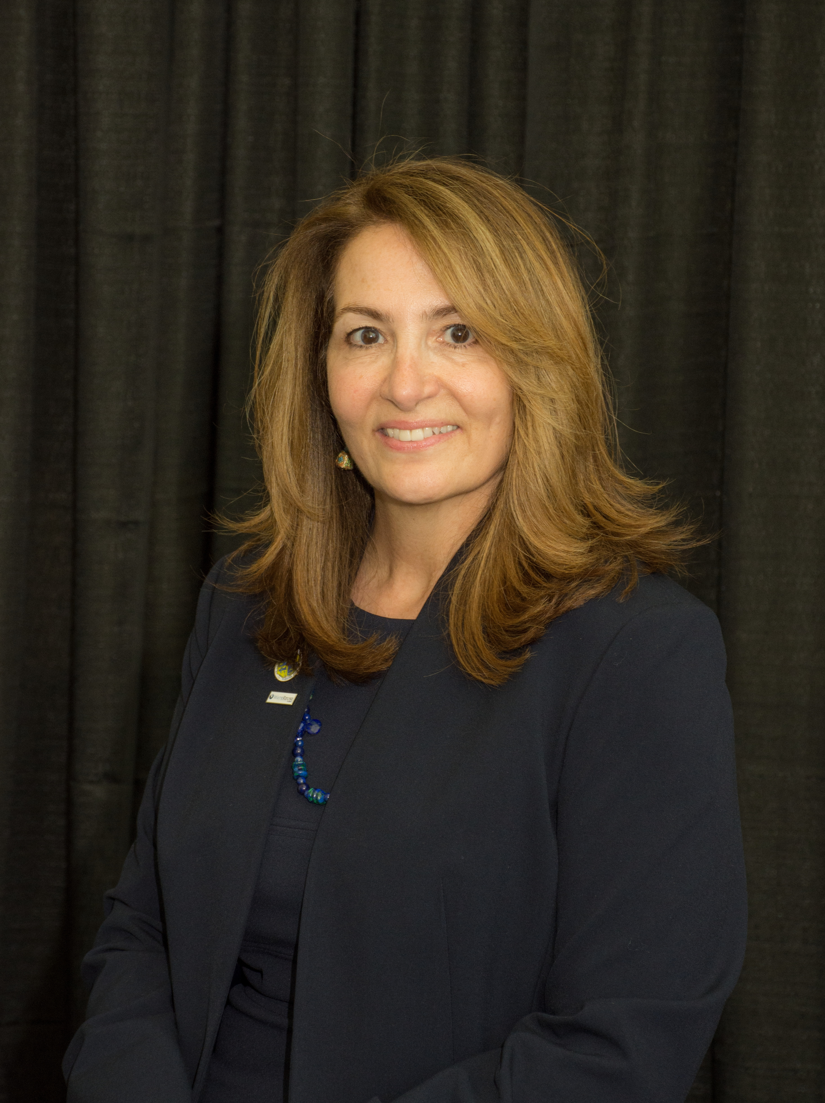
Speaker: Lynn Spivey, Director of Utilities, City of Plant City, Florida
Lynn Spivey is the Director of Utilities for the City of Plant City, Florida, with over 25 years of experience in water management, water and wastewater treatment, reclaimed water treatment for beneficial use, and potable reuse. She has worked in both the public and private sectors. Ms. Spivey holds a B.S. degree in Chemical Engineering from the University of South Florida. Ms. Spivey is currently the President of WateReuse Florida, the Florida Potable Reuse Chair, and a Florida Water Environment Association Director at Large.

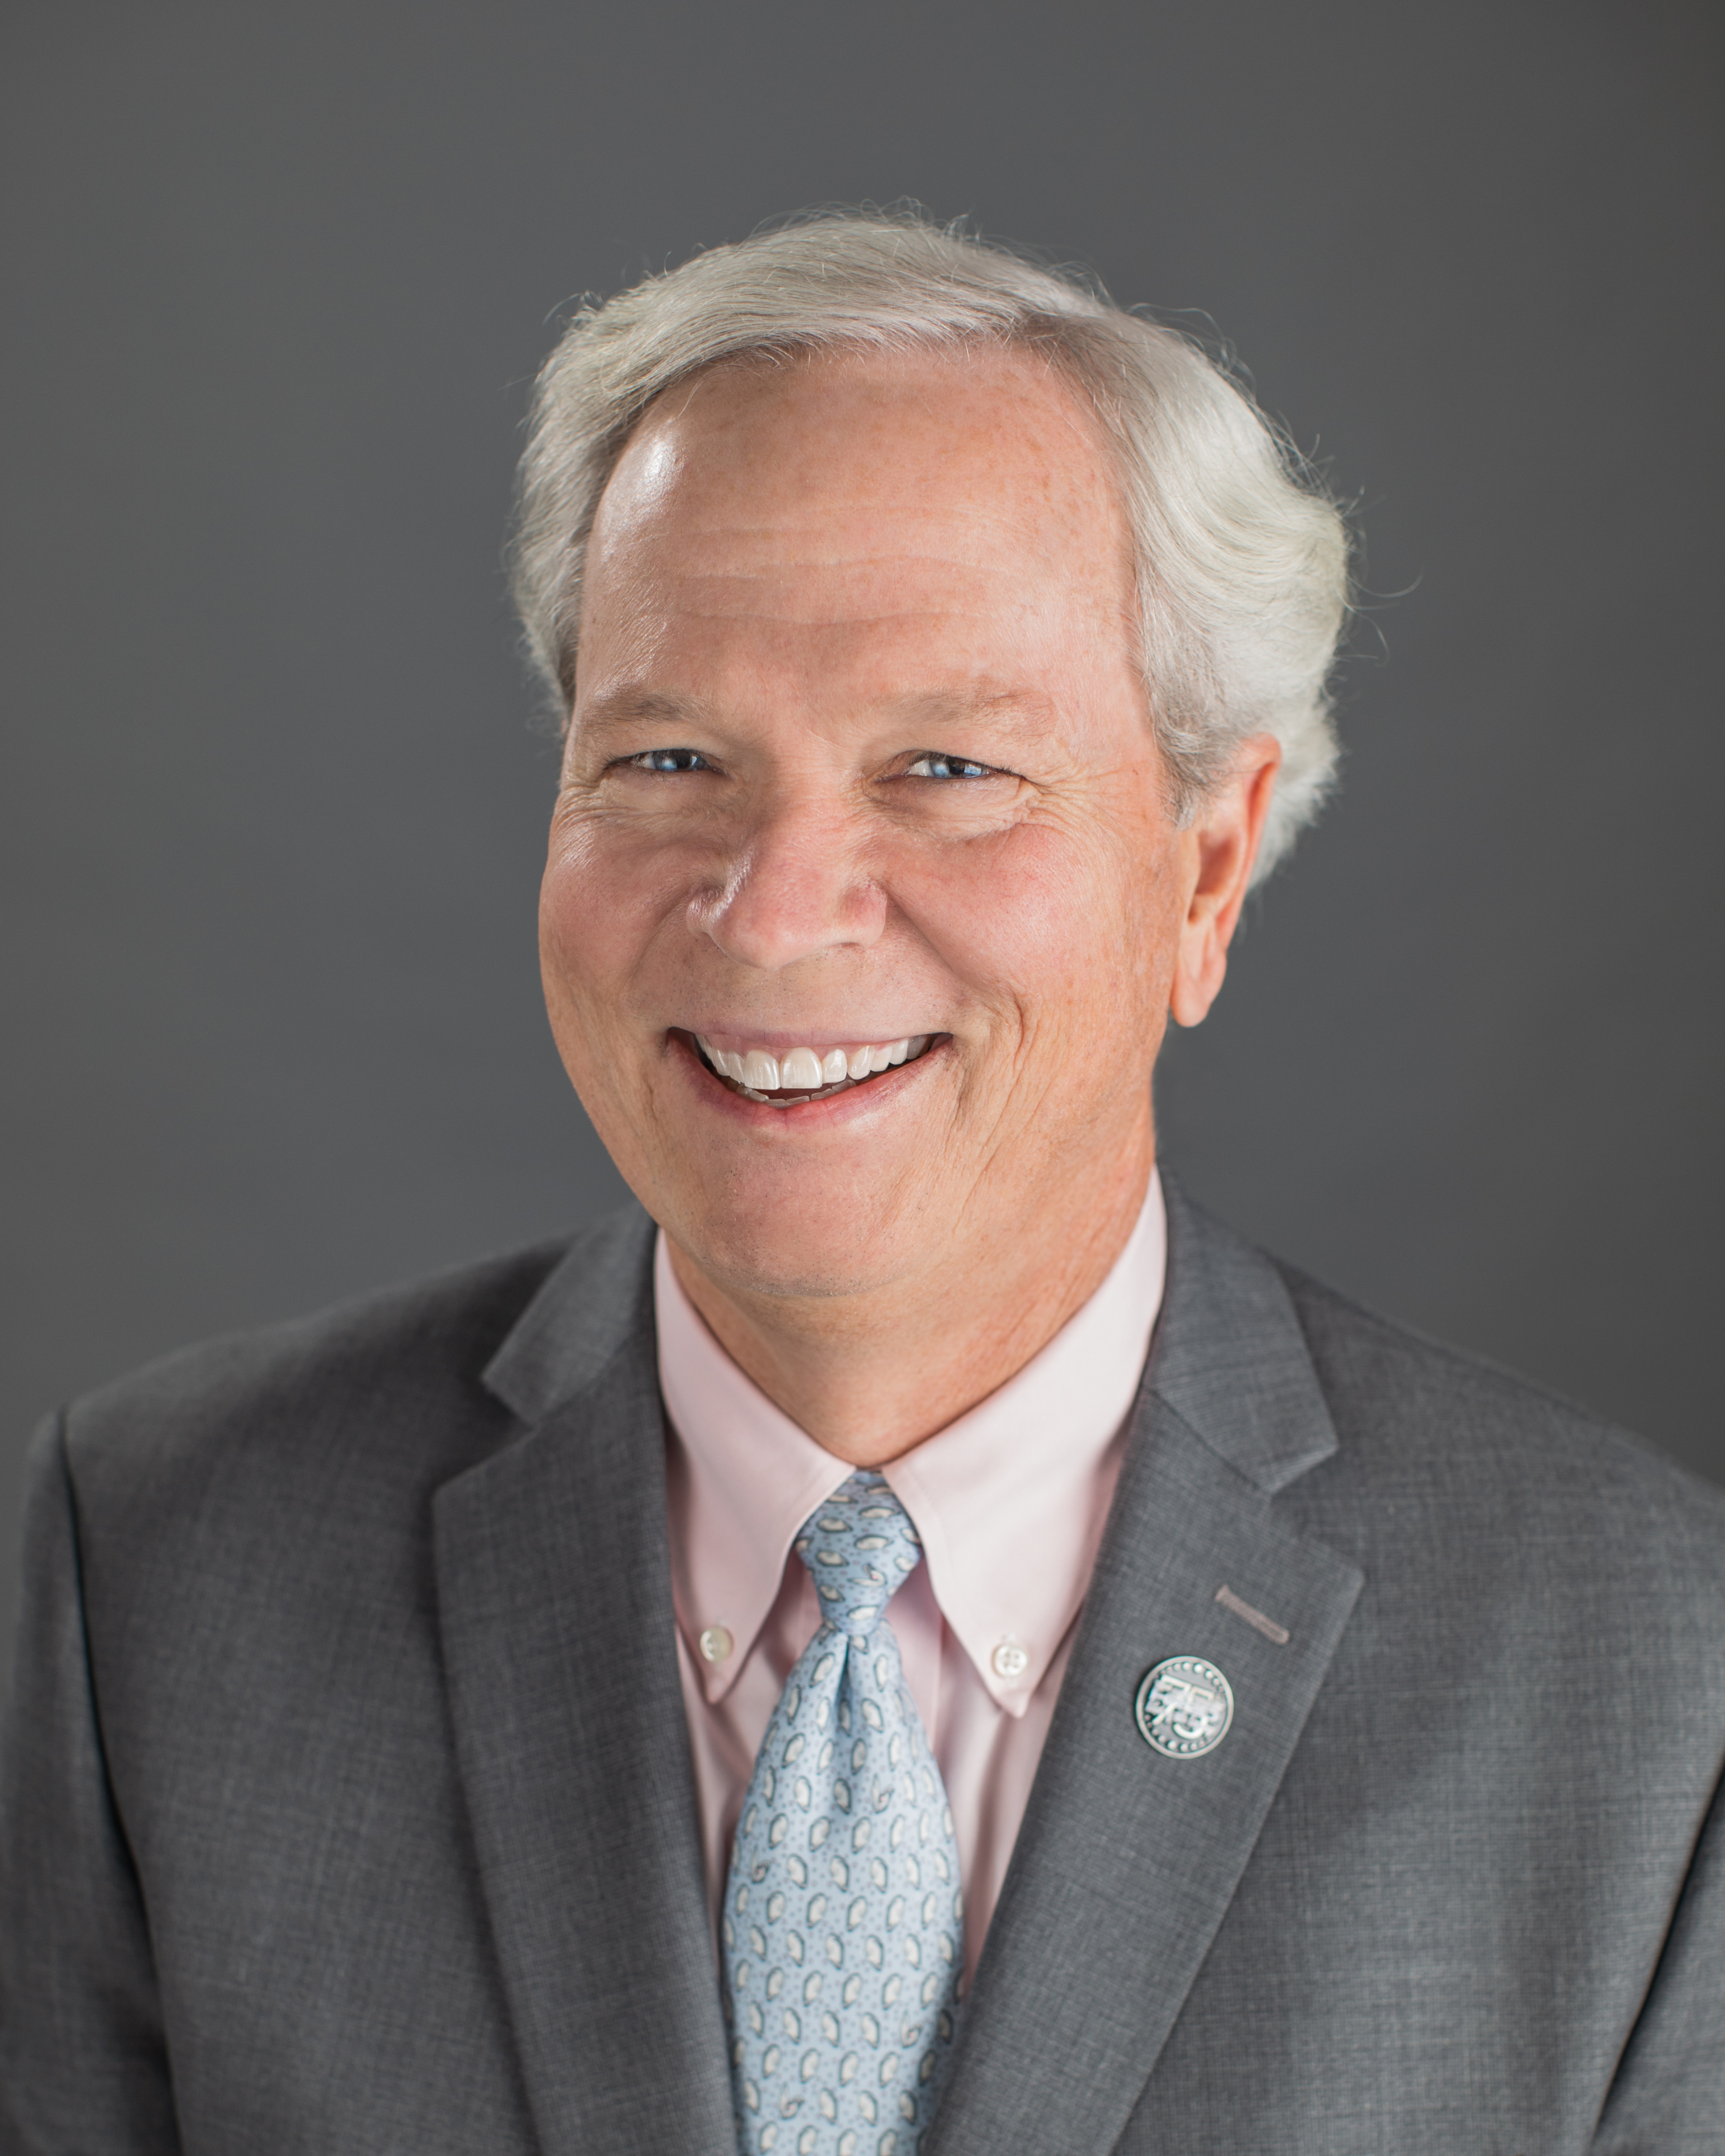
Speaker: Ted Henifin, General Manager, Hampton Roads Sanitation District, Virginia
Ted Henifin joined Hampton Roads Sanitation District in 2006, as General Manager. He previously served as Director of Public Works for the City of Hampton. Mr. Henifin holds a B.S. in Civil Engineering from the University of Virginia. His career has spanned more than 35 years with a focus on public works and utilities in federal, regional and local government in Hampton Roads. He is a registered professional engineer and has been active with professional associations throughout his career. He currently serves on the board of directors for the National Association of Clean Water Agencies, the Virginia Association of Municipal Wastewater Agencies, and Virginia Forever; is the chair of the US Water Alliance's One Water Council, and serves on the US EPA’s Environmental Financial Advisory Board. Mr. Henifin is active in various civic and community organizations in the Hampton Roads community currently serving as the vice chair of the board of directors for Langley Federal Credit Union and is a member of the board of directors for WHRO Public Media.

Event Details - Snapshot

Title | Water Reuse: An Essential Tool in Addressing Global Water Scarcity
Date and Time | Thursday, March 19 at 7:00 AM EDT (duration: one hour)
Promo Page URL | https://interactive.america.gov/iip_event/water-reuse-global-scarcity/  Bitly link for social media posts: http://bit.ly/2020water
Watch Page URL | https://interactive.america.gov/waterday
Format | 60-minute webcast with live Q&A
Topic | Water reuse, scarcity, and conservation
Audience | SCA
Hashtags | #WorldWaterDay  #WWD2020

Promotional Banners and Images

Promnotional banner image, social media toolkit can be downloaded here at the bottom of the page: https://interactive.america.gov/iip_event/water-reuse-global-scarcity/

Social Media Posts

Facebook and Instagram Posts

Suggested images to use with social media posts can be downloaded here:
https://app.box.com/s/aqhjtc7lwzxdq6bi4wt176zwzxdk16pu

Schedule date: March 5
Are you interested in celebrating #WorldWaterDay 2020? Interested in learning more about water reuse? Bring your questions and join our interactive webinar on March 19 at 7am EDT and learn more from our panel of water reuse experts! http://bit.ly/2020water {insert picture}

Schedule date: March 10
Did you know over the last century, the global population has been increasing, but water use has grown at twice that rate? Water reuse can increase access to water and make existing water supplies more reliable. On March 19 at 7am EDT, we are hosting an interactive webinar with a panel of water reuse experts! Hope you can join and we hope that you ask a lot of questions! #WorldWaterDay http://bit.ly/2020water {insert picture}

Schedule date: March 17
Did you know water reuse is an important way to address global water scarcity? Water reuse helps save water resources because it uses treated wastewater for agriculture, toilet-flushing, or drinking. Join our live #WorldWaterDay webinar on March 19 at 7am EDT to learn more! http://bit.ly/2020water {insert picture}

Schedule date: March 18
In celebration of #WorldWaterDay, we are hosting a live webinar with a panel of American water reuse experts who will talk about best practices, technologies, and policies to reduce water scarcity. Join us on March 19 at 7am EDT to learn more and bring your questions for our experts! http://bit.ly/2020water {insert picture}

Facebook Polls

Polls are be loaded directly into Facebook page at: https://www.facebook.com/ScienceDiplomacyUSA/

Schedule date: March 12
#WorldWaterDay poll! What can treated water be reused for? Find out the right answer during our water reuse webinar on March 19 at 7am EDT! http://bit.ly/2020water
- Agriculture
- Drinking
- Toilet Flushing
- All of the above

Schedule date: March 16
#WorldWaterDay poll! What would you most like to hear about at our water reuse webinar? Comment if you have another topic. Join us March 19 at 7 am EDT to hear more! http://bit.ly/2020water
- Water reuse technologies
- The different applications of water reuse
- Financing for water reuse
- Water reuse policy and regulations

Twitter Posts

Suggested images to use with social media posts can be downloaded here:
https://app.box.com/s/aqhjtc7lwzxdq6bi4wt176zwzxdk16pu

Schedule date: March 5
Are you interested in {include celebration emoji} celebrating #WWD2020 {water emoji}? Join our interactive webinar on {calendar emoji} March 19 at 7 am EDT & learn more about #water #reuse {recycle emoji}! #WorldWaterDay http://bit.ly/2020water {insert picture}

Schedule date: March 10
#DYK over the last century, the global pop. has been increasing, but water use has grown at twice that rate? #Water #reuse can increase #access to water and make existing water supplies more reliable. Join us March 19 at 7am EDT for a live webinar! #WWD2020 http://bit.ly/2020water {insert picture}

Schedule date: March 17
#DYK #water #reuse is an important way to address global water scarcity? Water reuse helps save water resources bc it uses treated #wastewater for #agriculture, toilet-flushing & #drinking. Check out our webinar on March 19 at 7am EDT! #WorldWaterDay http://bit.ly/2020water {insert picture}

Schedule date: March 18
For #WorldWaterDay we are hosting a webinar with #American #water #reuse experts who will talk about best practices, technologies & policies to reduce #waterscarcity. Join us on March 19 at 7am EDT to learn more! #WWD2020 http://bit.ly/2020water {insert picture}
Twitter Polls

Polls are be loaded directly into Twitter page at: https://twitter.com/scidiplomacyusa?lang=en

Schedule date: March 12
#WorldWaterDay poll! What can treated water be reused for? Find out the right answer during our water reuse webinar on March 19 at 7am EDT! #WWD2020 http://bit.ly/2020water
- Agriculture
- Drinking
- Toilet Flushing
- All of the above

Schedule date: March 16
#WorldWaterDay poll! What would you most like to hear about at our water reuse webinar? Comment if you have another topic. Join us March 19 at 7 am EDT to hear more! http://bit.ly/2020water
- Water reuse technologies
- The different applications of water reuse
- Financing for water reuse
- Water reuse policy and regulations

