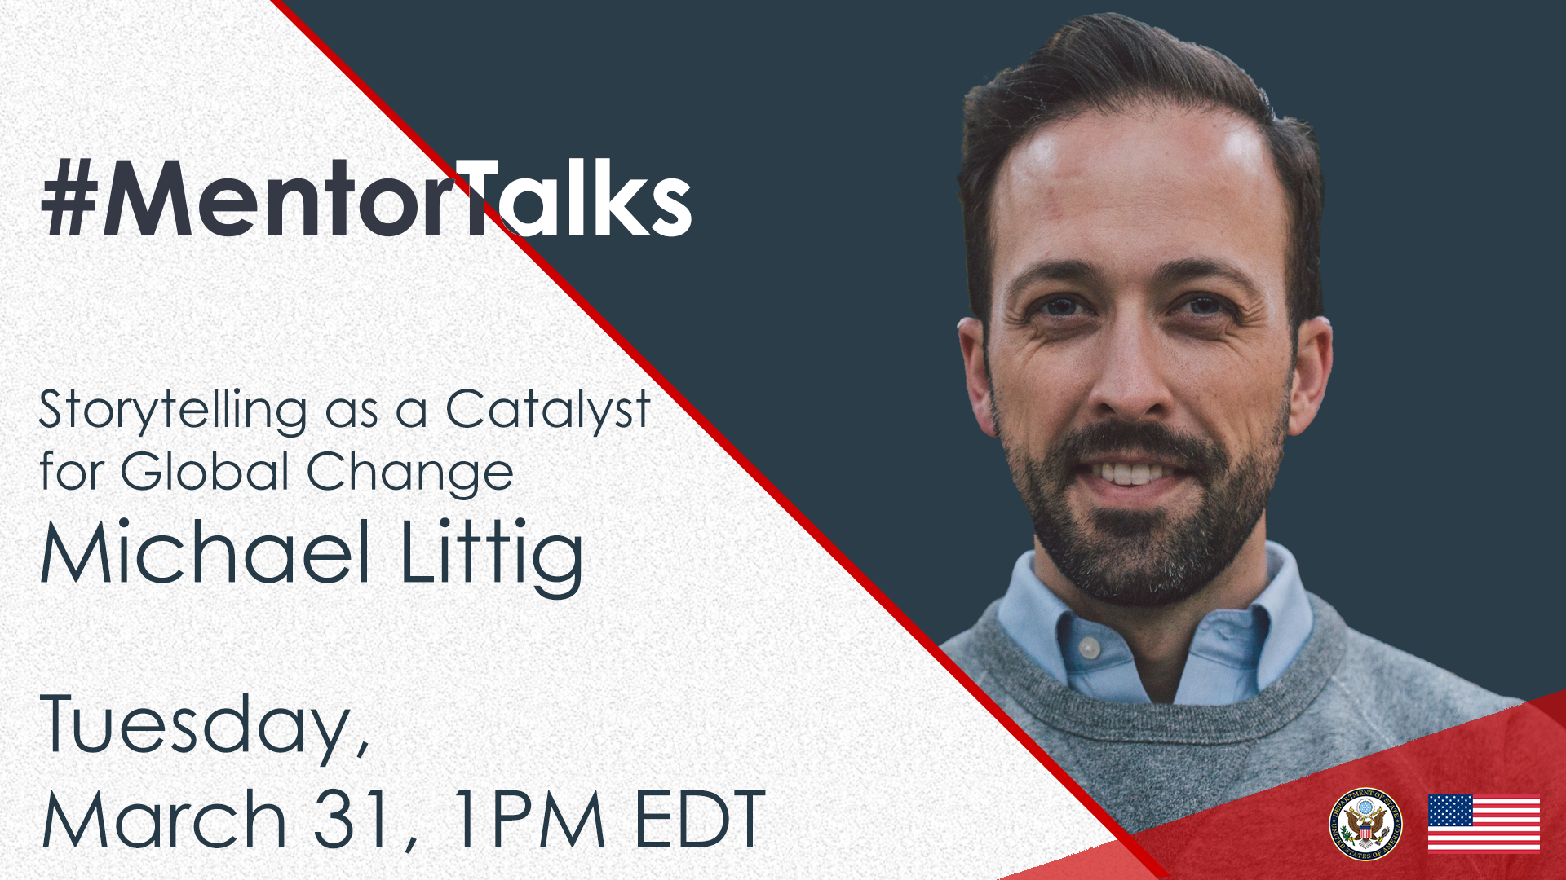

#MentorTalks: Storytelling as a Catalyst for Global Change
(Facebook Live)

Program Description

Got a few minutes? You’ve got a mentor! Join us for our next #MentorTalks, a Facebook Live series that puts exchange program alumni in touch with extraordinary mentors on a wide variety of topics.

Storytelling is a powerful way to enhance understanding and be a catalyst for solutions on global issues. How can you tap into the creativity, strategy, and innovation needed for powerful storytelling? Join our guest, Michael Littig, Mentor and Co-Founder of the Zuckerberg Institute in New York City, on Tuesday, March 31, 2020 at 1:00 p.m. ET to learn how you can identify, build, and share stories as part of your personal and professional life, and to create solutions on global issues. This episode will be livestreamed on the @internationalexchangealumni Facebook page.

Come ready to ask questions and be inspired! Tag #MentorTalks on your question, and we’ll see you online!

Speaker Biography

Michael Littig, Mentor and Co-Founder, Zuckerberg Institute

Michael Littig is an entrepreneur, investor, theater artist, and co-founder of Zuckerberg Institute. Michael has built lasting partnerships through his work in community with The Office of the Dalai Lama, National Endowment of the Arts, UNHCR (United Nations High Council for Refugees), Save the Children, The US State Department, MET Opera, Theater Mitu, and as the co-founder of the Patrick Page Acting Studio and Congregation Coaching. He is the founder of the Great Globe Foundation, an organization dedicated to creating artistic exchange with artists across cultures, most notably with youth in the Dadaab Refugee Camp on the border of Somalia. Education: The University of Cincinnati (CCM), where he received the distinguished alumnus award for career excellence, and a Fulbright Scholar (Mongolia).

Event Details - Snapshot

Title | #MentorTalks: Storytelling as a Catalyst for Global Change
Date and Time | Tuesday, March 31 @ 1:00 PM EDT
Watch Page URL | facebook.com/InternationalExchangeAlumni
Format | 30-minute Facebook Live with live Q&A
Topic | Marketing and Branding
Audience | Alumni of U.S. government-sponsored exchange programs and others aspiring to build successful careers.
Hashtags | #MentorTalks (program hashtag)  #ExchangeAlumni

Promotional Banners and Images

Download here (bottom of page): https://interactive.america.gov/iip_event/mentortalks-storytelling-for-powerful-business-marketing/

Sample Social Media Posts

Facebook and Instagram

[schedule for any time]
Michael Littig almost froze to death during his @The Fulbright Program exchange when he studied with shamans in Mongolia. Learn how he survived and how he has used storytelling as a powerful catalyst for solutions on global issues, like the refugee crisis in Somalia. That's on the next MentorTalks, Tuesday, March 31 at 1:00 p.m. ET! Got a question for Michael? Post it with the #MentorTalks tag and we'll share it with Michael, who will answer your question live during the program on facebook.com/InternationalExchangeAlumni. #ExchangeAlumni
[use Facebook or Instagram graphic]

[schedule for any time]
How can the art of storytelling be used as a catalyst for global change? Entrepreneur, investor, theater artist, @Zuckerberg Institute co-founder, and #Fulbright alumnus Michael Littig joins us on the next MentorTalks to share his personal and professional stories, with tips on how you can do the same to make a difference on global issues. Join him live on @internationalexchangealumni on Tuesday, March 31st at 1:00 p.m. ET.
Michael has built lasting partnerships through his work in community with The Office of the @Dalai Lama, @NationalEndowmentfortheArts, @UNHCR (United Nations High Council for Refugees), @savethechildren, the @U.S. Department of State, the @MetOpera, @theatermitu, and as the co-founder of the Patrick Page Acting Studio and Congregation Coaching. He is the founder of the Great Globe Foundation, an organization dedicated to creating artistic exchange with artists across cultures, most notably with youth in the Dadaab Refugee Camp on the border of Somalia.
[use Facebook or Instagram graphic]

[schedule for day before program]
TOMORROW at 1pm EDT [edit for local time]: Join fellow alumni of [Insert exchange program/U.S. Embassy handle] for #MentorTalks with Michael Littig, an #ExchangeAlumni of the @TheFulbrightProgram. Get 30 minutes of mentoring, inspiration, and advice for great storytelling! Come ready to ask questions about how you can identify, build, and use stories as a catalyst for change! facebook.com/InternationalExchangeAlumni #ExchangeAlumni Follow us on Facebook to receive updates! Tag your questions for Michael in the comments below with #MentorTalks.
[use Facebook or Instagram graphic]

[schedule for day of program]
LIVE TODAY at 1pm EDT [edit for local time]: Watch #MentorTalks with Michael Littig! Get 30 minutes of mentoring, inspiration, and advice for great storytelling! Come ready to ask questions about how you can identify, build, and use stories as a catalyst for change! facebook.com/InternationalExchangeAlumni #ExchangeAlumni Follow us on Facebook to receive updates! Send us your questions for Michael now in the comments below.
[use Facebook or Instagram graphic]

Twitter

[schedule for any time]
Michael Littig almost froze to death during his @FulbrightPrgrm exchange when he studied with shamans in Mongolia. How did he survive and end up connecting with the @DalaiLama? Join Michael on #MentorTalks Tuesday, March 31 at 1pm EDT [edit for local time] and find out! http://bit.ly/mentortalks #ExchangeAlumni
[use Twitter graphic]

[schedule for any time]
How can you tell a story or use art as a catalyst for change on global issues? Join Zuckerberg Institute co-founder Michael Littig for #MentorTalks on Tuesday, March 31 at 1pm EDT [edit for local time] and find out!
http://bit.ly/mentortalks #ExchangeAlumni
[use Twitter graphic]

[schedule for day before program]
TOMORROW at 1pm EDT [edit for local time]: Join @ FulbrightPrgrm alumnus Michael Littig for mentoring, inspiration, and advice on great storytelling as a catalyst for change! Got 30 minutes? You’ve got a mentor! http://bit.ly/mentortalks #MentorTalks #ExchangeAlumni
[use Twitter graphic]

[schedule for day of program]
LIVE TODAY at 1pm EDT [edit for local time]: Watch #MentorTalks with Michael Littig, co-founder of the Zuckerberg Institute! Got 30 minutes? You’ve got a mentor! Get mentoring, inspiration and advice! Come ready to ask questions. http://bit.ly/mentortalks #ExchangeAlumni
[use Twitter graphic]

[schedule for day of program]
Got 30 minutes? You’ve got a mentor! Tune in to #MentorTalks with @ FulbrightPrgrm alumnus/Zuckerberg Institute co-founder Michael Littig at 1pm EDT [edit for local time]. Head over to Facebook now to get ready for the conversation! http://bit.ly/mentortalks
[use Twitter graphic]

