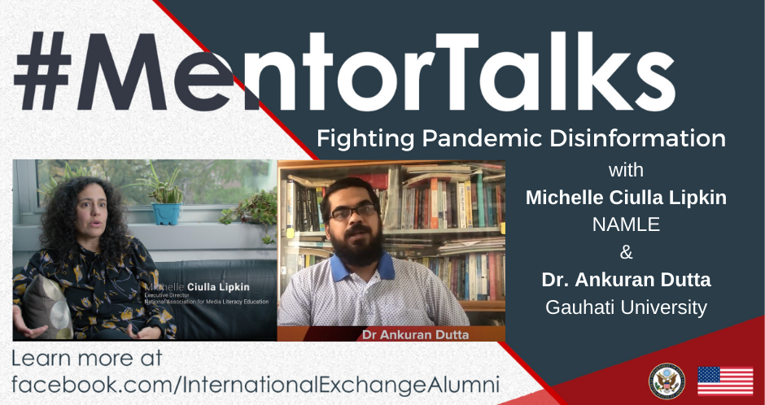

#MentorTalks: Fighting Pandemic Misinformation
When: Wednesday, May. 20, 2020 at 12:00 PM - 12:30 PM EDT
Watch Live on Facebook: International Exchange Alumni Facebook Page
Description:
Got 15 minutes? You’ve got a mentor! Join us for our next #MentorTalks, a Facebook Live series that puts exchange program alumni in touch with extraordinary mentors on a wide variety of topics.

On Wednesday, May 20th, we’ll discuss the value of media literacy. As the world fights the Covid-19 pandemic, it's also battling rumors and misinformation about the virus that may lead the public to believe and even take harmful actions. In this program, you’ll learn why media literacy is so important in this public health crisis, and how you can recognize good vs. misleading information.

We’ll be joined by Michelle Ciulla Lipkin of the National Association for Media Literacy, and Dr. Ankuran Dutta of Gauhati University Education. Come ready to Ask questions and be inspired! Ms. Ciulla Lipkin and Dr. Dutta will provide methods to identify disinformation and excellent examples of how you can prevent the spread of harmful rumors. Use #MentorTalks when asking your question, and we’ll see you online!

Speakers:
Michelle Ciulla Lipkin
Executive Director, National Association for Media Literacy Education
U.S. Speaker Program - Australia, 2018
Michelle Ciulla Lipkin is the Executive Director of the National Association for Media Literacy Education. As Executive Director, Michelle has helped NAMLE grow to be the preeminent media literacy education association in the United States. She launched the first ever Media Literacy Week in the United States., developed strategic partnerships with media companies such as Participant Media, Nickelodeon, and Twitter, and restructured both the governance and membership of the organization. She has also overseen four national conferences and done countless appearances at conferences, in the media, and before Congress regarding the importance of media literacy education.
Michelle Ciulla Lipkin is a U.S. Speakers Program alumna who has been featured on National Public Radio (NPR) and Al Jazeera English, as well as in The New York Times.
Dr. Ankuran Dutta
Associate Professor and Head, Department of Communication and Journalism, Gauhati University
Study of the U.S. Institutes (SUSI) alumnus - United States, 2018
Dr. Ankuran Dutta is Associate Professor and Head, Department of Communication and Journalism at Gauhati University in Guwahati, Assam, India. Dr Dutta is a media educator by profession with 15 years experience in different academic activities in India, Bangladesh, Canada, Maldives, Sri Lanka, Pakistan and Malaysia. Recently he has been awarded with India’s prestigious National Award for Outstanding Efforts in Science and Technology Communication in the Electronic Medium for 2018. He was also recognized as the Best Media Educator (Associate Professor) at the Media and Media Education Summit in 2018 in New Delhi. Dr. Dutta has participated in the Study of the United States Institutes program in Journalism and Media at E. W. Scripps School of Journalism at the University of Ohio, USA from June-August, 2018.

Facebook posts:
Join us for this month’s #MentorTalks on May 20th at 12:00 PM EDT! Michelle Ciulla Lipkin from @MediaLiteracyEd and Dr. Ankuran Dutta of @GauhatiUniversity will share their work on media literacy and tackling infodemics.
Dr. Ankuran Dutta’s current social media campaign is #CheckTheFake, which fights to limit fake information about the COVID-19 pandemic. Read more about his campaign → https://indianexpress.com/article/facebook-stories-of-strength-2020/case-studies/infodemic-and-pandemic-join-hands-to-take-on-covid-19-fake-news-in-assam-6379910/
Through @MediaLiteracyEd, Michelle Ciulla Lipkin created “Slowing the Infodemic: How to Spot COVID-19 Misinformation,” a guide to help the public fight the misinformation spreading about the pandemic. Read more about her campaign → https://www.thomsonreuters.com/en/about-us/social-impact.html#misinformation

What’s the difference between good versus misleading information? During a pandemic, it could be life or death. On Wednesday, May 20 at 12pm EDT, join Michelle Ciulla Lipkin from @MediaLiteracyEd and Dr. Ankuran Dutta of @GauhatiUniversity to hear their tips on how to #SlowTheInfodemic and #CheckTheFake, live on facebook.com/internationalexchangealumni!

Staying informed about the COVID-19 pandemic may be harder than it seems. Michelle Ciulla Lipkin from @MediaLiteracyEd and Dr. Ankuran Dutta of @GauhatiUniversity join us to talk about misinformation and how to navigate it on #MentorTalks May 20th at 12:00 PM EDT.

As the world fights the coronavirus pandemic, it's also battling rumors and misinformation that may lead the public to believe and even take harmful actions. Join Michelle Ciulla Lipkin from @MediaLiteracyEd and Dr. Ankuran Dutta of @GauhatiUniversity on the next #MentorTalks on May 20 at 12 p.m. EDT and learn how you can recognize good vs. misleading information.

Tweets:

What’s the difference between good versus misleading information? During a pandemic, it could be life or death. On May 20 at 12pm EDT, join #ExchangeAlumni Michelle Ciulla Lipkin from @MediaLiteracyEd and Dr. Ankuran Dutta of @GauhatiUni to talk #medialiteracy and how to fight misinfo -> facebook.com/internationalexchangealumni! @USAndIndia

Sub-tweet: Read more about Dr. Dutta’s current media literacy campaign #CheckTheFake https://indianexpress.com/article/facebook-stories-of-strength-2020/case-studies/infodemic-and-pandemic-join-hands-to-take-on-covid-19-fake-news-in-assam-6379910/

Sub-tweet: Learn more about @MediaLiteracyEd’s current media literacy campaign https://www.thomsonreuters.com/en/about-us/social-impact.html#misinformation

Join us May 20th at 12:00 PM EDT for #MentorTalks as we talk misinfo, pandemics, and #medialiteracy w/ Michelle Ciulla Lipkin of
@MediaLiteracyEd and Dr. Ankuran Dutta of @GauhatiUni. Got a Q for these #ExchangeAlumni? facebook.com/internationalexchangealumni
@USAndIndia @USAndKolkata

As researchers around the country monitor misinfo during the coronavirus pandemic, we’ll talk to #ExchangeAlumni Michelle Ciulla Lipkin from @MediaLiteracyEd and Dr. Dutta of @GauhatiUni on how to navigate the media ecosystem. Join us live on facebook.com/internationalexchangealumni! @USAndIndia @USAndKolkata

