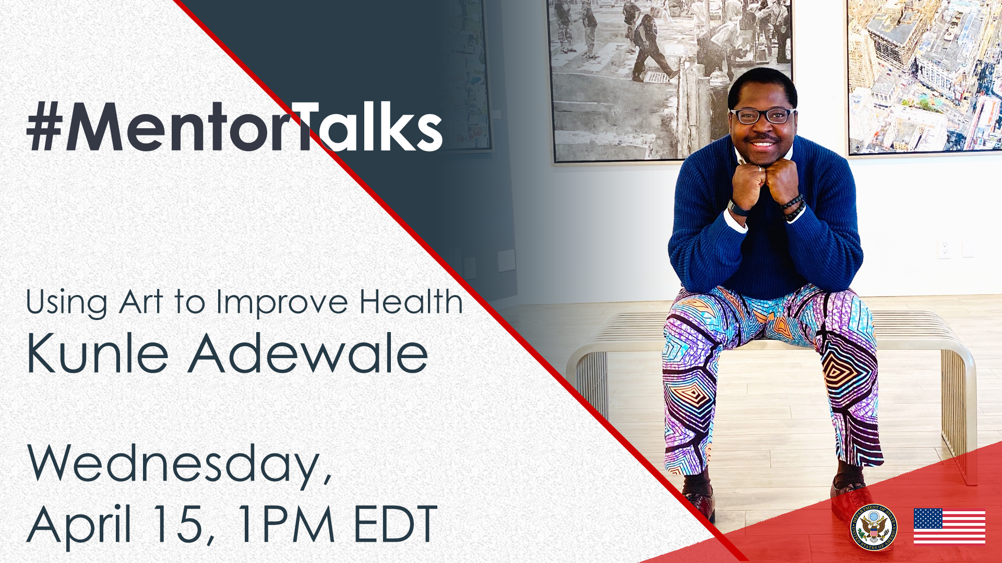
#MentorTalks: Using Art to Improve Health
With Kunle Adewale (Facebook Live)

Program Description
Got 30 minutes? You’ve got a mentor! Join us for our next #MentorTalks, a Facebook Live series that puts exchange program alumni in touch with extraordinary mentors on a wide variety of topics.
On Wednesday, April 15, at 1:00 pm EDT, Kunle Adewale, CEO and Creative Director of Tender Arts Nigeria, will share his stories and advice on how to use art to heal and improve physical and mental health. Kunle will also talk about his latest Arts in Medicine Project in response to COVID-19, #ArtResponds.
Come ready to ask questions and be inspired! Kunle will provide excellent examples of how you can use visual and performing arts for helping yourself and others. Got a question for Kunle? Post it with the #MentorTalks tag and we'll share your question with Kunle when we see you online!

Speaker Biography
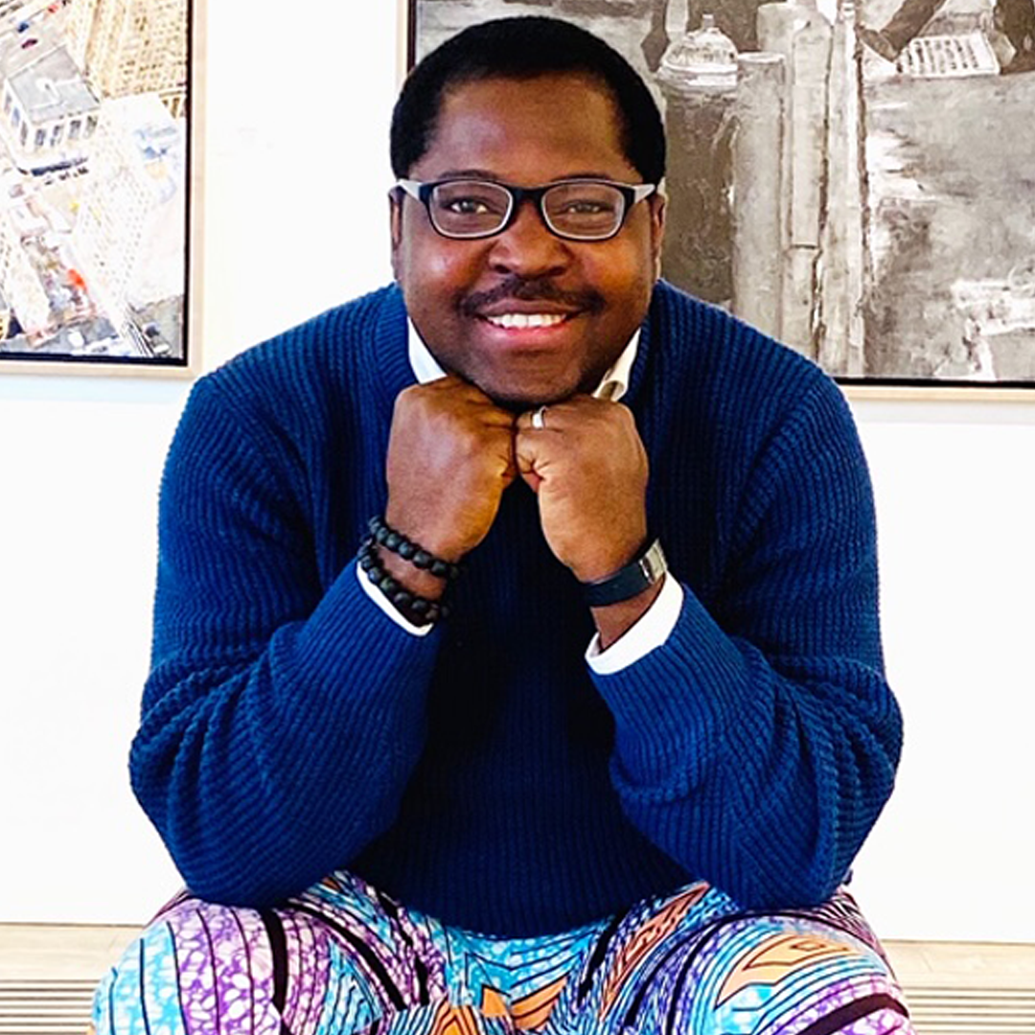
Kunle Adewale, CEO/Creative Director, Tender Arts Nigeria
Kunle Adewale is a development practitioner and an artist by profession. With over a decade experience as an artist and educationist, Kunle founded Tender Arts Nigeria in 2013, a social enterprise which positively impacts children, youth and adult populations by focusing on art education, talent development, and civic engagement. He has impacted over 15,000 beneficiaries through his art programs in Nigeria, Ghana, Kenya, South Africa and the United States. Kunle is an alumnus of the Mandela Washington Fellows program, and was recently shortlisted by the World Bank as one of the 68 Social Inclusion Heroes from all over the world, the only World Bank Social Inclusion Hero from Nigeria.

Event Details - Snapshot

Title | #MentorTalks: Using Art to Improve Health
Date and Time | Wednesday, April 15 at 1:00 PM EDT
Watch Page URL | facebook.com/InternationalExchangeAlumni
Format | 30-minute Facebook Live with live Q&A
Topic | Using art to heal and improve physical and mental health
Audience | Alumni of U.S. government-sponsored exchange programs and women entrepreneurs aspiring to build successful businesses.
Hashtags | #MentorTalks (program hashtag)  #ExchangeAlumni

Promotional Banners and Images

Download here (bottom of page): https://interactive.america.gov/iip_event/mentortalks-art-health/

Sample Social Media Posts

Facebook and Instagram

[schedule for any time]
Are you interested in building your own creative business enterprise, but not sure how to start? Join @MandelaWashingtonFellowship alumnus and @TenderArtsNigeria founder Kunle Adewale on #MentorTalks Wednesday, April 15 at 1:00 PM EDT [edit for local time] to find out! Kunle has impacted over 15,000 beneficiaries through his art programs in Nigeria, Ghana, Kenya, South Africa, and the United States. He started out small and he can teach you how! facebook.com/InternationalExchangeAlumni Follow our page to receive updates! #ExchangeAlumni #YALI10 @usembassynigeria
[use Facebook or Instagram graphic]

[schedule for any time]
Want advice from a key influencer in creative art and community development? Join Kunle Adewale, @MandelaWashingtonFellowship alumnus and @TenderArtsNigeria founder, on @InternationalExchangeAlumni’s #MentorTalks on Wednesday, April 15 at 1:00 PM EDT [edit for local time]! Send in your questions for Kunle now by tagging #MentorTalks. #ExchangeAlumni #YALI10 @usembassynigeria
[use Facebook or Instagram graphic]

[schedule for any time]
@MandelaWashingtonFellowship alumnus and @TenderArtsNigeria founder Kunle Adewale is passionate about using arts to improve community well-being. He has impacted over 15,000 beneficiaries through his art programs in Nigeria, Ghana, Kenya, South Africa, and the United States. How is Kunle using the arts to respond to the current global health crisis? Join him on the next #MentorTalks Wednesday, April 15 at 1:00 PM EDT [edit for local time]! Send in your questions for Kunle by tagging #MentorTalks. #ExchangeAlumni #YALI10 @usembassynigeria
[use Facebook or Instagram graphic]

[schedule for any time]
Got 30 minutes? You’ve got a mentor! Join Kunle Adewale, CEO and Creative Director of @TenderArtsNigeria and @MandelaWashingtonFellowship alumnus, on the next #MentorTalks Wednesday, April 15 at 1:00 PM EDT [edit for local time]! Kunle will share his stories and advice on how to use art to heal and improve physical and mental health. He will also talk about his latest project in response to COVID-19, #ArtResponds. Got a question for Kunle? Post it now using #MentorTalks. #ExchangeAlumni #YALI10 @usembassynigeria
[use Facebook or Instagram graphic]

[schedule for day before program]
TOMORROW at 1:00 pm EDT [edit for local time]: Join fellow alumni of [Insert exchange program/U.S. Embassy handle] for #MentorTalks with Kunle Adewale. Get 30 minutes of mentoring, inspiration, and advice! Come ready to ask questions about using the arts as a way to build communities and improve physical and mental health at facebook.com/InternationalExchangeAlumni. #ExchangeAlumni #YALI10 @usembassynigeria Send us your questions for Kunle in the comments below.
[use Facebook or Instagram graphic]

[schedule for day of program]
LIVE TODAY at 1:00 pm EDT [edit for local time]: Watch #MentorTalks with Kunle Adewale! Get 30 minutes of mentoring, inspiration and advice for entrepreneurs. Come ready to ask questions about using artistic expression as a way to build communities and improve physical and mental health! facebook.com/InternationalExchangeAlumni #ExchangeAlumni #YALI10 @usembassynigeria Follow @InternationalExchangeAlumni on Facebook to receive updates! Send us your questions for Kunle now in the comments below.
[use Facebook or Instagram graphic]

Twitter

[schedule for any time]
How can you use art to heal the mind, and improve physical and mental health? Join @TenderArtsNg founder and @WashFellowship alumnus Kunle Adewale for #MentorTalks on April 15 at 1:00 PM EDT [edit for local time]! http://bit.ly/mentortalks #ExchangeAlumni @USEmbassyAbuja
[use Twitter graphic]

[schedule for any time]
@TenderArtsNg founder and @WashFellowship alumnus Kunle Adewale has impacted over 15,000 people through his art programs worldwide. How is Kunle using art to respond to the #coronavirus? Join him on #MentorTalks April 15 at 1:00 PM EDT [edit for local time]! #ExchangeAlumni @USEmbassyAbuja
[use Twitter graphic]

[schedule for any time]
How can art be used to heal and to improve our mental health? Join award-winning @WashFellowship alumnus Kunle Adewale on #MentorTalks April 15 at 1:00 PM EDT [edit for local time]. Got a question for Kunle? Post it now using #MentorTalks. http://bit.ly/mentortalks #ExchangeAlumni #YALI10 @USEmbassyAbuja

[use Twitter graphic]

[schedule for day before program]
TOMORROW at 1:00 PM EDT [edit for local time]: Join @TenderArtsNg founder and @WashFellowship alumnus Kunle Adewale for mentoring, inspiration, and advice! http://bit.ly/mentortalks #MentorTalks #ExchangeAlumni #YALI10 @USEmbassyAbuja
[use Twitter graphic]

[schedule for day of program]
LIVE TODAY at 1:00 PM EDT [edit for local time]: Watch #MentorTalks with @TenderArtsNg founder and @WashFellowship alumnus Kunle Adewale! Come ready to ask questions. http://bit.ly/mentortalks #ExchangeAlumni #YALI10 @USEmbassyAbuja
[use Twitter graphic]

[schedule for day of program]
Got 30 minutes? You’ve got a mentor! Tune in to #MentorTalks with Kunle Adewale at 1:00 PM EDT [edit for local time]. Head over to Facebook now to get ready for the conversation! http://bit.ly/mentortalks #ExchangeAlumni #YALI10 @USEmbassyAbuja
[use Twitter graphic]

