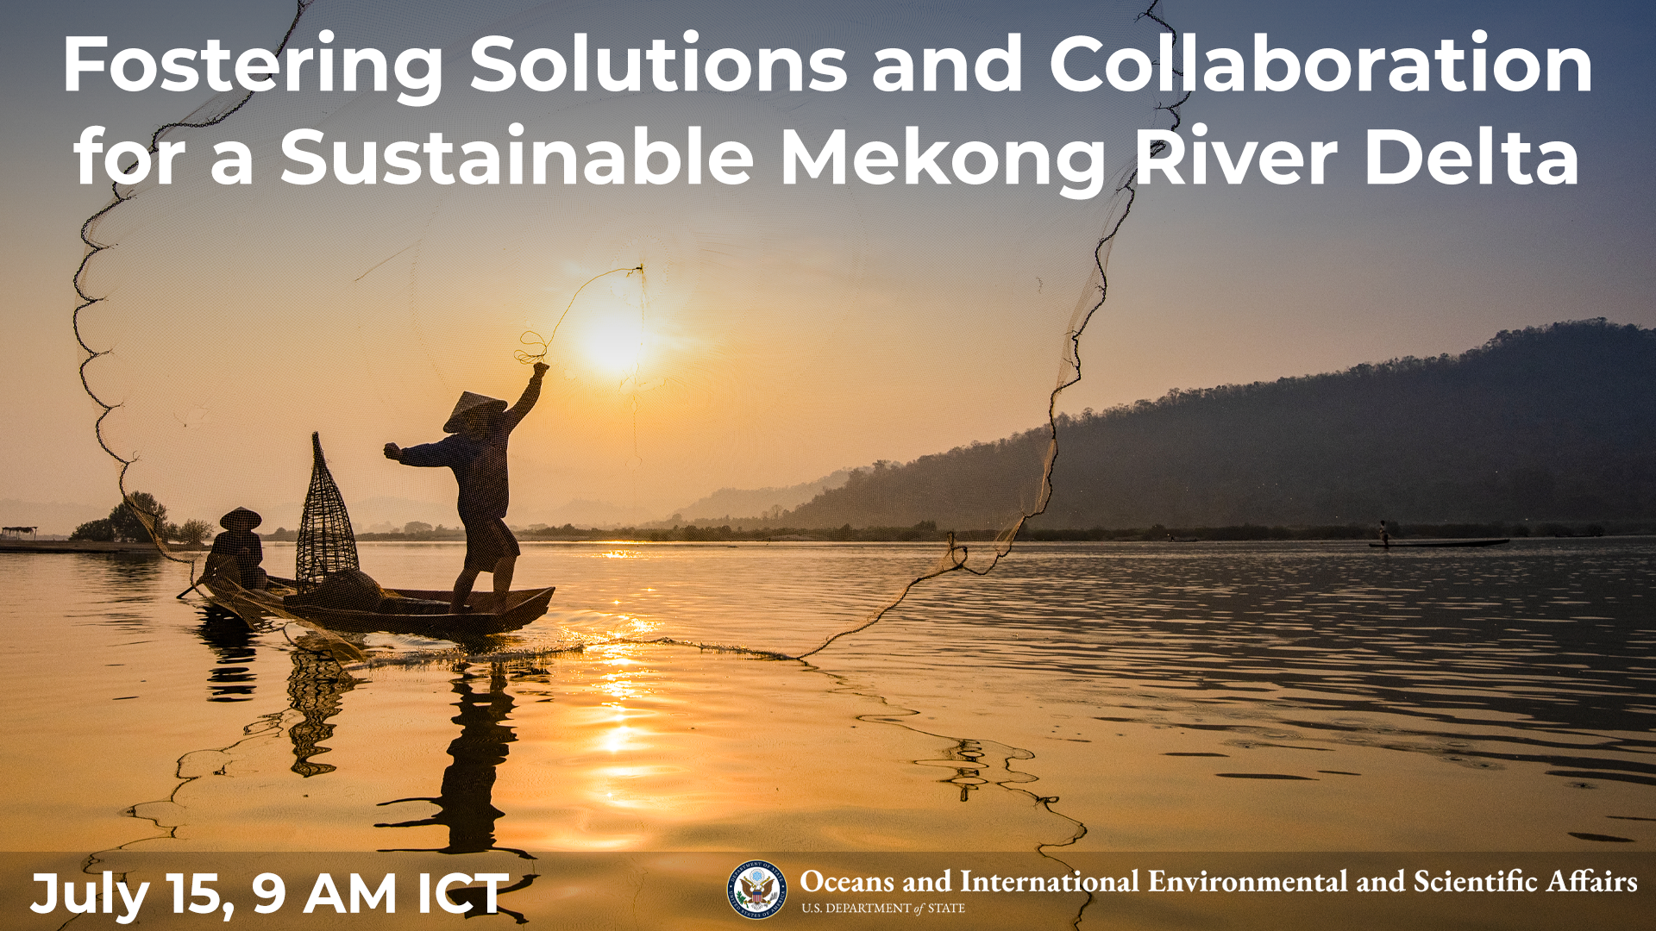

Fostering Solutions and Collaboration for a Sustainable Mekong River Delta

Summary
On Wednesday, July 15 at 9:00 am ICT, the Bureau of Oceans and International Environmental and Scientific Affairs (OES) and the Office of Global Public Affairs (GPA) are co-hosting an interactive webinar to highlight the importance of managing drought and salinity and in the Mekong Delta. Our panel of American salinity experts and Mekong delta management experts will educate key stakeholders about best practices, technologies, and policies for delta management to reduce salinity and its negative impacts, especially in the Mekong Delta region.

Program Description
As part of the U.S. Vision for a Free and Open Indo-Pacific the U.S. government is committed to providing a platform that encourages information sharing, dialogue, collaboration, and stakeholder engagement for cooperative, responsible management of the Mekong River. The U.S. engagement with the Mekong region has long emphasized cooperation on water-related policy and program activities. This engagement builds trust among partners and stakeholders and strengthens cooperation not only on water issues but for natural resources management more broadly.

This program will engage key stakeholders about the importance of managing drought and salinity and how to mitigate the adverse effects of saltwater in delta ecosystems. The Mekong River is home to one of the most productive and biodiverse river ecosystems in the world with over 1,100 species of fish. The Mekong River provides freshwater for these ecosystems and for agriculture, fisheries, drinking water, transportation, and energy. Every year, saltwater intrusion, or the presence of saltwater in inland rivers or groundwater, renders freshwater resources unusable for agriculture or drinking. Saltwater intrusion in the Mekong River, and especially in the delta, is exacerbated by drought, sea level rise, and lower water levels in the river from increasing dam and infrastructure development.

This program on managing drought and salinity builds upon existing efforts in the Mekong region to strengthen collaboration and dialogue on water issues and solutions and supports the Mekong Water Data Initiative (MWDI). The MWDI aims to strengthen the capacity of Lower Mekong countries to collect, analyze, and manage water and water-related data in order to reduce water-related risks and promote sustainable economic development across the water, food, energy, and environment nexus.

U.S.-based experts engage with Mekong stakeholders to identify strategies and methods to foster longer-term information sharing, collaboration, and expert consultation. This program benefits regional mid-level water, rural and urban development, energy, environment, and health ministry officials, water resource managers and utility operators, academics, and civil society in the Lower Mekong region.

Moderator and Speaker Biographies
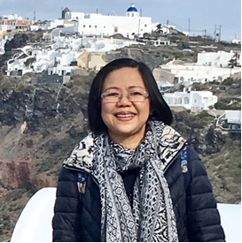
Moderator: Nguyen Huong Thuy Phan, Graduate Institute Geneva, Development Policies and Practices Executive Master Program

Dr. Phan Nguyen is a specialist in water and climate change. By training she has a Doctor of Engineering in Water Resource Development. Phan has more than 25 years of combined experiences in hydropower development projects in the South of Vietnam, coastal engineering projects in the Gulf of Thailand, climate change risk assessment programmes in the Vietnam’s Red River Delta and the Lower Mekong Basin (Cambodia, Lao PDR, Thailand and Vietnam), and higher education programmes in development studies in South East Asia. Prior to joining the Graduate Institute Geneva, Phan worked for the MRC Secretariat as a Climate Change and Environment Team Leader in 2016 and a Programme Coordinator of the MRC Climate Change and Adaptation Initiative (CCAI) in 2011-2015. She was the Head of Environment and Development Section at Asian Institute of Technology in Vietnam during 2002-2011; a research scientist at the University of Twente, the Netherlands during 2000-2002; a research engineer at the Asian Institute of Technology in 1994-2000; a water resource engineer at Vietnam Ministry of Energy in 1986-1992; and Board of Construction – Vietnam Institute of Hygiene, in 1984-1986.

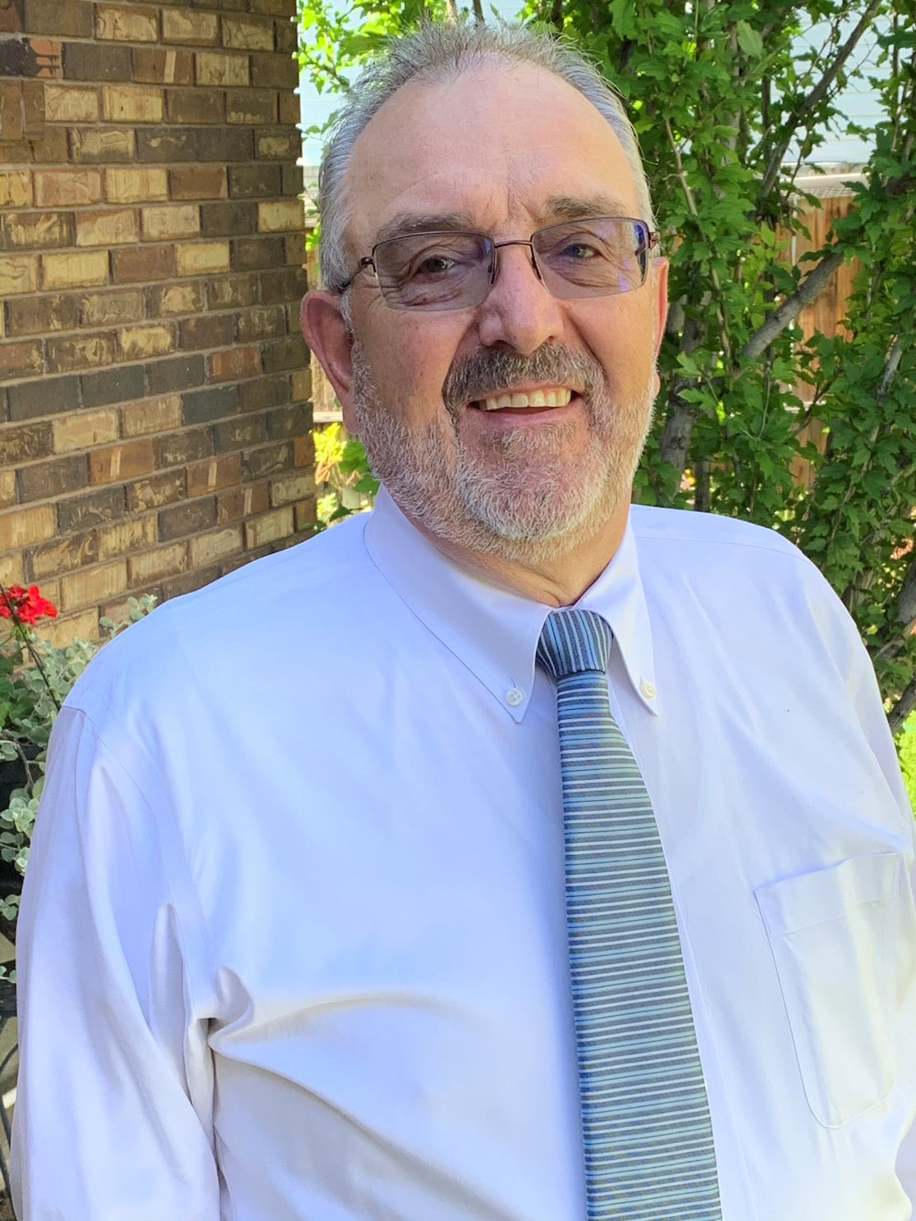
Speaker: Kib Jacobson, Project Manager, Colorado River Basin Salinity Control Program, U.S. Bureau of Reclamation

For the past 18 years Mr. Jacobson has been the Colorado River Basin Salinity Control Program Manager and Chief of the Water Quality Group. As the Program Manager he has been responsible for implementing the Title II Colorado River Basin Salinity Control Program that was authorized by Public Law 93-320. Mr. Jacobson has spent his professional career of 40 years as a public servant working in different capacities in the Upper Colorado (UC) Region of the Bureau of Reclamation located in Salt Lake City, UT. Mr. Jacobson has a M.S. in Agricultural Economics from Utah State University, Logan UT.

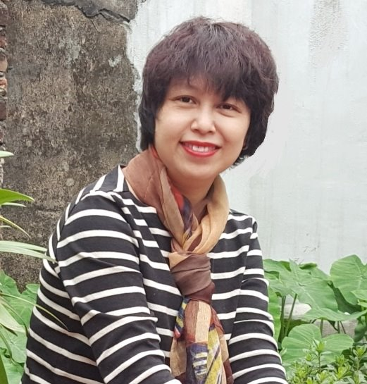
Speaker: Nguyen Hong Phuong, Deputy Director General of Vietnam Mekong Committee
Ms. Nguyen Hong Phuong is Deputy Director General of the Viet Nam National Mekong Committee Secretariat. Ms Phuong has over 20 years of working experience in different agencies, programs and projects in water and environment. Prior to joining the Viet Nam National Mekong Committee Secretariat in 2007, she was Viet Nam National Program Coordinator of the Mekong Biodiversity Conservation and Sustainable Use, a joint Program of UNDP, IUCN, and MRC. Ms Phuong holds a bachelor’s degree in Water Resources Engineering from the Ha Noi Water Resources University, Hanoi, Viet Nam, and a master’s degree in Water Resources Engineering and Management from the Asian Institute of Technology, Bangkok, Thailand.
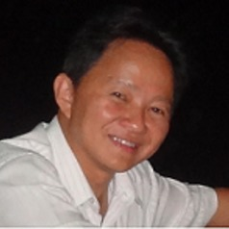
Speaker: Van Pham Dang Tri, Vice Dean, College of Environment and Natural Resources, Can Tho University

VAN Pham Dang Tri (Assoc. Prof., PhD.) is currently one of the Vice Deans at the College of Environment and Natural Resources at Can Tho University, Viet Nam. With a wide range of scientific background, he focuses on holistic research on integrated water resources management, irrigation, hydrodynamics modelling and possible impacts of climate change on behaviors of the different river networks, and on agriculture and aquaculture in the Vietnamese Mekong Delta. VAN Pham Dang Tri is presently participating in different national and international projects as either a project manager or a technical advisor. As a lecturer and a Vice Dean at Can Tho University, he pays great attention to capacity building for both the young generations who are doing their undergrad and postgrad students at Can Tho University and local practitioners who are doing their works related to environment and natural resources management.

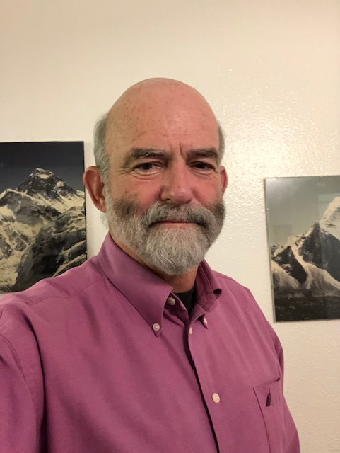
Speaker: Malcolm Wilson, Chief, Water Resources & Compliance Group, U.S. Bureau of Reclamation

Malcolm Wilson has been the Chief of the Water Resources Group for Reclamation’s Upper Colorado Region located in Salt Lake City, Utah since 2008. Malcolm participated in, and represented the Upper Colorado Region’s interests in, the development of the Colorado River Basin Drought Contingency Plans. The Water Resources Group is responsible for long term operations of the Colorado River Storage Project reservoirs, including Glen Canyon, Flaming Gorge, Fontenelle, the Aspinall Units, for oversight of all regional water service, repayment and O&M contracts and for Reclamation Reform Act administration. Malcolm also spent 23 years in Reclamation’s Eastern Colorado Area Office in Colorado working in multiple capacities including: overseeing operations and water rights for the Colorado-Big Thompson and Fryingpan-Arkansas projects. Malcolm has a degree in Civil & Agricultural Engineering from Cornell University.

Event Details - Snapshot

Title | Fostering Solutions and Collaboration for a Sustainable Mekong River Delta
Date and Time | Tuesday, July 14, 2020, 10:00 PM – 11:30 PM (duration: 90 minutes)
Promo Page URL | https://interactive.america.gov/iip_event/solutions-mekong-delta/  Bitly link for social media posts: http://bit.ly/2020mekong
Watch Page URL
Format | 90-minute webcast with live Q&A
Topic | Salinity, delta management, Mekong River
Audience | EAP
Hashtags | #MekongRiver  #MekongDelta

Promotional Banners and Images

Promotional banner image, social media toolkit can be downloaded here at the bottom of the page: https://interactive.america.gov/iip_event/solutions-mekong-delta/

Social Media Posts

Facebook and Instagram Posts

Suggested images to use with social media posts can be downloaded here: https://app.box.com/s/078uszdv2ezz00j42648vqtoezqzwnrv

Schedule Date: June 17
Save the date! Did you know the Mekong Delta is threatened by drought and saltwater intrusion? These environmental challenges are causing negative impacts on the amount of available water for drinking, agriculture, transportation, and energy along the Mekong Delta. We want to help find solutions to these problems and are hosting an interactive webinar on July 15 at 9am ICT. Join us and learn more from our experts on delta and river management! bit.ly/2020mekong [insert photo]

Schedule Date: July 6
The Mekong is home to one of the most productive and biodiverse river ecosystems in the world and the Mekong River flows through six countries: China, Myanmar, Thailand, Lao PDR, Cambodia, and Vietnam. The Basin is full of biodiversity including over 1,100 species of fish. Issues like drought and saltwater intrusion threaten these ecosystems. Learn more at our July 15 at 9am ICT for a live webinar! bit.ly/2020mekong [insert photo]

Schedule Date: July 12
What is saltwater intrusion? It is the movement of saltwater into inland freshwater rivers or groundwater aquifers and causes freshwater to be unusable for agriculture or drinking. Drought, sea level rise, and upstream infrastructure development such as dams all worsen saltwater intrusion in the Mekong River Delta. Discover how this negatively impacts the Delta and join our interactive webinar on July 15 at 9 am ICT! bit.ly/2020mekong [insert photo]

Schedule Date: July 15
Do you want to learn more about how to reduce drought and salinity in the Mekong Delta? Join us LIVE TODAY (July 15) at 9am ICT for a webinar where our panel of innovative river delta experts will discuss how managing environmental challenges can help maintain a sustainable Mekong Delta. Bring your questions! bit.ly/2020mekong [insert photo]

Facebook Polls

Polls are be loaded directly into Facebook page at: https://www.facebook.com/ScienceDiplomacyUSA/

Schedule Date: July 10 – Interactive Poll
True or False: the 4,800 kilometers of the Mekong provides freshwater for ecosystems, agriculture, fisheries, drinking water, transportation, and energy. Join our interactive webinar on July 15 at 9am ICT to learn more! bit.ly/2020mekong

A: True
B: False
Schedule Date: July 15 – Interactive Poll
The next Mekong Virtual Symposium event will be this fall! What topic would you most like to learn about next?

A: Tonle Sap Lake
B: 3S System
C: Role of Civil Society in the Mekong
D: Social Science & Water

Twitter Posts

Suggested images to use with social media posts can be downloaded here: https://app.box.com/s/078uszdv2ezz00j42648vqtoezqzwnrv

Schedule Date: June 17
Save the date! We are hosting an interactive webinar on salinity and drought in the Mekong Delta on July 15 at 9am ICT. Join us and bring your questions! #MekongRiver bit.ly/2020mekong [insert photo]

Schedule Date: July 1
Did you know the Mekong Delta is threatened by drought and saltwater intrusion? Join our interactive webcast on July 15 at 9am ICT to learn about how we can address these issues! #MekongRiver bit.ly/2020mekong [insert photo]

Schedule Date: July 6
The Mekong is home to one of the most productive and biodiverse river ecosystems in the world with 1,100+ species of fish. Issues like drought & saltwater intrusion threaten these ecosystems. Learn more during our live webinar on July 15 at 9am ICT! bit.ly/2020mekong [insert photo]

Schedule Date: July 12
What is saltwater intrusion? It is the movement of saltwater into inland rivers or groundwater aquifers & causes the water to be unusable for agriculture or drinking. Discover how this negatively impacts the Mekong Delta: bit.ly/2020mekong [insert graphic for webinar]

Schedule Date: July 13
Drought, sea level rise & upstream infrastructure development such as dams all worsen saltwater intrusion in the Mekong River Delta. Join us July 15 at 9am ICT for a live discussion w/delta mgmt experts to learn more! bit.ly/2020mekong [insert photo]

Schedule Date: July 14
Join us TOMORROW (July 15) at 9am ICT for a live webinar -- our panel of dynamic river delta experts will discuss the importance of managing drought & salinity in the Mekong Delta. #MekongRiver bit.ly/2020mekong [insert photo]

Schedule Date: July 15
LIVE IN 1 HOUR: our panel of river delta experts are discussing the challenges of salinity, drought, and saltwater intrusion in the Mekong. Tune in and bring your questions! #MekongRiver bit.ly/2020mekong [insert photo]

Twitter Polls

Polls are be loaded directly into Twitter page at: https://twitter.com/scidiplomacyusa?lang=en

Schedule Date: July 10 – Interactive Poll
True or False: the 4,800 kilometers of the Mekong provides freshwater for ecosystems, agriculture, fisheries, drinking water, transportation, and energy. Join our interactive webinar on July 15 at 9am ICT to learn more! bit.ly/2020mekong

A: True
B: False
Schedule Date: July 15 – Interactive Poll
The next Mekong Virtual Symposium event will be this fall! What topic would you most like to learn about next?

A: Tonle Sap Lake
B: 3S System
C: Role of Civil Society in the Mekong
D: Social Science & Water

