30 Years of Moving Forward with the ADA
A live webchat celebrating the 30th Anniversary
of the Americans with Disabilities Act
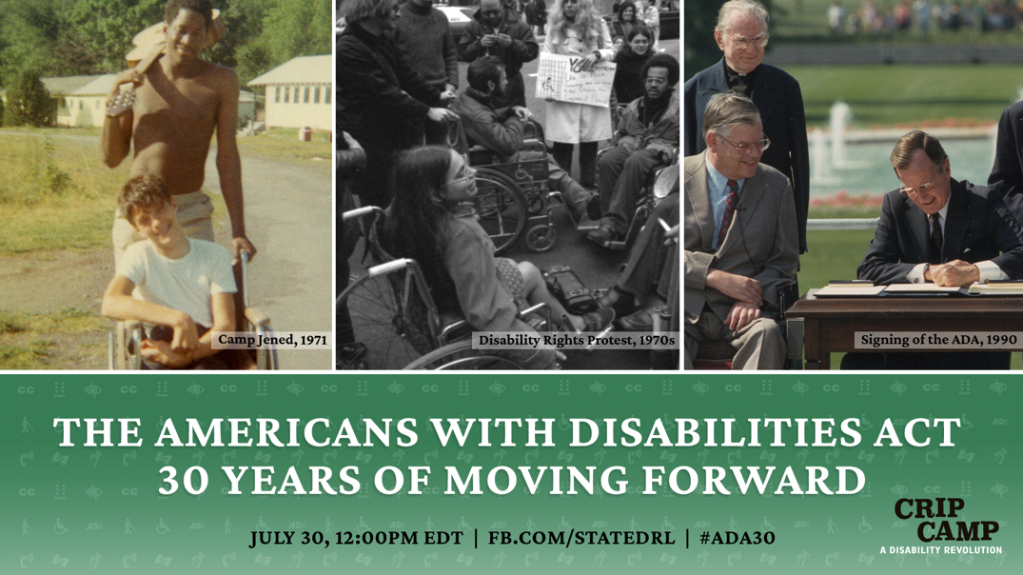

-Social Media Package-

#ADA30 interactive webchat
- Title: 30 Years of Moving Forward with the ADA
- Date/time: Thursday, July 30, 12:00 - 1:00pm EDT (Washington time)
- Event page: www.Facebook.com/StateDRL
- Shortened link: FB.com/StateDRL
- Language: English
- If you have any questions: Please reach out to Simon van Steyn
- Promotional materials and Speaker bios: interactive.america.gov/iip_event/ada30-webchat
- Facebook accessibility page with info on navigation assistant & keyboard shortcuts: www.facebook.com/help/273947702950567
Description:
This year marks the 30th anniversary of the Americans with Disabilities Act (the ADA). In honor of this landmark occasion, the U.S. Department of State is hosting an interactive webchat to discuss the importance of the law to the everyday lives of persons with disabilities, and how individuals and organizations advocating for disability rights built a successful movement that created lasting and impactful change.
Panelists, including renowned human rights advocate Judy Heumann and filmmaker Jim LeBrecht, will share how their experiences at Camp Jened, the focus of the award-winning documentary Crip Camp, helped inspire their lifelong commitments to disability rights issues. The discussion will be led by university professor and Paralympian, Anjali Forber-Pratt.

Ask the panelists your questions during the Facebook Live webchat on July 30 at 12:00pm EDT (Washington, DC time). To join the conversation, go to www.facebook.com/StateDRL. #ADA30 #AccessforAll

What is the Americans with Disabilities Act? The ADA is a civil rights law that prohibits discrimination on the basis of disability in employment, state and local government, public accommodations, commercial facilities, transportation, and telecommunications.
Time Zone: 12:00 p.m. EDT can be converted to your time zone here: http://bit.ly/2UrTRBS

Hashtags/Handles:
- #ADA30 #AccessforAll
- Dept. of State, Bureau of Democracy, Human Rights and Labor @StateDRL
- Judy Heumann @judithheumann, Jim LeBrecht @JimLeBrecht,
Anjali Forber-Pratt @anjalifp, Crip Camp @CripCampFilm

Panelists:
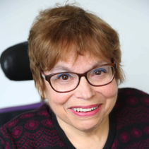
Judy Heumann - Founder, Disabled in Action, World Institute on Disability and internationally recognized civil rights leader
An internationally recognized leader in the disability community, Heumann is a lifelong civil rights advocate for people with disabilities. Her work with governments and NGOs has produced significant contributions since the 1970s to the development of human rights legislation and policies benefiting children and adults with disabilities. Through her work at the World Bank and the Department of State, Heumann led the mainstreaming of disability rights in international development.
Jim LeBrecht - Filmmaker, Disability Rights Activist and Co-director of Crip Camp
LeBrecht is the founder of Berkeley Sound Artists (BSA), an audio post-production house. Films that he has mixed have screened at film festivals including Sundance, Tribeca, SXSW, Telluride and Berlin. Jim’s work as a disabled rights advocate began in his teens as a member of Disabled in Action, a pioneering disability rights group. While at the University of California, San Diego, he helped found the Disabled Students Union. Jim is currently a board member at the Disability Rights Education & Defense Fund, a leading organization working for the rights of persons with disabilities through education, legislation and litigation.

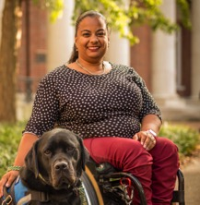
Moderator: Anjali Forber-Pratt, Ph.D. - Assistant Professor, Department of Human & Organizational Development at Vanderbilt University
At Vanderbilt University, Forber-Pratt’s research agenda adopts a social-ecological framework and looks at issues surrounding identity, equity and empowerment through methodology for individuals who are different in some way, with a large focus on disability. Anjali is also a bronze medal winning Paralympian, having represented the United States in wheelchair racing at the Beijing and London games.

Sample Social Media Posts

Facebook

[Post anytime]
- In honor of the 30th anniversary of the Americans with Disabilities Act (ADA), the U.S. Department of State is hosting an interactive webchat to discuss the importance of the law to the everyday lives of people with disabilities, and how individuals and organizations advocating for disability rights built a successful movement that created lasting and impactful change.
Panelists, including renowned human rights advocate Judy Heumann and filmmaker Jim LeBrecht, will discuss organizing & advocacy and Disability identity, and share how their experiences at Camp Jened - the focus of the award-winning documentary Crip Camp - helped inspire their lifelong commitments to disability rights issues. The discussion will be led by university professor and Paralympian, Anjali Forber-Pratt. Ask the panelists your questions during this Facebook Live webchat on July 30 at 12:00pm EDT (Washington, DC time). To join the conversation, go to www.facebook.com/StateDRL. #ADA30 #AccessforAll #CripCamp

- The award-winning documentary Crip Camp explores the formative experiences of campers with disabilities who found freedom, acceptance, and liberation at Camp Jened in the 60s and 70s.
As we celebrate the 30th anniversary of the Americans with Disabilities Act (ADA), hear from the film’s co-director, Jim LeBrecht, and fellow camper and internationally recognized civil rights leader, Judy Heumann, as they discuss the impact of their Camp Jened experience on their future careers as disability rights advocates. Anjali Forber-Pratt, professor at Vanderbilt University, will moderate the chat. Join the discussion by sharing your questions with the speakers on July 30 at 12:00pm EDT. Event page: www.facebook.com/StateDRL. #ADA30 #CripCamp

- Thanks to changes resulting from the ADA, most street corners in the United States now have curb cuts; elevators have buttons with Braille characters and an audio announcement identifying the floor at which it stopped; and movies and television shows offer closed caption text – universally-designed features that improve access for everyone.
These are just a few examples of how the 1990 Americans with Disabilities Act (ADA) has helped persons with disabilities gain greater independence, inclusion and equality. In honor of the 30th anniversary of the ADA, join an interactive webchat to hear disability rights experts talk about how the ADA opened doors and removed barriers, and how a well-organized advocacy movement played a critical role in getting the law passed.
Learn more during a Facebook Live virtual discussion on July 30 at 12:30 p.m. EDT (Washington, DC time). Share your thoughts and ask your questions - www.Facebook.com/StateDRL #ADA30 #CripCamp

[Post July 30, before the live event]
- Live Today! Join a #ADA30 Facebook Live webchat with internationally recognized civil rights leader, Judy Heumann, and filmmaker and disability rights advocate, Jim LeBrecht, who will share their thoughts on the significance of this occasion. Judy and Jim will also discuss how they evolved from young idealists with high aspirations to experienced advocates helping to change the country’s laws and social attitudes toward persons with disabilities. The discussion will be led by university professor and Paralympian, Anjali Forber-Pratt.

Be part of the conversation by asking your questions and sharing your perspectives. The program will start at 12:00 p.m. EDT (Washington, DC time) at www.facebook.com/StateDRL #ADA30 #CripCamp

Twitter

[Post anytime]
- Celebrate the 30th anniversary of the American with Disabilities Act (ADA) by joining a live webchat to hear disability rights icon @judithheumann and @CripCampFilm co-director @JimLeBrecht discuss their paths to advocacy >> July 30, 12:00pm EDT >> www.Facebook.com/StateDRL #ADA30
- Take part in an #ADA30 webchat - @anjalifp leads a discussion with disability rights experts @judithheumann @JimLeBrecht about the importance of the ADA and how advocacy and organizing was critical in creating the law. 12:00pm EDT @ www.Facebook.com/StateDRL #ADA30 #CripCamp
- Crip Camp tells the story of youth with disabilities finding acceptance & empowerment at a summer camp in the 70s. Hear from @JimLeBrecht & @judithheumann as they connect their camp experience with their lifelong commitment to advocacy. www.Facebook.com/StateDRL #ADA30
- Add your voice to the #ADA30 disability rights webchat! Ask civil rights icon Judy Heumann & director of award-winning film Crip Camp, Jim LeBrecht, your questions about why the ADA, advocacy & Disability identity matter. July 30 @ 12pm EDT www.Facebook.com/StateDRL #ADA30

- The ADA has helped persons with disabilities gain greater independence, inclusion and economic opportunities. On the 30th anniversary, join a webchat about the critical role grassroots advocacy played and how it impacted millions of lives. www.Facebook.com/StateDRL #ADA30

[Post July 30, before the live event]
- LIVE TODAY!: Don’t miss the #ADA30 webchat - disability rights experts discuss how they evolved from young idealists to experienced advocates helping to change the country’s laws & social attitudes toward people with disabilities. 12:00pm EDT @ www.Facebook.com/StateDRL #ADA30

Additional Resources:

Videos:

[Insert link to free version of Crip Camp]

