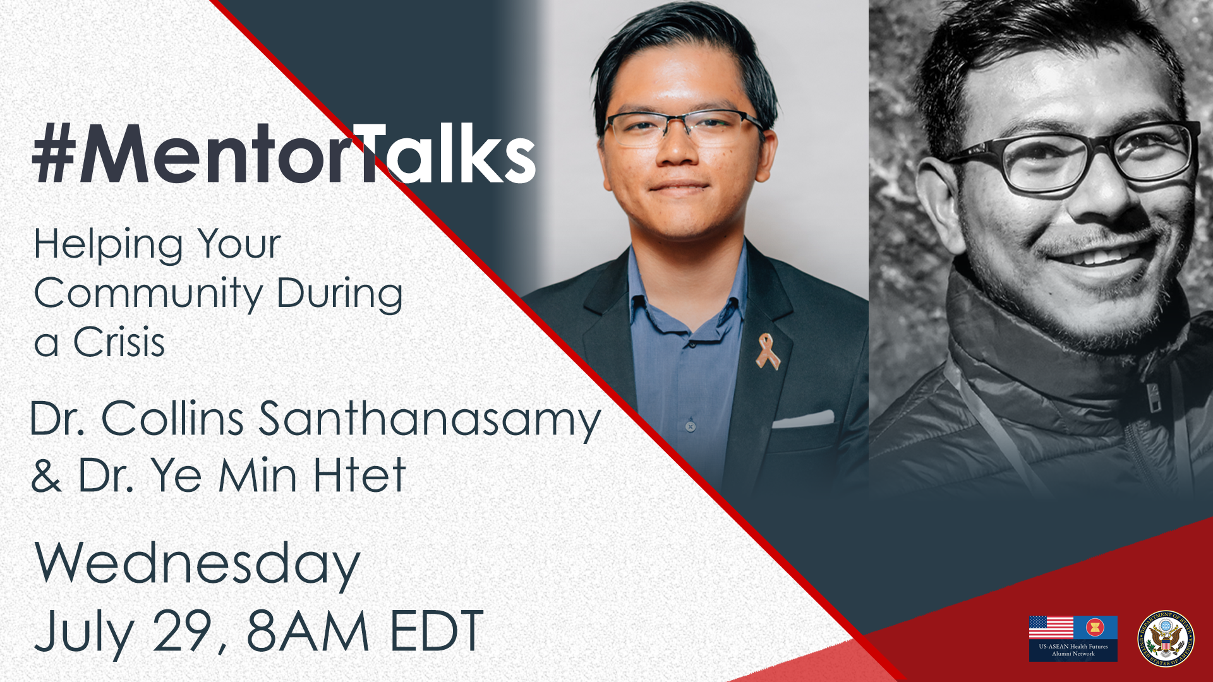

Social Media Toolkit
#MentorTalks: Helping Your Community During a Crisis

Join us for the latest #MentorTalks, a Facebook Live series that puts you in touch with mentors and leaders doing extraordinary things.

Description
Is your community reeling from COVID-19 and its side effects? Are you looking for ways to help?
Join us Wednesday, July 29 at 8:00 a.m. EDT to find out how two #ExchangeAlumni doctors are making a difference in their communities and on the front lines, and learn how you can do the same in your community!
Dr. Collins Santhanasamy from Malaysia and Dr. Ye Min Htet of Myanmar will talk about their efforts to address the ripple effect of the pandemic for at-risk and disadvantaged communities and how they have managed to deliver on many fronts during this time.
Tune in and ask your questions during the live program!

Event Details

Title #MentorTalks: Helping Your Community During a Crisis

Format 30-minute Facebook Live with live Q&A - audience questions welcomed!
Language English
Date and Time Wednesday, July 29 at 8:00 a.m. ET (Washington, DC)
URL facebook.com/InternationalExchangeAlumni

Speakers (bios below)
- Dr. Collins Santhanasamy - Community Solutions Program and YSEALI alumnus, Malaysia
- Dr. Ye Min Htet - Hubert H. Humphry alumnus, Myanmar

Topic
Public health initiatives/community service during COVID-19

Audience Open to all; also targeted to alumni of U.S. government-sponsored exchange programs, working in health-related fields.

Promo page (with program graphics) https://interactive.america.gov/iip_event/mentortalks-covid-19-community-support/

Hashtags
#MentorTalks #ExchangeAlumni #USASEANHealthFutures

Graphics (download from promo page) https://interactive.america.gov/iip_event/mentortalks-covid-19-community-support/

Social Media Posts
[Facebook/Instagram (for IG, verify Embassy handles)]
[schedule for any time]
How are two #ExchangeAlumni doctors making a difference in their communities outside of the hospital? On Wednesday, July 29 at 8am EDT [edit for local time], join🥼Dr. Collins Santhanasamy (Malaysia 🇲🇾) and 🥼Dr. Ye Min Htet (Myanmar 🇲🇲) on #MentorTalks to hear how they set up projects that are helping the most vulnerable members of their communities! Dr. Collins and Dr. Ye Min will also answer your questions live, during the show. Follow facebook.com/InternationalExchangeAlumni to receive updates and to watch the live program! @usembassykl @usembassy.rangoon @yseali #USASEANHealthFutures
[use Facebook/Twitter or Instagram graphic]

[schedule for any time]
Has your community been hard hit by COVID-19? Do you want to do something to help? Join #MentorTalks with🥼Dr. Collins Santhanasamy (Malaysia 🇲🇾) and 🥼Dr. Ye Min Htet (Myanmar 🇲🇲) on Wednesday, July 29 at 8am EDT [edit for local time] to hear how these awesome #ExchangeAlumni started projects that are helping the most vulnerable members of their communities! Dr. Collins and Dr. Ye Min will also answer your questions. Follow
facebook.com/InternationalExchangeAlumni to receive updates and to watch the live program! @usembassykl @usembassy.rangoon @yseali #USASEANHealthFutures
[use Facebook/Twitter or Instagram graphic]

[schedule for any time]
Wondering how you can help your community during the COVID-19 crisis? Join #ExchangeAlumni 🥼Dr. Collins Santhanasamy (Malaysia 🇲🇾) and 🥼Dr. Ye Min Htet (Myanmar 🇲🇲) for the next #MentorTalks facebook.com/InternationalExchangeAlumni on Wednesday, July 29 at 8am EDT [edit for local time]! Find out how Dr. Htet is addressing the mental wellbeing of children in Myanmar and how Dr. Collins is delivering emergency supplies, while also monitoring how the crisis is affecting breast cancer patients 🏥. Listen, ask questions, and be inspired! @usembassykl @usembassy.rangoon @yseali #USASEANHealthFutures
[use Facebook/Twitter or Instagram graphic]

[schedule for July 28]
TOMORROW at 8am EDT [edit for local time]: Join the next #MentorTalks for 30 minutes ⏰ of inspiration and mentorship! Hear from #ExchangeAlumni 🥼Dr. Collins Santhanasamy (Malaysia 🇲🇾) and 🥼Dr. Ye Min Htet (Myanmar 🇲🇲) about how they started projects to help the most vulnerable members of their community during the COVID-19 crisis. Follow on facebook.com/InternationalExchangeAlumni to receive updates and watch the live program! @usembassykl @usembassy.rangoon @yseali #USASEANHealthFutures
[use Facebook/Twitter or Instagram graphic]

[schedule for July 29]
LIVE TODAY at 8am EDT [edit for local time]: Wondering how you can help your community during the COVID-19 crisis? Join #ExchangeAlumni 🥼Dr. Collins Santhanasamy (Malaysia 🇲🇾) and 🥼Dr. Ye Min Htet (Myanmar 🇲🇲) for the next #MentorTalks: facebook.com/InternationalExchangeAlumni! Find out how Dr. Htet is addressing the mental well-being of children in Myanmar and how Dr. Collins is delivering emergency supplies while also monitoring how the crisis is affecting breast cancer patients. Listen, ask questions, and be inspired! @usembassykl @usembassy.rangoon @yseali #USASEANHealthFutures
[use [Facebook/Twitter or Instagram graphic]

______________________________
[Twitter]

[schedule for any time]
How are two #ExchangeAlumni doctors making a difference in their communities outside of the front lines? Join us for #MentorTalks on July 29 8am EDT [edit for local time] to be inspired and take action! http://bit.ly/2YnXWnM @usembassykl @USEmbassyBurma @yseali

[schedule for any time]
Got 30 minutes ⏰ and want to know how you can help your community from the ripple effects of the COVID-19 crisis? Join us for #MentorTalks on July 29 8am EDT [edit for local time] to be inspired and take action! http://bit.ly/2YnXWnM @usembassykl @USEmbassyBurma @yseali
[use Facebook/Twitter graphic]

[schedule for any time]
Got some ⏰? Two #ExchangeAlumni from Myanmar 🇲🇲and Malaysia 🇲🇾will share how they are helping their communities during COVID-19 on #MentorTalks July 29 at 8am EDT [edit for local time] and be ready to ask questions: http://bit.ly/2YnXWnM @usembassykl @USEmbassyBurma @yseali
[use Facebook/Twitter graphic]

[schedule for July 29]
TOMORROW 8am EDT [edit for local time]: #ExchangeAlumni 🥼Dr. Collins Santhanasamy (Malaysia 🇲🇾) and 🥼Dr. Ye Min Htet (Myanmar 🇲🇲) join #MentorTalks to talk about supporting your community through COVID-19. Watch live at http://bit.ly/2YnXWnM @usembassykl @USEmbassyBurma @yseali
[use Facebook/Twitter graphic]

[schedule for July 29]
LIVE TODAY @8am EDT [edit for local time]: Watch #MentorTalks with #ExchangeAlumni 🥼Dr. Collins Santhanasamy (Malaysia 🇲🇾) and 🥼Dr. Ye Min Htet (Myanmar 🇲🇲)! Watch live & ask questions on Facebook at http://bit.ly/2YnXWnM @usembassykl @USEmbassyBurma @yseali #USASEANHealthFutures
[use Facebook/Twitter graphic]

[schedule for July 29 an hour before program start time]
IN ONE HOUR: Join #ExchangeAlumni 🥼Dr. Collins Santhanasamy (Malaysia 🇲🇾) and 🥼Dr. Ye Min Htet (Myanmar 🇲🇲) on Facebook http://bit.ly/2YnXWnM to learn how you can help your community during a crisis! #MentorTalks @usembassykl @USEmbassyBurma @yseali #USASEANHealthFutures
[use Facebook/Twitter graphic]

[schedule for July 29 shortly before program start time]
Join @AlumniExchange NOW for #MentorTalks with #ExchangeAlumni 🥼Dr. Collins Santhanasamy (Malaysia 🇲🇾) and 🥼Dr. Ye Min Htet (Myanmar 🇲🇲) . Go to Facebook http://bit.ly/2YnXWnM to learn how you can help your community during a crisis! @usembassykl @USEmbassyBurma @yseali #USASEANHealthFutures
[use Facebook/Twitter graphic]
------------------------------------------
Speaker Bios
Both speakers are part of the recently launched U.S.-ASEAN Health Futures Alumni Network, which connects medical and public health alumni in ASEAN with U.S. experts.
Dr. Collins Santhanasamy
Founder, M Exchange
Dr. Collins Santhanasamy is a medical doctor and the founder of the M Exchange, a pilot project that works with vulnerable communities by hosting free medical camps and building sustainable schools. He is also country director for the Magical Light Foundation, which builds schools and provides educational resources for disadvantaged children in Myanmar.

Dr. Collins also serves as the Donor Engagement Manager for Cancer Research Malaysia. He has volunteered in countries across Asia including Bangladesh, Cambodia, India, Indonesia, Malaysia and Thailand, and is passionate about empowering communities through the development of innovative healthcare solutions to build community resilience.

Dr. Collins is a 2018 exchange alumnus of the Community Solutions Program and a 2019 YSEALI alumnus.

Dr. Ye Min Htet
Founder, Moe Thauk Yaung Chi ("Dawn")
Dr. Ye Min Htet is a medical doctor with a Masters of Science in International Health and is the founder of “Moe Thauk Yaung Chi” (Dawn), a community-based organization in Myanmar that promotes quality education at orphanages and other non-governmental informal education institutions for disadvantaged children. He currently works as a National Program Officer for the Swedish International Development Cooperation Agency located in Yangon, Myanmar.

Dr. Ye Min is devoted to improving the mental health and well-being of Myanmar’s disadvantaged youth, as well as providing them with key social and educational skill sets.

Dr. Ye Min is a 2018 exchange alumnus of the Hubert H. Humphrey Fellowship program.

