SOCIAL MEDIA TOOLKIT
GIST TechConnect: Global Healthcare Innovations

About GIST TechConnect
GIST TechConnect provides entrepreneurs around the world with direct access to leading U.S. experts from business and academia, but without the travel and other related costs. Young science and technology entrepreneurs can engage with experts and the larger GIST community to learn about best business practices and startup resources.

Title: TechConnect: Global Healthcare Innovations
Date/Time: 25 August, 15:00 UTC (11:00am ET)
Description: The spotlight on healthcare innovation has never been more intense and urgent as it is today. Across the globe, governments, corporations, universities, and startups are feverishly working to develop new healthtech, biotech, and medtech solutions to address our most pressing global issues. This degree of innovation and collaboration is unprecedented. From new diagnostic tests for diseases to innovative telehealth solutions, our world is entering a new generation of healthcare.

This GIST TechConnect will be co-hosted with JLABS @ Washington, DC. Johnson & Johnson Innovation – JLABS is a global network of open innovation ecosystems, enabling and empowering innovators across a broad healthcare spectrum including pharmaceutical, medical device, consumer and health tech sectors to create and accelerate the delivery of life-saving, life-enhancing health and wellness solutions to patients around the world.

SOCIAL CARDS

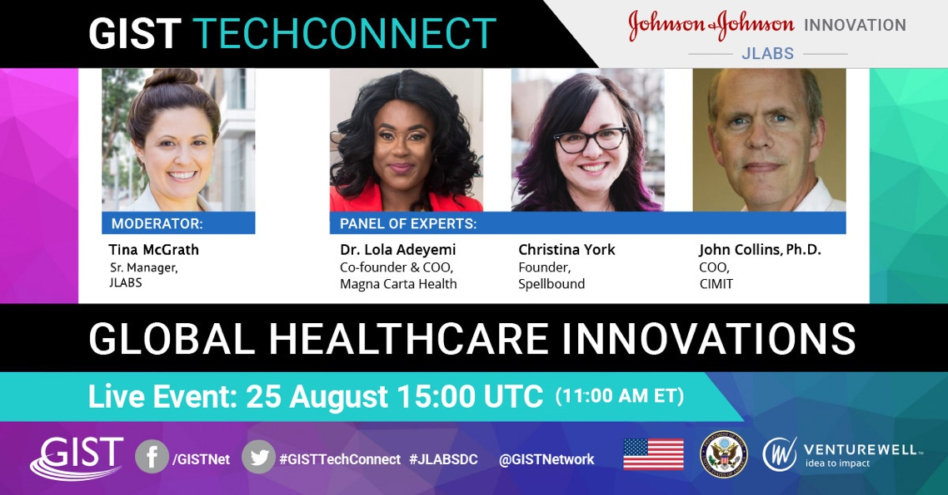

SOCIAL POSTS

Week of August 10
Twitter
Mark your calendars! 🗓 Tuesday, 25 August, we’re joining #GISTTechConnect and @JLABS for a spotlight on healthcare innovation with @Tina_McGrath_, @UXtina, @DrLoladeAdeyemi, Dr. John M. Collins of @CIMIT and @VentureWell. Tune in: http://bit.ly/GISTTechConn @GISTNetwork

Facebook
Mark your calendars! 🗓 Tuesday, 25 August, we’re joining #GISTTechConnect and #JLABSDC for a spotlight on healthcare innovation with Christina McGrath of JLABS DC, Dr. Lola Adeyemi of @magnacartahealth, Christina York of @SpellBoundAR, Dr. John M. Collins of @CIMITBoston, and @VentureWell. Tune in at 15:00 UTC (11:00AM ET) to learn more about the new generation of healthcare. Learn more: http://bit.ly/GISTTechConn @GISTNet

Twitter
Save the date for the next #GISTTechConnect on 8/25 at 15:00 UTC (11:00AM ET) 🎥 Join us for a new episode on healthcare innovation co-hosted by @JLABS. Tune in to learn more about what we do, and ask us questions LIVE! Learn more: http://bit.ly/GISTTechConn

Facebook
Save the date for the next #GISTTechConnect on 8/25 at 15:00 UTC (11:00AM ET), co-hosted by #JLABSDC 🎥 Join us for a spotlight on healthcare innovation featuring our own [name] and streaming live! Learn more: http://bit.ly/GISTTechConn

Week of August 17
Twitter
(1/2) Across the globe, governments, corporations, universities, and startups are tirelessly working to develop new healthtech, biotech, and medtech solutions to address our most pressing global issues. http://bit.ly/GISTTechConn
(2/2) Join us on 8/25 at 15:00 UTC (11:00AM ET) for a spotlight on healthcare innovation @GISTNetwork, co-hosted by @JLABS, to get an inside look at the new generation of healthcare. http://bit.ly/GISTTechConn

Facebook
Across the globe, governments, corporations, universities, and startups are tirelessly working to develop new healthtech, biotech, and medtech solutions to address our most pressing global issues.
Join us on Tuesday, August 25, at 15:00 UTC (11:00AM ET) for a live interview with @GISTNetwork, co-hosted by #JLABSDC, to get an inside look at new diagnostic tests, ground-breaking telehealth solutions, and other innovations in this new generation of healthcare. http://bit.ly/GISTTechConn

Twitter
Next Tuesday on #GISTTechConnect, @DrLoladeAdeyemi shares the story of how she became a #healthcare innovator— and her #advice for others looking to do the same. Learn more and tune in: http://bit.ly/GISTTechConn. #Cohosted by @JLABS.

Next Tuesday on #GISTTechConnect, Dr. John M. Collins of @CIMIT shares the story of how he became a #healthcare innovator— and his #advice for others looking to do the same. Learn more and tune in: http://bit.ly/GISTTechConn. #Cohosted by @JLABS.

Facebook
Next Tuesday on #GISTTechConnect, Dr. Lola Adeyemi of @magnacartahealth shares the story of how she came to be a healthcare innovator—and her #advice for others looking to do the same. Learn more: http://bit.ly/GISTTechConn Don’t forget to save this link or bookmark the page to tune in on Tuesday! #Co-hosted by #JLABSDC

Next Tuesday on #GISTTechConnect, Christina York of @SpellBoundAR shares the story of how she came to be a healthcare innovator—and her #advice for others looking to do the same. Learn more: http://bit.ly/GISTTechConn Don’t forget to save this link or bookmark the page to tune in on Tuesday! #Co-hosted by #JLABSDC
Week of August 24

Twitter
The spotlight on healthcare innovation has never been more intense and urgent as it is today—and #startups are a critical part of the new generation of healthcare. Learn more during tomorrow’s #GISTTechConnect with @GISTNetwork, co-hosted by @JLABS. Tune in: http://bit.ly/GISTTechConn

Facebook
The spotlight on healthcare innovation has never been more intense and urgent as it is today—and #startups are a critical part of the new generation of healthcare.
We’ll talk about why on tomorrow’s #GISTTechConnect with @GISTNetwork, co-hosted by #JLABSDC. Join here: http://bit.ly/GISTTechConn

Twitter
From new diagnostic tests to innovative telehealth solutions, our world is entering a new generation of healthcare. Join #GISTTechConnect with @JLABS on Tuesday at 15:00 UTC (11:00AM ET)—we’ll share our experience and expertise in #medtech, and answer your questions live on the show. Learn more and join us on Tuesday: http://bit.ly/GISTTechConn

Facebook
From new diagnostic tests for diseases to innovative telehealth solutions, our world is entering a new generation of #healthcare. Tune in to this week’s #GISTTechConnect with #JLABSDC on August 25 at 15:00 UTC (11:00AM ET) where we’ll share our experience and expertise in #medtech, and answer your questions live on the show. Learn more and bookmark this page to join us on Tuesday: http://bit.ly/GISTTechConn

Twitter
Tomorrow! Tune in to #GISTTechConnect for a live interview with #healthcare innovators to learn more about the next generation of #medtech. Featuring @Tina_McGrath_, @UXtina, @DrLoladeAdeyemi, Dr. John M. Collins of @CIMIT and @VentureWell! Get an inside look at their inventions and answer your questions live on the show. @JLABS http://bit.ly/GISTTechConn

Facebook
Tomorrow! Tune in at 15:00 UTC (11:00AM ET) for a live interview with rising innovators and healthcare experts Christina McGrath of JLABS DC, Dr. Lola Adeyemi of @magnacartahealth, Christina York of @SpellBoundAR, Dr. John M. Collins of @CIMITBoston, and @VentureWell.! Get an inside look at #healthcare as they shine a light on new #healthtech, #biotech, and #medtech solutions that address some of our most pressing global issues. #GISTTechConnect #JLABSDC http://bit.ly/GISTTechConn

During the live TechConnect
Twitter
We’re live with @Tina_McGrath_, @UXtina, @DrLoladeAdeyemi, Dr. John M. Collins of @CIMIT and @VentureWell talking about global healthcare innovations. Ask these experts your questions at http://bit.ly/GISTTechConn

Facebook
We’re live with Christina McGrath of JLABS DC, Dr. Lola Adeyemi of @magnacartahealth, Christina York of @SpellBoundAR, Dr. John M. Collins of @CIMITBoston, and @VentureWell. Ask these experts your questions at http://bit.ly/GISTTechConn

