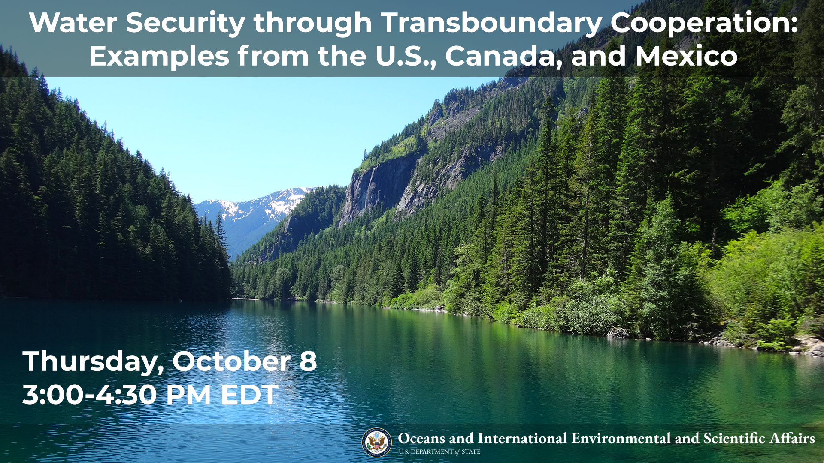

Summary
On Thursday, October 8 at 3 pm EDT, the Bureau of Oceans and International Environmental and Scientific Affairs (OES) and the Bureau of Global Public Affairs (GPA) are co-hosting an interactive webinar to showcase how the United States approaches transboundary water management and promotes water security in North America. U.S. experts engage with Mexican and Canadian counterparts to identify strategies and methods to foster longer-term information sharing, collaboration, and expert consultation for water management.

Program Description
The United States and Canada share over 150 transboundary rivers and lakes. Since 1909, the United States and Canada’s shared waters management has been negotiated and managed through the International Joint Commission (IJC). The IJC manages a wide range of transboundary issues including water levels and flows, water and air quality, and stakeholder engagement. To the south, the United States and Mexico share fewer, but no less important, rivers. Governed by the International Boundary and Water Commission (IBWC) since 1889, the United States and Mexico collaboratively navigate national ownership of waters, sanitation, water quality, and flood control in the border region. Millions of people, communities, tribal nations, companies, schools, hospitals, and industries rely on the water resources shared between the U.S. and Canada and the U.S. and Mexico.

The first half of the program will highlight and compare approaches for transboundary water cooperation with Canada and Mexico, with case studies from the International Joint Commission (IJC) and the example of the Colorado River that highlight the roles of stakeholders including the U.S. government interagency, local communities, states and territories, tribal nations, the private sector, and civil society. The second portion of the program will examine the role of national and sub-national water management practices, such as the case of El Paso Water, water reuse, and water-savings programs, and their influence on regional water security and shared waters management.

The U.S. government is committed to providing a platform that encourages information sharing, dialogue, collaboration, and stakeholder engagement for cooperative, responsible management of shared water resources in North America. U.S. engagement with the region has long emphasized cooperation on environmental management, including water management. This engagement builds trust among partners and stakeholders and strengthens cooperation not only on water issues but for natural resources management more broadly.

Moderator and Speaker Biographies
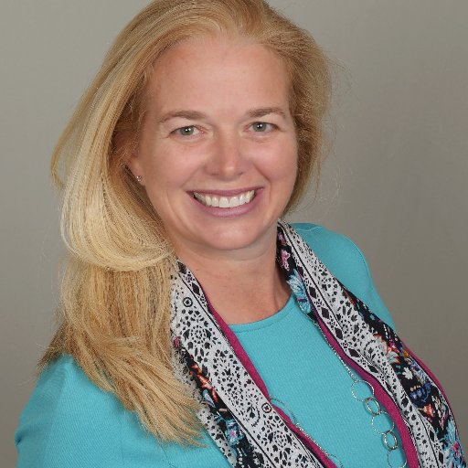
Moderator: Melissa Meeker, CEO, The Water Tower
Melissa has over 25 years of experience in water resources management, with an emphasis on alternative water supply development and research, workforce development and public engagement. Melissa previously served as the CEO of The Water Environment and Reuse Foundation and was instrumental in the merger of three critical water-related research foundations. She also served as Executive Director of the South Florida Water Management District and Deputy Secretary of the Florida Department of Environmental Protection.

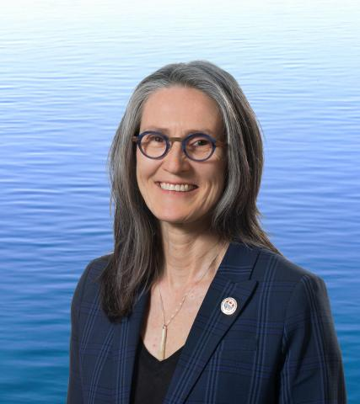
Speaker: Merrell-Ann Phare, Canadian Commissioner, International Joint Commission
Ms. Phare is a lawyer, writer, strategist, negotiator and relationship-builder who worked extensively in and with indigenous organizations on environmental, land, water, rights and governance issues. She, along with 10 First Nation Chiefs, was the founding Executive Director of the Centre for Indigenous Environmental Resources (CIER), a national First Nation charitable environmental organisation. As Chief Negotiator for the Government of the Northwest Territories, Ms. Phare leads the negotiation of transboundary water agreements in the Mackenzie River Basin and the creation of Thaidene Nene, a national and territorial park in the east arm of Great Slave Lake. She is the author of the book “Denying the Source: the Crisis of First Nations Water Rights” and co-author of “Ethical Water”. She is a member of the Forum for Leadership on Water, Smart Prosperity's Leadership Council, and is a recipient of Canada's Clean 50 Award. She served as legal counsel and advisor to a number of First Nation and Metis governments and organizations. Ms. Phare holds a Bachelor of Arts in Economics (Environmental) Bachelor of Laws, Master of Law (Aboriginal Water Rights and International Trade Law) from the University of Manitoba a Master of Fine Arts (Creative Writing) from University of British Columbia. She resides in Winnipeg, Manitoba.
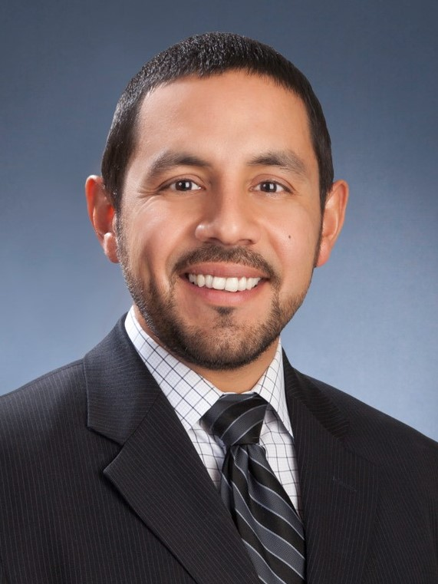
Speaker: Gilbert Trejo, Chief Technical Officer, El Paso Water and President of the WateReuse Association
Mr. Trejo oversees the technical services portfolio for the utility, which includes engineering, planning and development, and project and construction management. Before coming to El Paso Water in 2014, he was the Principal in charge of Arcadis’ Water Division in the El Paso, TX region. In that role, he led business development, designed and managed projects, and ensured financial performance. Trejo is a Board Member for the WateReuse Association and Water Environment and Reuse Research Foundation. He is a published author on water reuse and water infrastructure topics. He is a licensed professional engineer in the State of Texas and a Certified Floodplain Manager. Trejo earned a Bachelor’s of Science in Civil Engineering from the University of Texas at El Paso and a Master’s of Science in Environmental and Water Resources Engineering from the University of Texas, Austin.
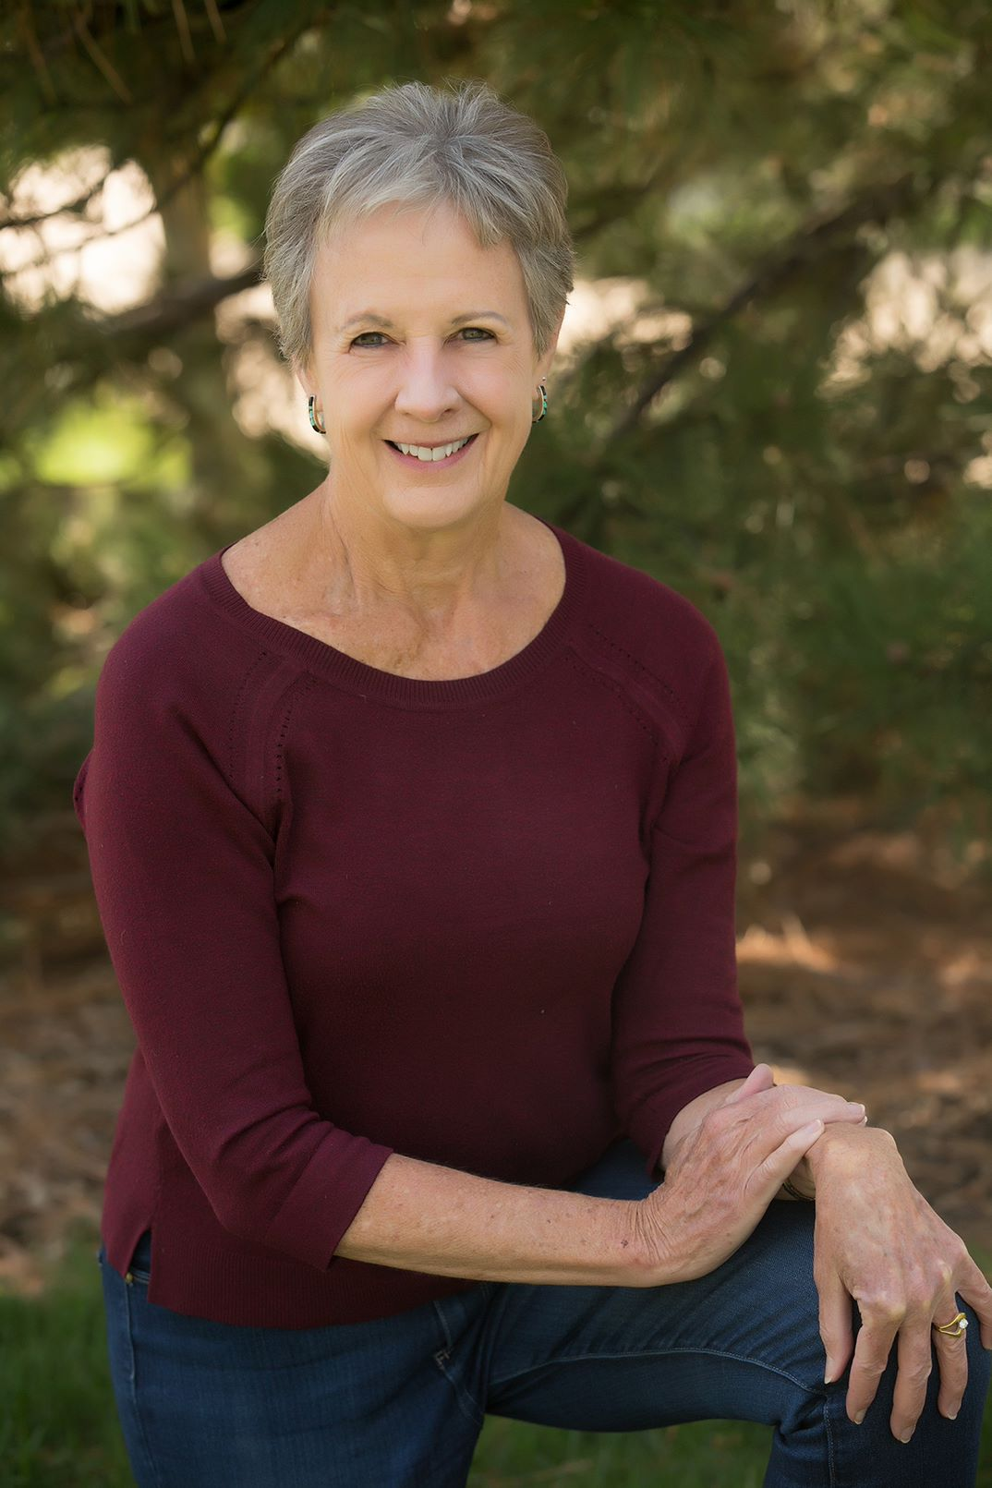
Speaker: Anne Castle, Senior Fellow, Getches-Wilkinson Center for Natural Resources, Energy, and the Environment, University of Colorado Law School
Anne Castle is a senior fellow at the Getches-Wilkinson Center for Natural Resources, Energy, and the Environment at the University of Colorado Law School, focusing on western water issues including Colorado River operational policy and the integration of water and land use planning. She is a founding member of the Water Policy Group, comprised of select water sector experts who have been decision makers and trusted advisers within governments and international bodies handling complex water policy and strategy. From 2009 to 2014, she was Assistant Secretary for Water and Science at the U.S. Department of the Interior where she oversaw water and science policy for the Department and had responsibility for the U.S. Bureau of Reclamation and the U.S. Geological Survey. Castle is a recovering lawyer, having practiced water law for 28 years with the Rocky Mountain law firm of Holland & Hart where she chaired the Management Committee and Natural Resources Department. She serves on boards or advisory committees for Western Resource Advocates, Colorado Legal Services, the Colorado Water Trust, the Salazar Center for North American Conservation, the Airborne Snow Observatory, Stanford University’s Water in the West program, and the Colorado River Water and Tribes Initiative, where she is co-leading an initiative for universal access to clean and safe water on Indian reservations.

Event Details - Snapshot

Title | Water Security through Transboundary Cooperation: Examples from the U.S., Canada, and Mexico
Date and Time | Thursday, October 8 from 3:00 – 4:30 PM EDT (duration: 90 minutes)
Promo Page URL | https://interactive.america.gov/iip_event/north-america-water-security/
Watch Page URL | Link on promo page
Format | 90-minute webcast with live Q&A
Topic | Water Security, Water Reuse, Transboundary Water Cooperation
Audience | North America
Hashtags | #USWater

Promotional Banners and Images

Promotional banner image, social media toolkit can be downloaded here at the bottom of the page: https://interactive.america.gov/iip_event/north-america-water-security/

Social Media Posts

Facebook and Instagram Posts

Suggested images to use with social media posts can be downloaded here: https://app.box.com/s/it4bo3lcb4kvlc7psc2r7yw3izginybg

Schedule Date: September 24
Save the date! Our panel of water resources management and transboundary water experts will discuss how the US, Canada, and Mexico work together to address water security. Join us for an interactive webinar on October 8 at 3 pm EDT to learn more! http://bit.ly/usawater [insert photo]

Schedule Date: September 30
Did you know water reuse is one way the United States is working to strengthen our water security? Utilities like El Paso Water recycle water and use water-efficient technologies to make every drop count. Learn more about how US water management practices promote water security and strengthen our relationship with our neighbors at our October 8 at 3 pm EDT live webinar! http://bit.ly/usawater [insert photo]

Schedule Date: October 5
The US and Canada share over 150 transboundary rivers and lakes. They have jointly managed these water resources through the International Joint Commission since 1909. Join us for an interactive webinar on October 8 at 3 pm EDT to learn more about US-Canada water cooperation and how we are working together to achieve water security in both nations. http://bit.ly/usawater [insert photo]

Schedule Date: October 6
United States and Mexico share many water resources, including the Colorado River and the Rio Grande. Governed by the International Boundary and Water Commission (IBWC) since 1889, the United States and Mexico collaboratively navigate national ownership of waters, sanitation, water quality, and flood control in the border region. Join us for an interactive webinar on October 8 at 3 pm EDT to learn more about US-Mexico water cooperation and how we are working together to achieve water security in both nations. http://bit.ly/usawater [insert photo]

Schedule Date: October 7
Join us TOMORROW October 8 at 3 pm EDT to learn from water resources management and transboundary water experts about the many ways the US works with Canada and Mexico to promote water security in North America. http://bit.ly/usawater[insert photo]

Schedule Date: October 8 at 2 pm EDT
LIVE IN 1 HOUR! Our panel of water experts will discuss water resources management, transboundary cooperation, and water reuse to highlight how the US, Canada, and Mexico collaborate to promote water security in North America. http://bit.ly/usawater [insert photo]

Facebook Polls

Polls are to be loaded directly into Facebook page at: https://www.facebook.com/ScienceDiplomacyUSA/
Schedule Date: September 27 – Interactive Poll
We are hosting an interactive webinar on October 8 at 3 pm EDT on how the US, Canada, and Mexico work together to promote water security in North America. Which topic would you most like to learn more about? http://bit.ly/usawater
A: Water sharing
B: Water quality impacts
C: Water reuse
D: Stakeholder engagement

Schedule Date: October 1 – Interactive Poll
True or False: The US and Canada share more than 150 transboundary lakes, rivers, and aquifers. Join our interactive webinar on October 8 at 3 pm EDT to learn more! http://bit.ly/usawater

A: True
B: False

Twitter Posts

Suggested images to use with social media posts can be downloaded here: https://app.box.com/s/it4bo3lcb4kvlc7psc2r7yw3izginybg

Schedule Date: September 24
Save the date! Our panel of water resources management and transboundary water experts will discuss how the US, Canada, and Mexico work together to address water security. Join us for an interactive webinar on October 8 at 3 pm EDT to learn more! http://bit.ly/usawater [insert photo] [insert event link]

Schedule Date: September 30
#DYK water reuse is one way the US works to strengthen our water security? Utilities like @EPWater recycle water & use water-efficient technologies to make every drop count. Learn more at our October 8 at 3 pm EDT live webinar! http://bit.ly/usawater [insert photo]

Schedule Date: October 4
#DYK the US & Canada share 150+ transboundary rivers and lakes and have jointly managed these water resources through the @IJCSharedWaters since 1909? Join us for an interactive webinar on Oct 8 at 3 pm EDT to learn more about US-Canada water cooperation & security. http://bit.ly/usawater [insert photo]

Schedule Date: October 5
#DYK the US & Mexico work together through the International Boundary and Water Commission to collaboratively navigate national ownership of waters, sanitation, water quality, and flood control in the border region. Join us on Oct 8 at 3 pm EDT to learn more! http://bit.ly/usawater [insert photo]

Schedule Date: October 7
Join us TOMORROW October 8 at 3 pm EDT to learn from water resources management and transboundary water experts about the many ways the US works with Canada and Mexico to promote water security in North America. http://bit.ly/usawater [insert photo]

Schedule Date: October 8 at 2 pm EDT
LIVE IN 1 HOUR! Our panel of water experts will discuss water resources management, transboundary cooperation, and water reuse to highlight how the US, Canada, and Mexico collaborate to promote water security in North America. http://bit.ly/usawater [insert photo]

Twitter Polls

Polls are to be loaded directly into Twitter page at: https://twitter.com/scidiplomacyusa?lang=en

Schedule Date: September 27 – Interactive Poll
We are hosting an interactive webinar on October 8 at 3 pm EDT on how the US, Canada, and Mexico work together to promote water security in North America. Which topic would you most like to learn more about? http://bit.ly/usawater
A: Water sharing
B: Water quality impacts
C: Water reuse
D: Stakeholder engagement

Schedule Date: October 1 – Interactive Poll
True or False: The US and Canada share more than 150 transboundary lakes, rivers, and aquifers. Join our interactive webinar on October 8 at 3 pm EDT to learn more! http://bit.ly/usawater

A: True
B: False

